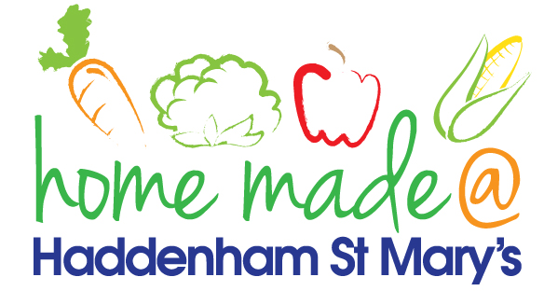

MENU – week commencing 27th June 2022
**Please note that the fish on a Friday may be substituted for a similar fish on the day due to current supply issues**
 | Meat Free Monday | Tuesday  Choose Day | Wednesday  Wonderful Roast | Thursday  Joyful Jackets | Friday  Fish Friday
Lunch | Pasta bake with vegetables | Chilli with rice and nachos | Roast sausage with all the trimmings and gravy | Jacket potato with a choice of toppings | Fishcake, chips and vegetables
Vegetarian option | Pasta bake with vegetables | Quorn chilli with rice and nachos | Quorn sausage roast with all the trimmings | Jacket potato with a choice of toppings | Veggie bites, chips and vegetables
Dessert | Peach slices | Mousse | Fruit | Jelly | Choc chip cookie
Free From  option | Pasta bake with vegetables  Peach slices | Chilli with rice and nachos  Rocky Road | Roast sausage with all trimmings and gravy  Fruit | Jacket potato with a choice of toppings  Fruit | Fish fingers, chips and vegetables  Flapjack
All meals will contain or be served with at least one portion of vegetables.
All hot puddings will be accompanied by custard or cream.
All roast dinners, sausage & mash and pie dishes will have the option of extra gravy.
All children will also be offered bread, a piece of fruit and a drink of milk or water with their main meal.

