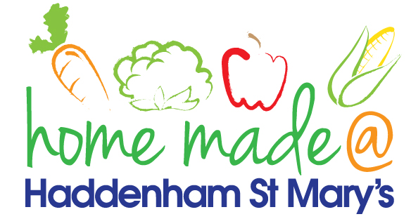

MENU – week commencing 25th April 2022
**Please note that the fish on a Friday may be substituted for a similar fish on the day due to current supply issues**
 | Meat Free Monday | Tuesday  Choose Day | Wednesday  Wonderful Roast | Thursday  Joyful Jackets | Friday  Fish Friday
Lunch | Pasta bake with vegetables | Chicken goujons, potato crispers and vegetables | Roast beef with all the trimmings and gravy | Jacket potato with a choice of toppings | Battered fish, chips and vegetables
Vegetarian option | Pasta bake with vegetables | Veggie bites, potato crispers and vegetables | Quorn roast with all the trimmings | Jacket potato with a choice of toppings | Veggie burger, chips and vegetables
Dessert | Fruit cocktail | Mousse | Chocolate cookie | Fruit | Flapjack
Free From  option | Pasta bake with vegetables  Fruit cocktail | Veggie patty, potato crispers and vegetables  Jelly | Roast beef with all trimmings and gravy  Biscuit | Jacket potato with a choice of toppings  Fruit | Fish fingers, chips and vegetables  Biscuit
All meals will contain or be served with at least one portion of vegetables.
All hot puddings will be accompanied by custard or cream.
All roast dinners, sausage & mash and pie dishes will have the option of extra gravy.
All children will also be offered bread, a piece of fruit and a drink of milk or water with their main meal.

