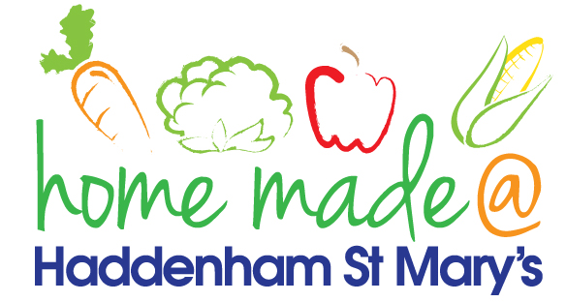

MENU – week commencing 23rd May 2022
**Please note that the fish on a Friday may be substituted for a similar fish on the day due to current supply issues**
 | Meat Free Monday | Tuesday  Choose Day | Wednesday  Wonderful Roast | Thursday  Joyful Jackets | Friday  Fish Friday
Lunch | Macaroni cheese | Cottage pie and vegetables | Roast sausage with all the trimmings and gravy | Jacket potato with a choice of toppings
Vegetarian option | Macaroni cheese | Quorn cottage pie and vegetables | Veggie sausage roast with all the trimmings | Jacket potato with a choice of toppings
Dessert | Fruit smoothie | Mousse | Ginger crunch biscuit | Fruit
Free From  option | Macaroni cheese  Fruit smoothie | Cottage pie and vegetables  Tiffin | Roast sausage with all trimmings and gravy  Jelly | Jacket potato with a choice of toppings  Fruit
All meals will contain or be served with at least one portion of vegetables.
All hot puddings will be accompanied by custard or cream.
All roast dinners, sausage & mash and pie dishes will have the option of extra gravy.
All children will also be offered bread, a piece of fruit and a drink of milk or water with their main meal.

