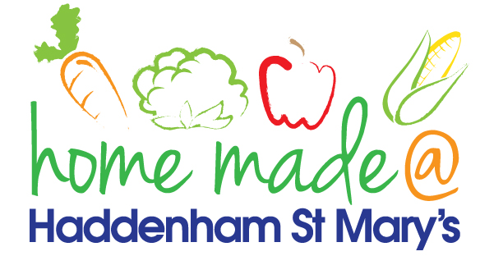

MENU – week commencing 9th May 2022
**Please note that the fish on a Friday may be substituted for a similar fish on the day due to current supply issues**
 | Meat Free Monday | Tuesday  Choose Day | Wednesday  Wonderful Roast | Thursday  Joyful Jackets | Friday  Fish Friday
Lunch | Vegan sausage roll, potato rosti and vegetables | Meatballs with spaghetti | Roast sausage with all the trimmings and gravy | Jacket potato with a choice of toppings | Cod bites, chips and vegetables
Vegetarian option | Vegan sausage roll, potato rosti and vegetables | Quorn meatballs with spaghetti | Quorn roast with all the trimmings | Jacket potato with a choice of toppings | Veggie bites, chips and vegetables
Dessert | Mandarin segments | Sponge and custard | Angel Delight | Fruit | Carrot cake cupcakes
Free From  option | Bubble & squeak bites, potato squares and vegetables  Mandarin segments | Meatballs and pasta  Custard | Roast sausage with all trimmings and gravy  Caramel pudding | Jacket potato with a choice of toppings  Fruit | Fish fingers, chips and vegetables  Yoghurt
All meals will contain or be served with at least one portion of vegetables.
All hot puddings will be accompanied by custard or cream.
All roast dinners, sausage & mash and pie dishes will have the option of extra gravy.
All children will also be offered bread, a piece of fruit and a drink of milk or water with their main meal.

