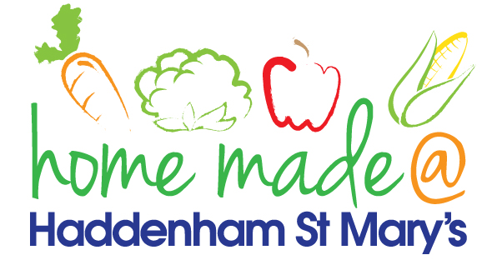

MENU – week commencing 2nd May 2022
**Please note that the fish on a Friday may be substituted for a similar fish on the day due to current supply issues**
 | Meat Free Monday | Tuesday  Choose Day | Wednesday  Wonderful Roast | Thursday  Joyful Jackets | Friday  Fish Friday
Lunch |  | Pasta with a choice of toppings | Roast turkey with all the trimmings and gravy | Jacket potato with a choice of toppings | Jumbo fish finger, chips and vegetables
Vegetarian option |  | Pasta with a choice of toppings | Quorn sausage roast with all the trimmings | Jacket potato with a choice of toppings | Veggie fingers, chips and vegetables
Dessert |  | Yoghurt | Peach slices | Fruit | Choc chip cookies
Free From  option |  | Pasta with a choice of toppings  Yoghurt | Roast turkey with all trimmings and gravy  Peach slices | Jacket potato with a choice of toppings  Fruit | Fish fingers, chips and vegetables  Chocolate pudding
All meals will contain or be served with at least one portion of vegetables.
All hot puddings will be accompanied by custard or cream.
All roast dinners, sausage & mash and pie dishes will have the option of extra gravy.
All children will also be offered bread, a piece of fruit and a drink of milk or water with their main meal.

