Home Learning – Cuddington and Dinton C of E Primary School
Year 4 – Daily Lesson Plans Week 1
_____________________________________
Day 1
Lesson 1  Phonics, Spelling and/or Guided Reading | - Practise learning a selection of spellings from this half-term’s overview. There is a copy on our class web page. See if you can spot patterns. Make word pyramids, write vowels in red and consonants in blue, write in bubble writing.  - Get comfortable and spend 20 minutes reading your library book or a book of your choice from home.  - You could also listen to Chapters 1-6 of The Wild Robot Escapes, the sequel to The Wild Robot by Peter Brown. Follow the link.  01 The Wild Robot Escapes - Ch 1-5 AUDIOBOOK - YouTube
Lesson 2 Maths

Lesson 3
English
Lesson 4
French

Day 2
Lesson 1  Phonics, Spelling or Guided Reading | Reading comprehension activity
Lesson 2  English  This is a 3- day activity | Write a sound poem. Complete the tasks below to help you .  This is a poem all about sounds. Read the poem quietly to yourself or out loud to a member of your family. If you prefer, you can listen to the poet reading his poem by following this link.  https://www.bbc.co.uk/bitesize/clips/zc6qxnb  The Sound Collector – by Roger McGough  A stranger called this morning  Dressed all in black and grey  Put every sound into a bag  And carried it away  The whistling of the kettle  The turning of the lock  The purring of the kitten  The ticking of the clock  The popping of the toaster  The crunching of the flakes  When you spread the marmalade  The scraping noise it makes  The hissing of the frying pan  The ticking of the grill  The bubbling of the bathtub  As it starts to fill  The drumming of the raindrops  On the window pane  When you do the washing up  The gurgle of the drain  The crying of the baby  The squeaking of the chair  The swishing of the curtain  The creaking of the stair  A stranger called this morning  He didn’t leave his name  Left us only silence  Life will never be the same  Task 1  https://www.youtube.com/watch?v=g-4jywjdiy0  Listen to this video to kickstart your collection of sound words. Write down some ideas as you listen. Remember you don’t need to write sentences, just words or phrases.  For example: The swishing of the water; the crying of the seagulls  Task 2 – Now think about other noises that you might hear by the coast or on the beach.  Animals and birds that live along the coast  People - fossil hunting, crabbing, flying a kite, digging, playing games, chatting, laughing, listening to music, eating their lunch, moving around on rocks, pebbles, sand, walking in welly boots, rock pooling, diving, swimming…  Nature – the sea, the wind, rocks falling. How do these sounds change if the weather changes?  Other activities/ objects that make a sound – sailing, motorboats, surfing, fishing boats with chains and anchors  Make a word bank to organise your ideas and vocabulary. You could use a thesaurus to uplevel words. Try to be as creative as you can with the types of sounds you might hear.  Task 3 – Draft your own Sound Collector poem  Remember that the first verse has already been written for you.  A stranger called this morning  Dressed all in black and grey  Put every sound into a bag  And carried it away  Here are three more verses that I wrote. Remember that you can borrow my ideas, but you must change them to make them your own. I chose to write about a bad weather day. I didn’t use rhyme in my verses, but you can if you want to. It does make the poetry writing trickier.  The whirring of the motor  Coming closer to the beach  The clanging of the bell  On the mast of the sailing boat.  The wailing of the wind  Howling around the rocks  The drumming of the rain  The crying of the gulls.  The shouting of the fishermen  unloading their catch  The crunching of wet boots  on pebbly ground.  Finish your poem by borrowing the last verse from Roger McGough.  A stranger called this morning  He didn’t leave his name  Left us only silence  Life will never be the same  Task 4: Practise reading your poem then perform it to a member of your family. You could record your performance and send it to our homelearning email account.
Lesson 3
Maths
Lesson 4
Geography

Day 3
Lesson 1  Phonics, Spelling or Guided Reading | Look back at the spellings you practised on Day 1. Choose six of the words that you find most tricky to spell and write a super sentence for each of them; make sure you include an interesting verb, an exciting adjective or an ambitious adverb as well as the spelling word. Check your sentence makes sense.
Lesson 2
Maths

Lesson 3  English | See Day 2
Lesson 4  Comput-ing | BBC Dance Mat Typing  Follow the link to this online program to practice your typing skills. If you make an account, you will be able to save your work and move up the levels.  https://www.bbc.co.uk/bitesize/topics/zf2f9j6/articles/z3c6tfr

Day 4
Lesson 1  Spelling | Go back to your list of spelling words from Days 1 and 3. For each word, use a dictionary to research the definition (meaning and then explain it to an adult. Challenge members of your family to come up with a sentence that uses each word, make up your own sentence, then award points for the best sentence. See you wins.
Lesson 2  English | See Day 2
Lesson 3  Maths | Log onto Times Table Rockstars and practise your times tables
Lesson 4  RE | RE - Thinking and reflecting  Sometimes we don’t need to write or draw anything to learn. We can read and reflect – that means, think about what we have read and how it might effect us and the people in our school and our community. Christians use the bible as a sort of instruction book to help them reflect on what God wants for them in their life.  Read this passage from Genesis and think about what God is saying to us about how we should treat his wonderful Creation.  I think that God is telling us to be caretakers of his Creation and that it is our job to look after the world. I would like you to think about ways in which you do this in your life; it could be using energy-saving activities such as turning off lights or walking rather than driving to places, collecting rain water in water butts, protecting animals in the wild, reusing paper… Maybe you use your talents or give money to help look after other people and or the world.  Remember the sponsored silence that we did in school a while ago – that raised money for Water Aid, Shelter and the Florence Nightingale hospice. Talk to your family about other things you have done in your life, giving your time, energy and skills to do something good for others. Maybe there is something new you would like to start doing.  Extra challenge: write a short prayer thanking God for his wonderful creation and asking for his help as you try to be a good ‘caretaker’ for him.

Day 5
Lesson 1  Spellings | Ask an adult at home to test you on this week’s spelling words.
Lesson 2  Maths | Today’s number is 4706  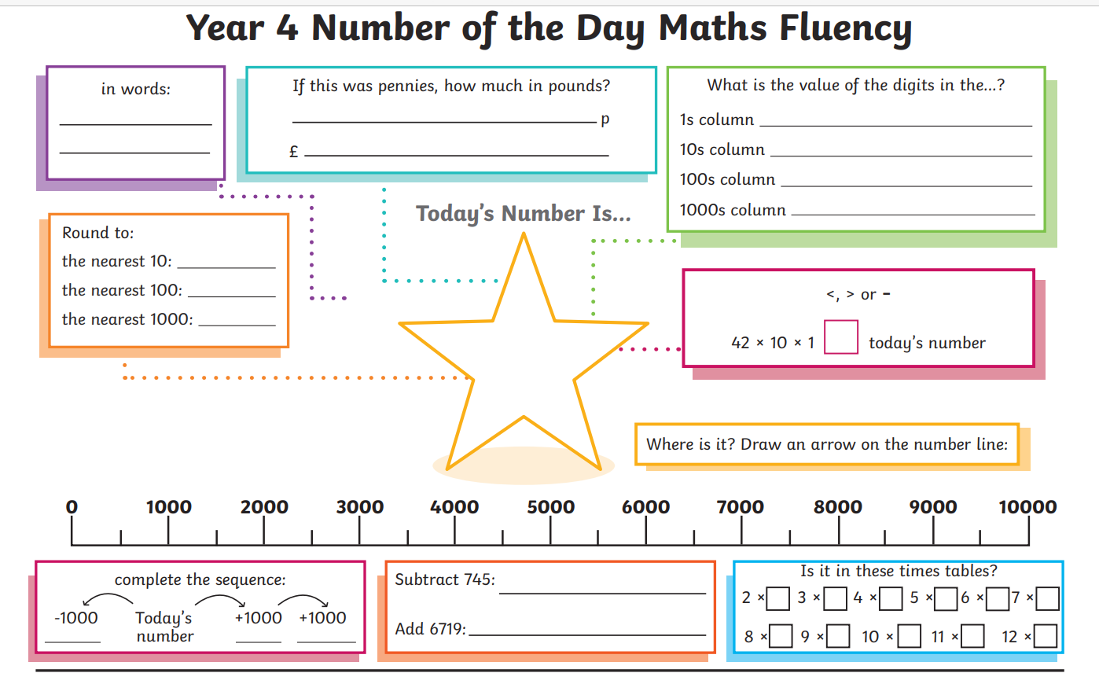
Lesson 3
English
Lesson 4  Art | https://www.tate.org.uk/kids/make/paint-draw/make-soundscape

