Home Learning – Cuddington and Dinton C of E Primary School
Year 1 – Spring Term - Daily Lesson Plans – Week 1
Day 1
Lesson 1  Phonics and Spelling | Today, you are going to learn about the phoneme /ai/ written as ‘ay’.  Task 1: Read the words below.  rain tail nail snail  The phoneme /ai/ can also be written as ‘ay’.  Now, try to read these words.  say pray away  Task 2: Complete the worksheet below.  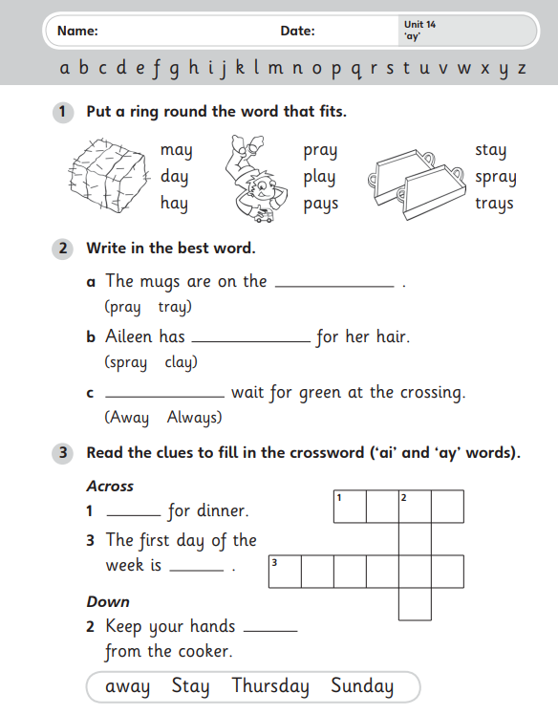
Lesson 2 Maths | LO: Can I recognise and name 3D shape?  Warm up: Answer the questions below.  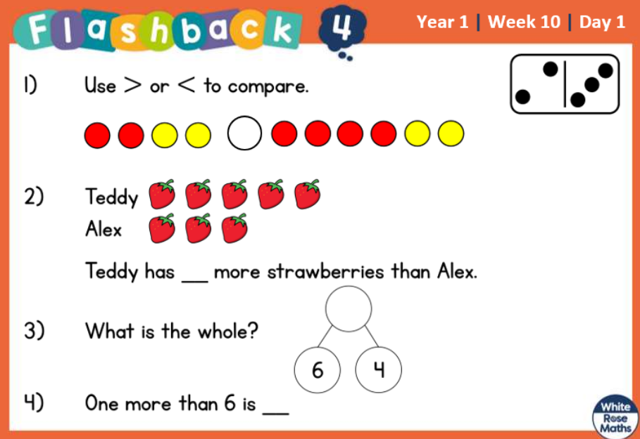  For this lesson, please watch the video below.  Aut1.10.1 - Recognise and name 3-D shapes on Vimeo  Then complete the task below.  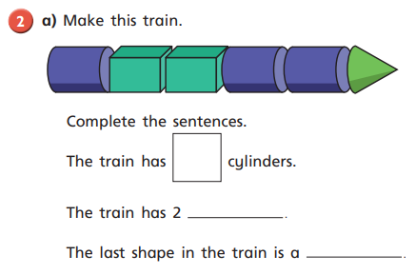  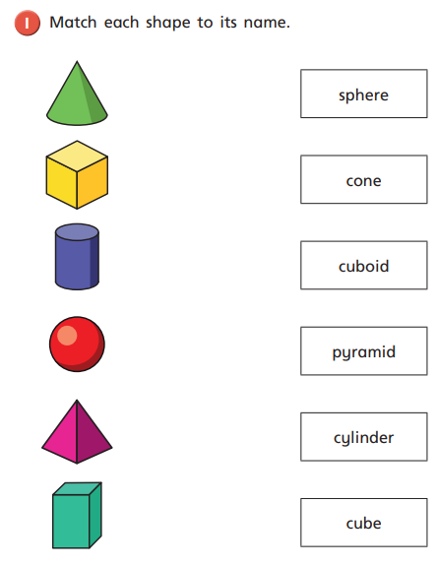  Problem-solving and reasoning task:  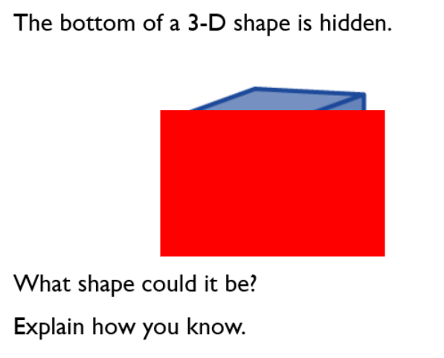  ________________________________________________________________________________  ________________________________________________________________________________  ________________________________________________________________________________
Lesson 3  English  Writing | LO: Can I recognise nouns, adjectives and verbs?  Please read the sentences below and put the correct symbol around the word types. You are only spotting nouns, adjectives and verbs.  My little dog played with his toy.  A man driving a green van delivered a large parcel.  The fluffy squirrel ran up the tall tree.  Can you write your own sentence? You must use at least one adjective to describe a noun and include a verb.  _________________________________________________________________________  _________________________________________________________________________  _________________________________________________________________________  _________________________________________________________________________  _________________________________________________________________________
Lesson 4  PE | 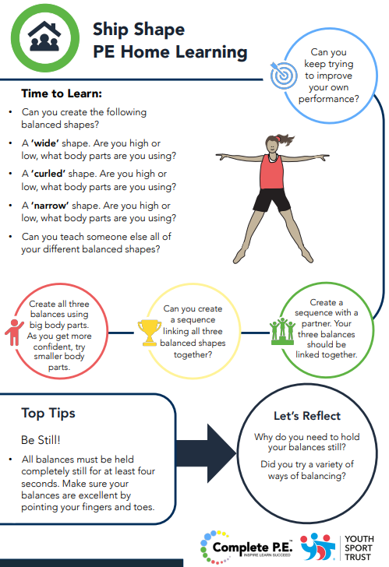

Day 2
Lesson 1  Phonics and spelling | Today, you are going to learn about the phoneme /ai/ written as ‘a-e’.  Task 1: Read the words below.  stray Sunday hay tray  The phoneme /ai/ can also be written as ‘a-e’. We call this a split digraph.  Now, try to read these words.  ape name snake plate grape  Task 2: Complete the worksheet below.  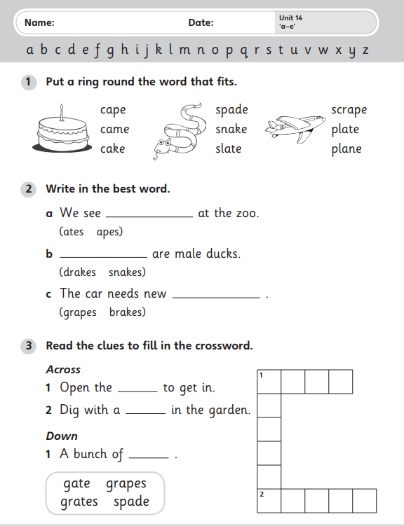
Lesson 2  English  Reading | LO: Can I find words quickly in a text?  Please read this text with an adult.  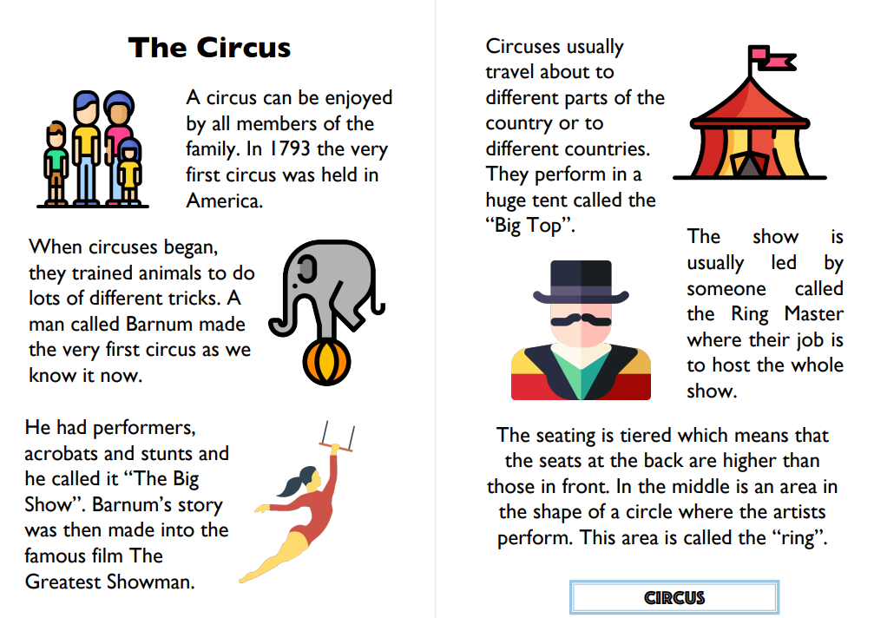  Can you find the words below?  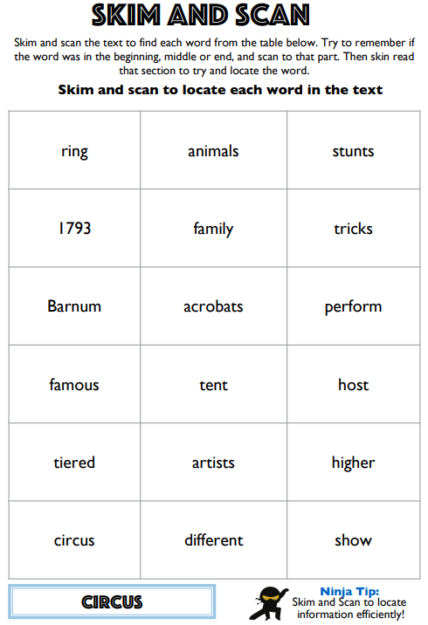
Lesson 3  Maths | LO: Can I sort 3D shapes?  Warm up: Answer the questions below  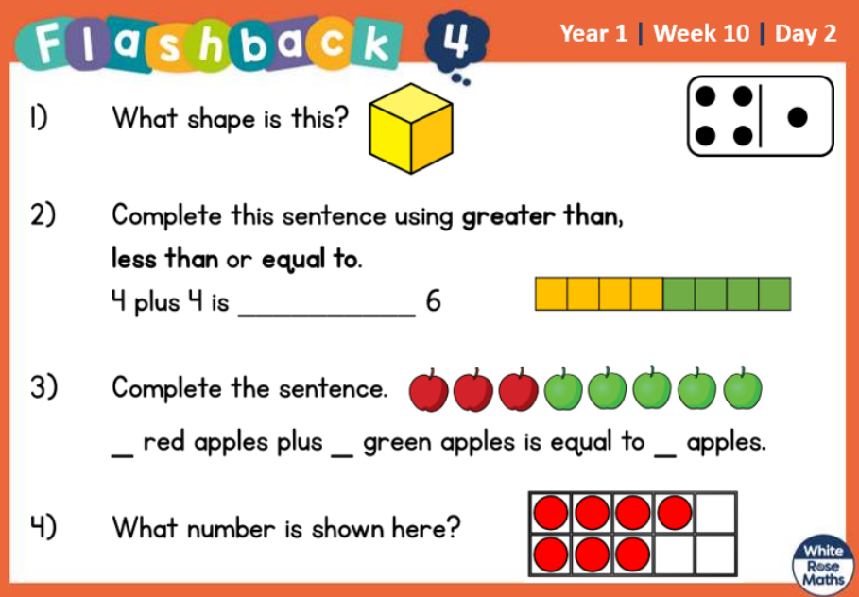  For this lesson, please watch the video below.  Aut1.10.2 - Sort 3-D shapes on Vimeo  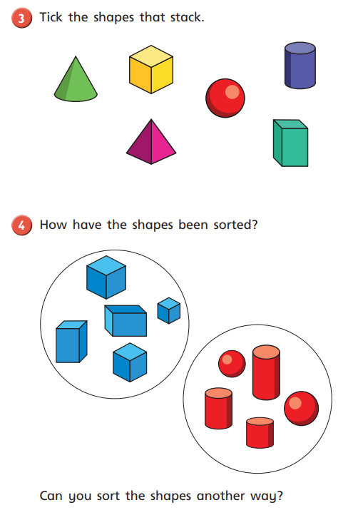  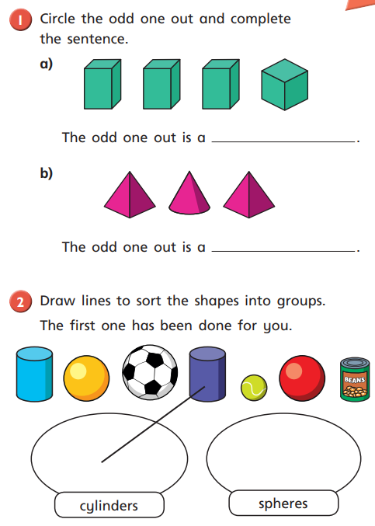  Then complete the task below.  Problem-solving and reasoning task:  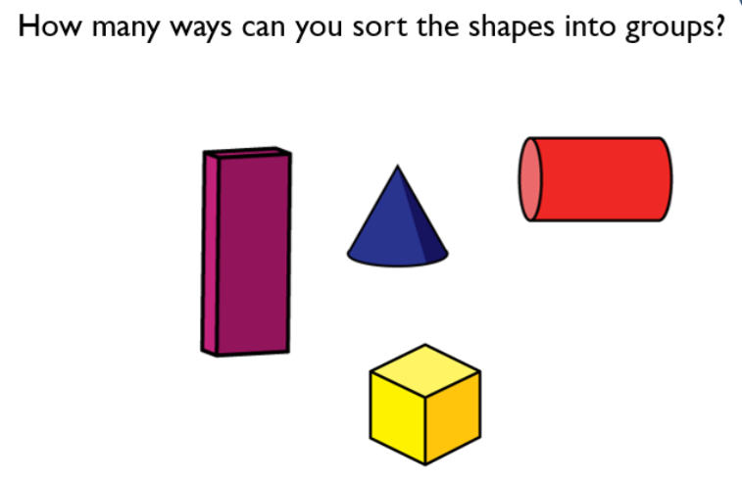
Lesson 4  Outdoor learning | LO: Can I care for the world around me?  This term in outdoor learning we are thinking about the world around us and how we can care for it. We will be thinking about looking after living things. Whilst at school we will look at making bug hotels, at home I would like you to think about making bird feeders.  Please follow the link below to help you create your own bird feeder.  Make a bird feeder - CBeebies - BBC

Day 3
Lesson 1  Phonics and Spelling | Today, you are going to learn about the phoneme /ai/ written as ‘eigh’, ‘ey’ and ‘ei’.  Task 1: Read the words below.  made take spade grapes  The phoneme /ai/ can also be written as ‘eigh’, ‘ey’ and ‘ei’.  Now, try to read these words.  weight grey reins  Task 2: Complete the worksheet below.  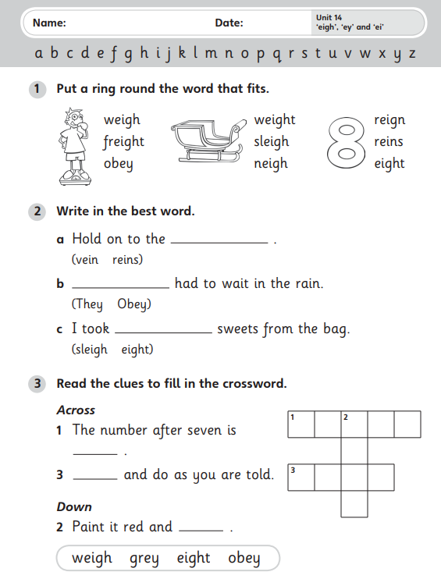
Lesson 2  Maths | LO: Can I recognise and name 2D shapes?  Warm up: Answer the questions below  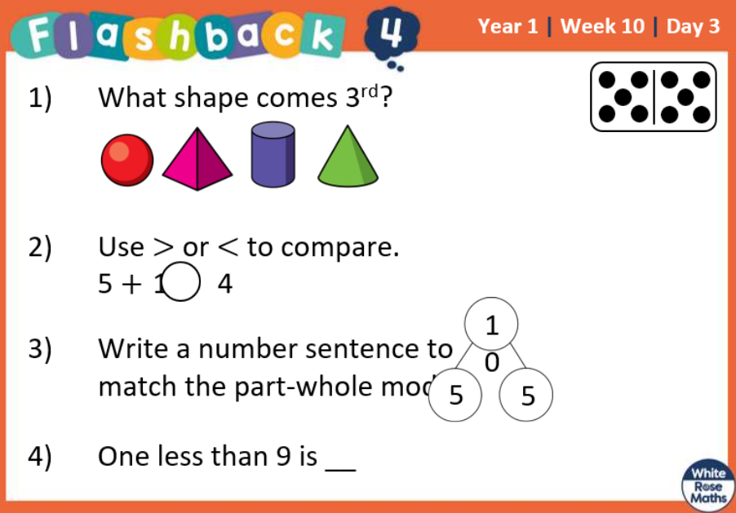  For this lesson, please watch the video below.  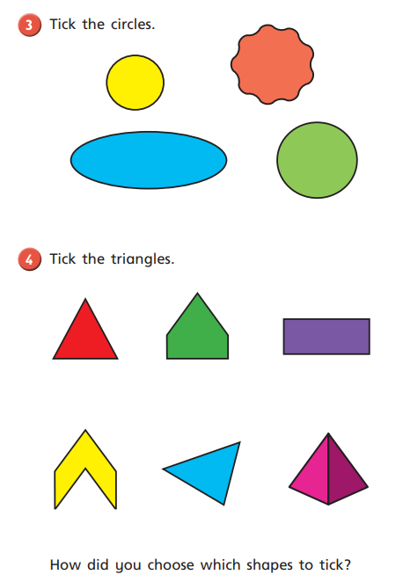  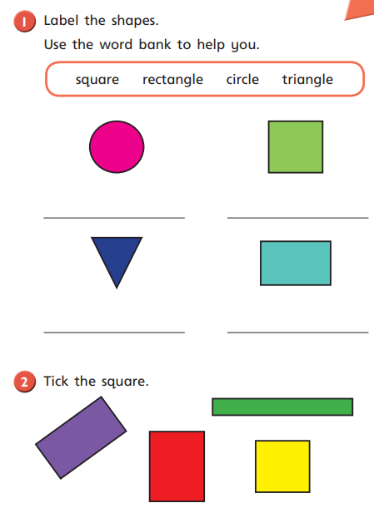  Aut1.10.3 - Recognise and name 2-D shapes on Vimeo  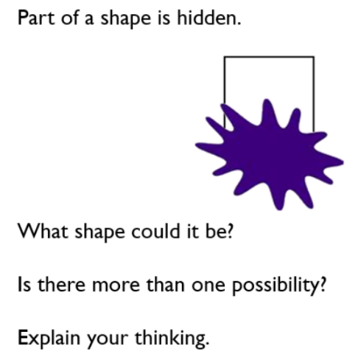  Problem-solving and reasoning task:  ______________________________________________  ______________________________________________  ______________________________________________  ______________________________________________  ______________________________________________
Lesson 3  English  Writing | LO: Can I use ‘and’ correctly within a sentence?  You have learnt about adjectives, nouns and verbs and today you are going to think about a conjunction.  A conjunction is a joining word. Today you are going to think about ‘and’.  Task 1:  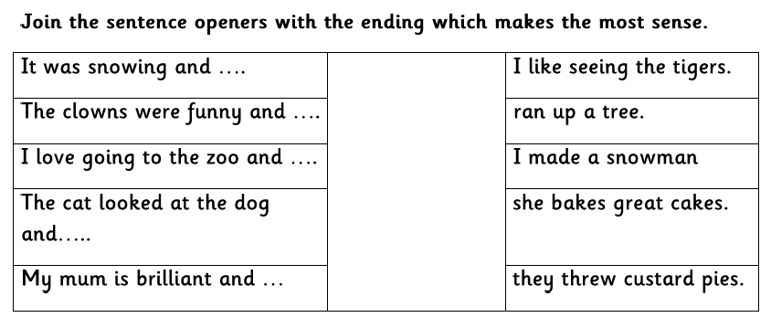  Task 2:  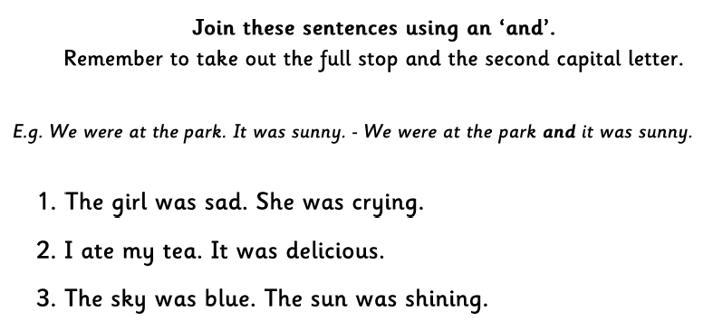  ___________________________________________________________________________  ___________________________________________________________________________  ___________________________________________________________________________  ___________________________________________________________________________  ___________________________________________________________________________  ___________________________________________________________________________  ___________________________________________________________________________
Lesson 4  Computing | LO: Can I practise my typing skills?  Please practise level one from the website below.  Dance Mat Typing - BBC Bitesize

Day 4
Lesson 1  Phonics and Spelling | Today, you are going to recap the graphemes you have focused on in the last three days.  Task 1: say the phoneme (sound) for each grapheme.  ay a-e eigh ey ei  Task 2: Read the words below  play shake eight vein obey  prey weigh delay shape veil  Task 3: Now, choose a word from above and write it in a sentence. Please write at least four sentences.
Lesson 2  English  Reading | LO: Can I read words with the phonemes and graphemes I know?  For English today, spend some time reading your phonics reading book. You may have already read it a couple of times this week but try to focus on your fluency today.  Can you read it quicker today compared to when you last read it?  What makes it easier?  Are there any words which are still a bit tricky? Can you practise saying those words?  There will also be books on your Bug Club platform for you to read too.
Lesson 3  Maths | LO: Can I sort 2D shapes?  Warm up: Answer the questions below  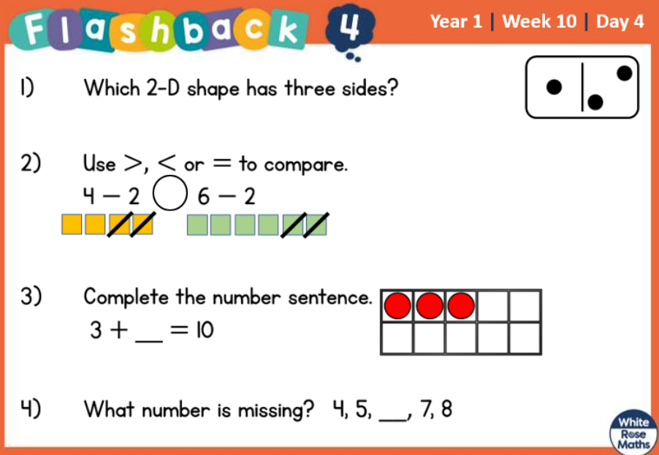  For this lesson, please watch the video below.  Aut1.10.4 - Sort 2–D shapes on Vimeo  Then complete the task below.  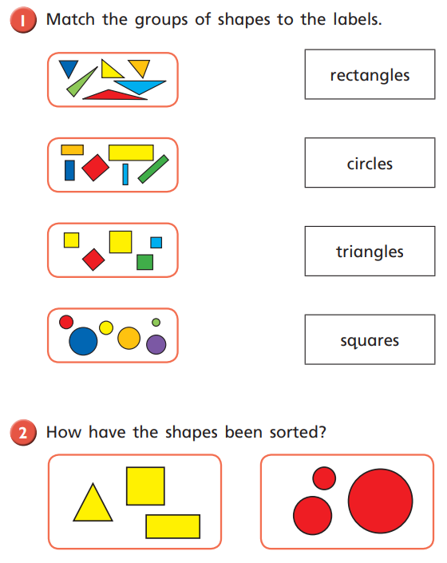  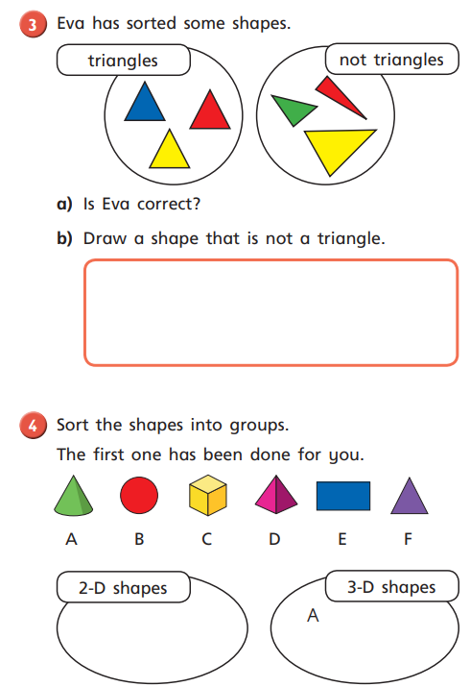  Problem-solving and reasoning question:  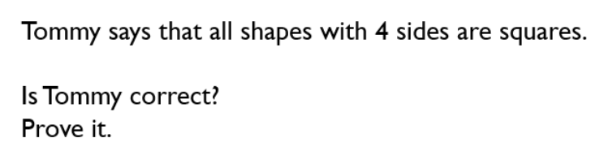
Lesson 4  D&T | LO: Can I make a simple slider?  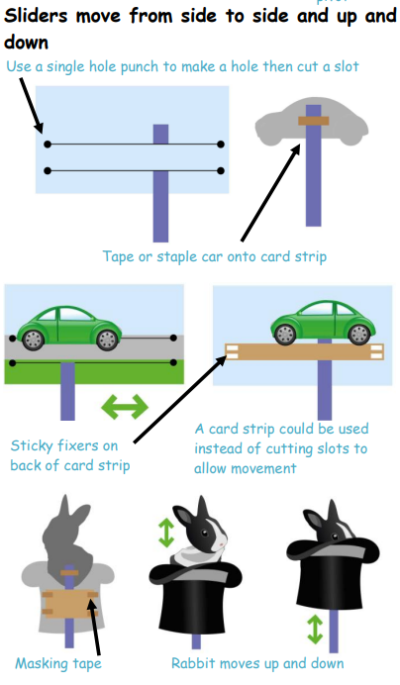  For your Design and Technology task today, I would like you to make a simple slider. You can choose whether you would like your slider to move side-to-side or up and down.  The picture to the left shows some examples.  If you are choosing a side-to-side slider, you may want a different theme. You could have a bus travelling or somebody walking. It is up to you.  You can also choose a different design for your up and down slider if that is what you choose.

Day 5
Lesson 1  Phonics and Spelling | Today is a language lesson.  Task 1: Please read these tricky words.  Mr Mrs Ms  Task 2: Please read the sentences below.  Gail and Ray are twins.  Mr and Mrs Blane made a cake for their party.  They are eight today.  Ms Cane let me play in the garden.  Task 3: Please complete the worksheet below.  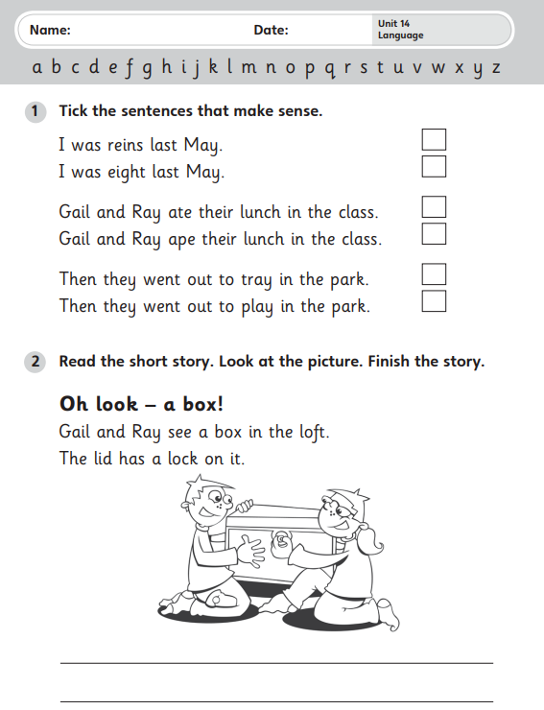
Lesson 2  Maths | LO: Can I recognise and make patterns with shape?  Warm up: Answer the questions below  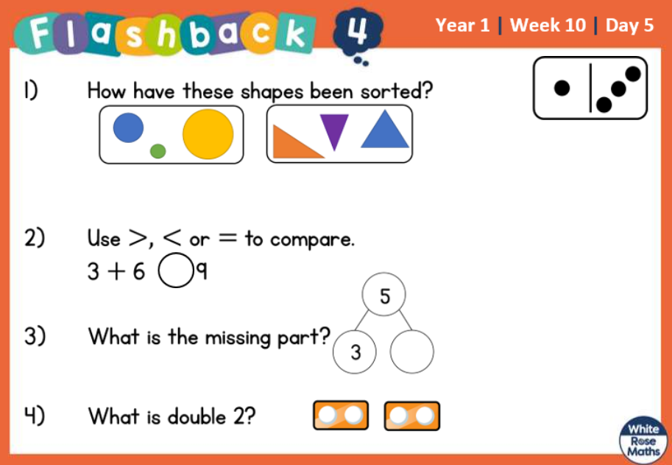  For this lesson, please watch the video below.  Aut1.10.5 - Patterns with 3–D and 2-D shapes on Vimeo  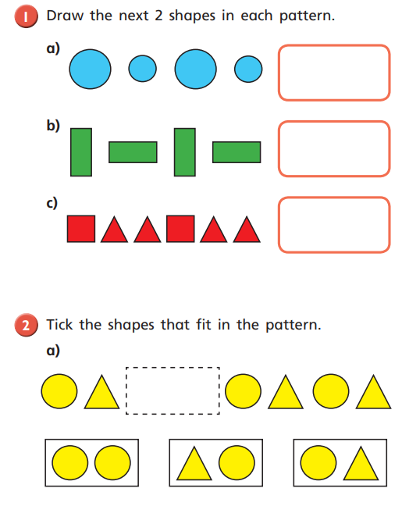  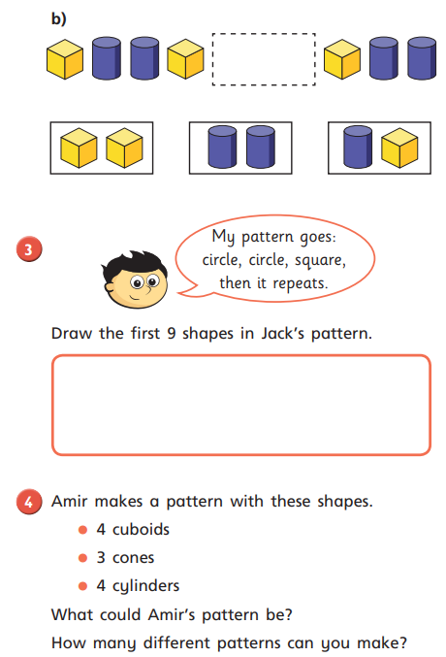  Then complete the task below.  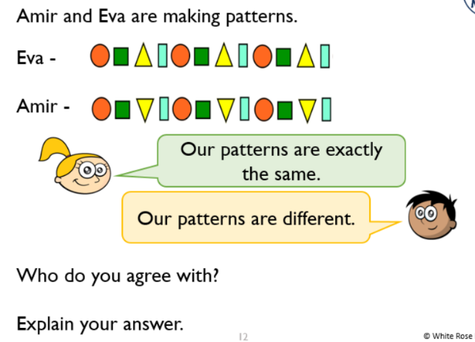  Problem-solving and reasoning question:  _____________________________________  _____________________________________  _____________________________________  _____________________________________  _____________________________________

Lesson 3  English  Writing | LO: Can I use ‘and’ correctly in sentences?  Earlier on in the week you started to use the word ‘and’ within sentences.  Today, have a go at the activity below.  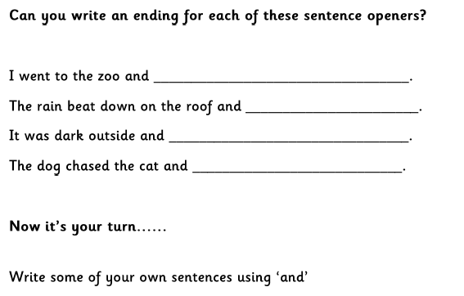
Lesson 4  D&T | LO: Can I make a simple slider?  Please carry on with your Design and Technology task from yesterday.

