Home Learning – Cuddington and Dinton C of E Primary School
Year 4 – Daily Lesson Plans
Week 2
Day 1
Lesson  1 | Spellings and Reading  - Practise learning a selection of spellings from this half-term’s overview. There is a copy on our class web page. See if you can spot patterns. Make word pyramids, write vowels in red and consonants in blue, write in bubble writing.  - Get comfortable and spend 20 minutes reading your library book or a book of your choice from home.
Lesson  2  Maths | Starter:  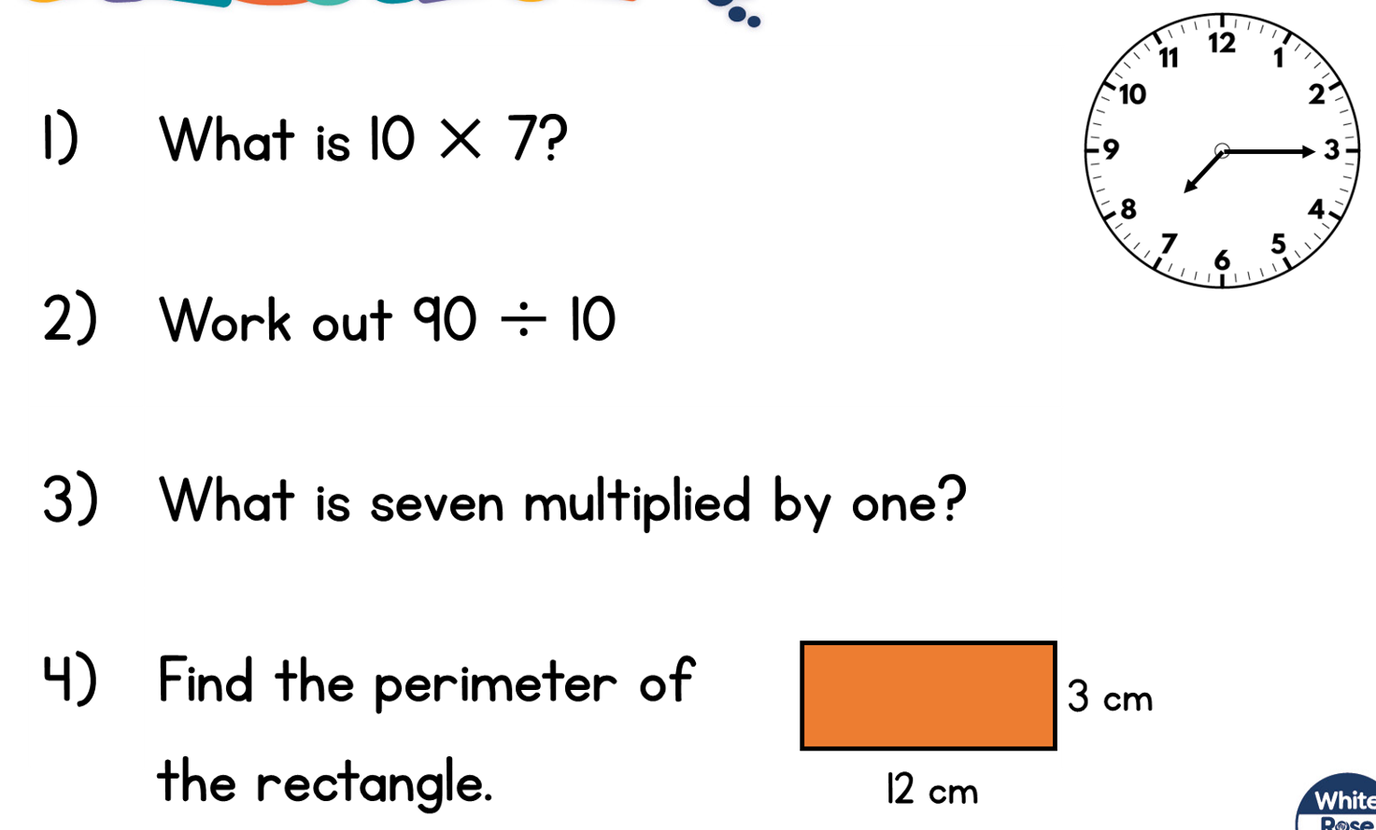  Main Task:  Remember to start in the ones column and to think about the place value of the numbers as you multiply and exchange ones for one ten and tens for one hundred.
Lesson 3  English | SPAG
Lesson 4
PE
Day 2
Lesson 1  Word Games | - Making compound words  Watch this BBC Bitesize video to remind yourself about compound words then take the quiz.  What are compound words? - BBC Bitesize  See how many compound words you can make starting with:  - Snow  - Rain  - Sun  Use a dictionary to check that the words you have created are actually compound words as opposed to two separate words.  - Spend time reading your chosen novel. As you read, write down three words you are unsure of or really like and when you have finished, use a dictionary to look them up.
Lesson 2  English | This English task can last for up to four days.  Follow the link to this reading of the story of The Trojan Horse.  6. Odysseus and the Trojan Horse - BBC Teach  There is also a transcript of the story that you can downloaded and read afterwards.  Make a list of the main characters – it can get a bit confusing trying to remember who is who. You can copy the names from the transcript.
Lesson 3  Maths | Starter:  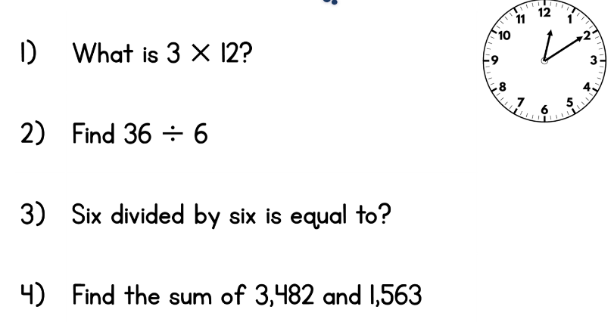  Main Task:
Lesson 4
Out
door learning
Day 3
Lesson 1  Spelling  Reading | - Look back at Monday’s spelling words. Make sure you know the meaning of each word. Put each word into a sentence. Check your spelling carefully.  - Spend time reading your novel. Can you remember the words you write down yesterday and their meanings. Ask an adult to check.
Lesson 2  Maths | Starter:  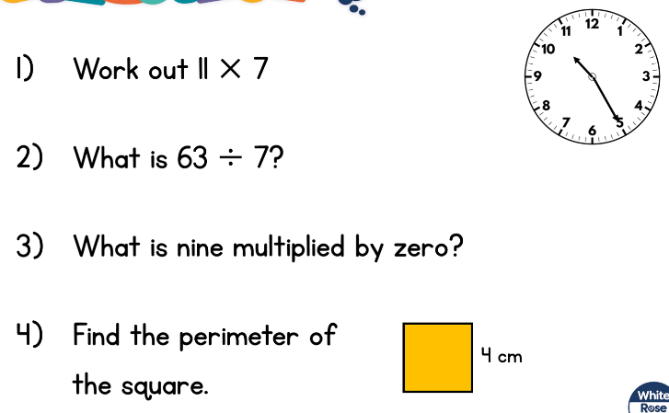  Main Task:  Use the short column method to calculate:  1. 124 x 6 =  2. 4 x 137 =  3. 5 x 205 =  4. 292 x 7 =
Lesson 3  English | Write a diary extract as if you are one of the soldiers hiding inside the giant wooden horse. How would you be feeling? What would you be able to see, hear and smell? How would you feel when the horse was pushed in through the gates into the city of Troy? This should take you two lessons in total so don’t rush and plan what you are going to write first.  OR  Re-write the story in your own words from the point when the plan is hatched, remembering to use exciting vocabulary such as powerful verbs, adverbs and adjectives to inspire and entertain the reader. Try to use different ways to start your sentences. On Friday, you will need to edit and improve your work as you would in school. Check for non-negotiables and sense and see if you can up-level any of your vocabulary.
Lesson 4  Geography | World Time Zones  Think about someone you know who lives in another part of the world or a favourite place you have been or would like to go. Look at the clock and work out what time it is in England then find out what time it is in that foreign place. What is the difference?  Work out what the people there would be doing when you are 1) eating breakfast 2) having breaktime at school 3) going to your swimming/gym/football/karate/dancing lesson/ after school activity 4) going to bed.  If you have an atlas at home, see if it has a page about time zones. How many time zones are there in the world? How many time zones does USA have? What else can you discover about time zones? If you don’t have an atlas, you could research time zones on the computer. The link below will take you to a useful video.  https://www.youtube.com/watch?v=-j-SWKtWEcU  Choose your own way to present your learning. You could write about the creation of time zones in the 19th century, find out whose idea it was, describe why time zones are necessary, draw clocks to show the differences in time across the world.

Day 4
Lesson 1  Reading | Reading Comprehension – The Skeleton  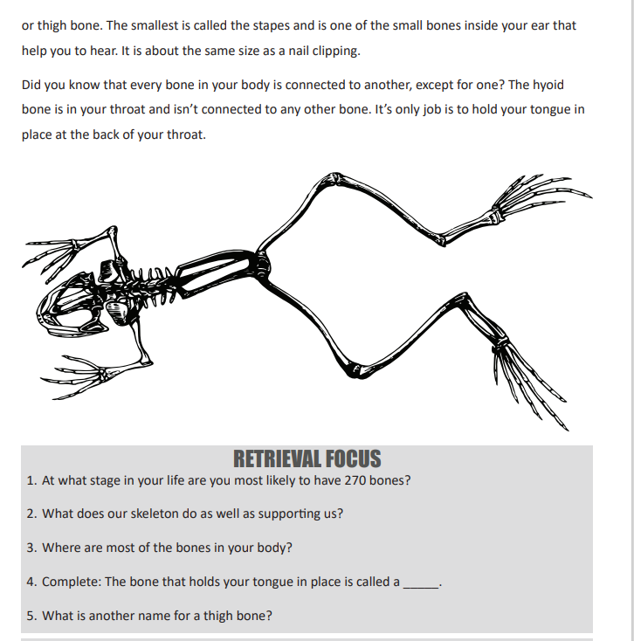  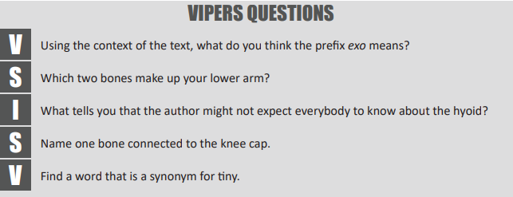  You will find the answers at the end of this document – don’t peek!
Lesson 2  English | See Day 2 and 3
Lesson 3  Maths | Starter:  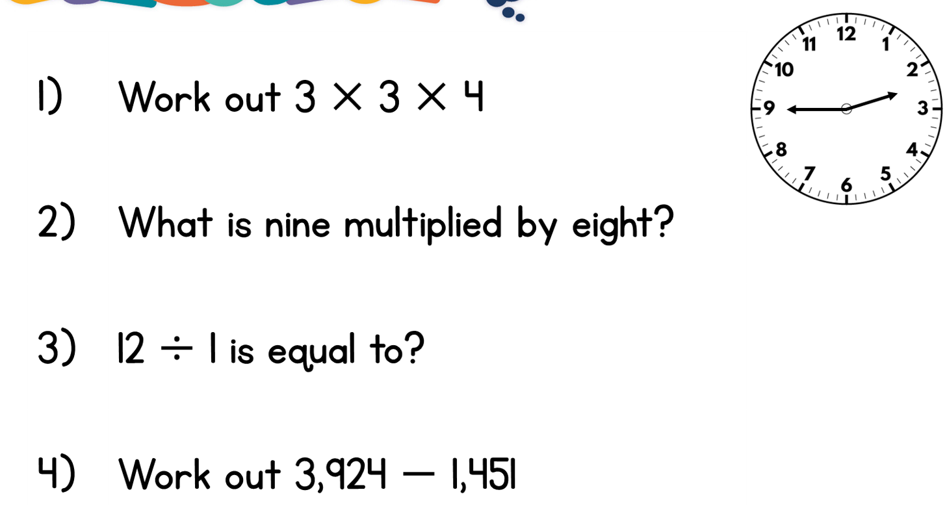  Main Task:  Follow this link to the instructions for the Nice or Nasty game and a copy of the scoring sheet. You will need a 6 or 9 sided dice or you could use the digital spinner to create your numbers. You will need to find a partner to play with. Remember that you need to agree whether you are trying to make the highest or lowest number or maybe the number nearest to 5000, for example.  Nice or Nasty (maths.org)  If you don’t have a partner to play, use this lesson to log on to Times Table Rockstars and challenge yourself to answer questions on all the times tables. Remember the strategies we have learned to help with the trickier ones!
Lesson 4  Science | Memory Masters – investigate how your memory works and learn a cunning trick to help you remember more. Don’t be put off by the age of the boy in the video, this idea and way of remembering can work for all of us.  First watch this video.  Memory masters | The Royal Institution: Science Lives Here (rigb.org)  Then use this link to read more about the game, how memory works and how the strategies you will learn can help you.  memory_masters_infosheet_0.pdf (rigb.org)
Day 5
Lesson 1  Spelling  Reading | - Ask a member of your family to test you on this week’s spelling words.  - Spend time reading your chosen novel.
Lesson 2  English | See Day 2 and 3 – today you should be editing and improving. You could use this checklist to help you.  - Non-negotiables  - Read your writing to someone else or whisper-read it to yourself. Remember to read the exact words you have written to check it makes sense. You might need to re-write a sentence or two.  - Up-level your vocabulary – no over-used words such as ‘nice’, ‘lovely’, ‘very’. Think about the word continuums we made before Christmas (the long lines of words where we placed each word according to its status – least powerful at the left-hand end and most powerful at the right-hand end.) Make sure you have used the best word for the job.  - Have you written in paragraphs, starting a new paragraph for each new section of your story?  - Have you used interesting sentence starters such as: conjunctions (Beside the…/ Deep inside the…); fronted adverbials that tell you when, where or how the action is happening; an -ing or -ed verb; an expanded noun phrase (An enormous wooden horse…).
Lesson 3  French | 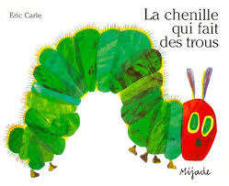  French – La chenille qui fait des trous  This is the French version of the story of  The Very Hungry Caterpillar by Eric Carle.  Watch the video and listen out for any French words you recognise. You don’t need to understand all the words in order to understand the story. You can use your prior knowledge of the story to help you.  https://www.youtube.com/watch?v=gQvPQZs_kgE  Now make a poster of all the items of food that la chenille eats. Label each of your pictures with the appropriate French vocabulary. You will need to include number words – for example - une pomme (one apple), quatre fraises (four strawberries). When you get to the food that she eats on Saturday (samedi), you will need to include the words un or une before each noun – example – un saucisson, une brioche.  la chenille - caterpillar un cornichon – pickled gherkin  le soleil - sun un bout de gruyère – a piece of gruyère  Elle a faim – she was hungry un saucission - salami  un trou – a hole une sucette – a lollypop  une pomme – an apple un quartier de tarte aux cerises - cherry tart  deux poires – two pears une saucisse – a sausage  trois prunes – three plums une brioche - a brioche bun  quatre fraises – four strawberries une tranche de pastèque – a slice of watermelon  cinq oranges – five oranges une feuille – a leaf  un morceau de gâteau – a slice of cake un cocon - cocoon  un cornet de glace – an ice-cream cone un papillon - butterfly
Lesson 4
PE

Answers for Reading Comprehension – The Skeleton
