Home learning week 2 Cuddington and Dinton School
Year 5 and 6 daily lesson plans 2022
Day 1
Lesson 1 Guided Reading | 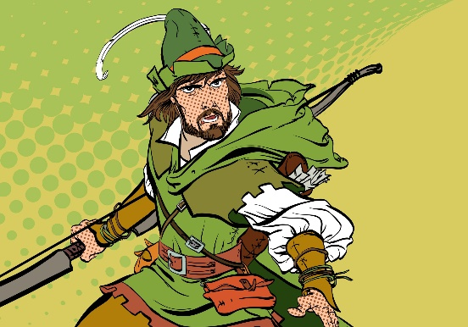  Robin had only taken a few steps onto the bridge when there was a flurry of movement at the other end. Either side of the bridge, men with bows erupted from the foliage; their arrows aimed at Robin and Will. One of the men started to cross the bridge towards them. The man was one of the tallest that they had ever seen. He was a whole head taller than Robin. He carried a long staff as thick as a man’s wrist and he was grinning from ear to ear - flashing his teeth at the two weary travellers. “Look sharp!” Robin hissed at Will.  “Bridge tax!” the tall man bellowed, “stand where you are!” The two of them continued to edge further forwards until Robin was standing face to face with the brigand. “You cannot come across this bridge without paying the fee!”  With unnatural speed, Robin had pulled an arrow from his quiver, nocked it and was now stood with his drawn bow pointing in the giant’s bearded face. “Now, now…” said the Giant taking a step backwards, “there is no need for that.” Robin took half a step towards the bandit who suddenly swung his staff violently, knocking Robin’s bow into the river; sending his arrow flying off to embed itself into the trunk of a nearby by tree.  The outlaw laughed, “if you want to fight rather than pay, then it needs to be a fair fight.” he said as he handed Robin another staff. “If you can knock me, Little John, from the bridge then I will waive the fee.”  Robin let out a deep sigh as he hefted the staff. ‘Little John?’ he thought to himself, ‘the man is as big as a bull and twice as fierce!’  R How far onto the bridge was Robin when John appeared?  V Which words show that the men appeared quickly?  E Explain how you know that this story is set in the past.  I What is Robin thinking/feeling when he ‘let out a ‘deep sigh?’  S How does Little John earn money?
Lesson 2 Maths | Shape Puzzles – Have a watch of the video. You do not need to send anything in as mentioned on the video.  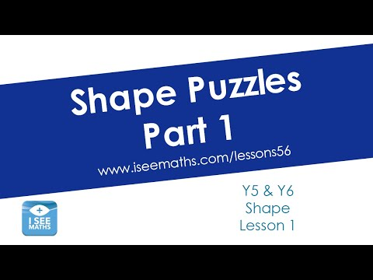  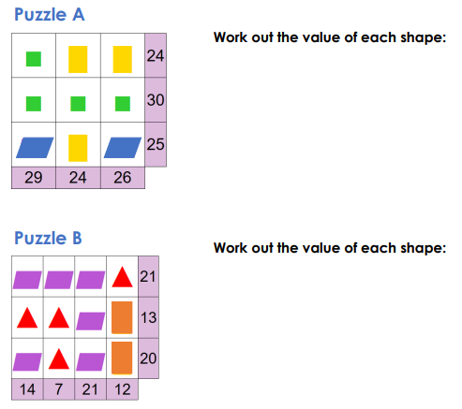  Answers:  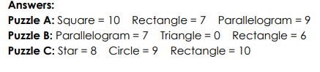
Lesson 3 English | Write a piece of dialogue between the two characters below:  Remember how to write speech:  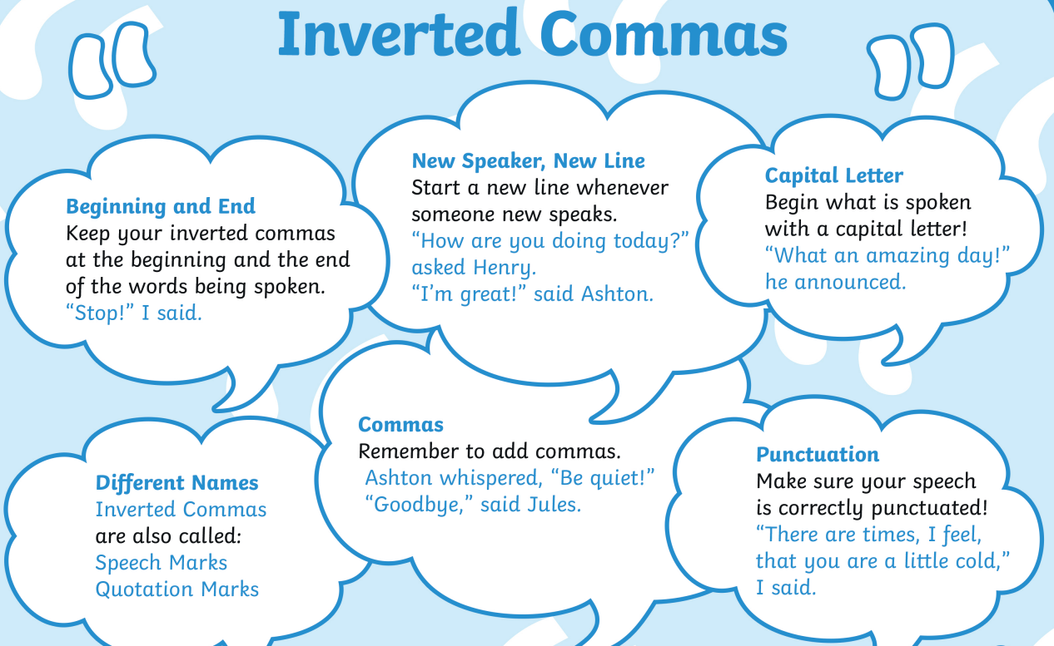  What would they say to each other?  Would they like each other?  What might they want from each other?  How might they speak?
Lesson 4 PE | 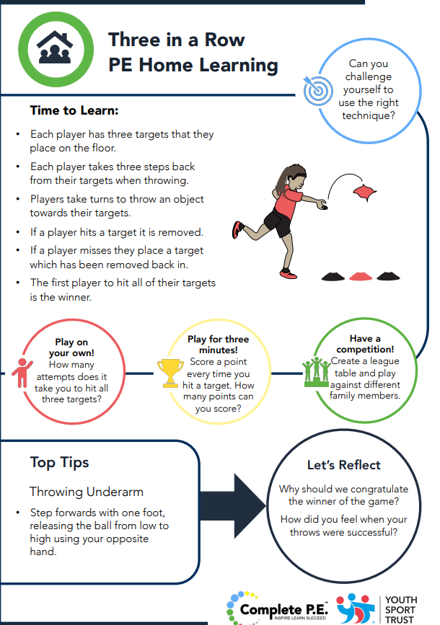

Day 2
Lesson 1 Guided Reading | 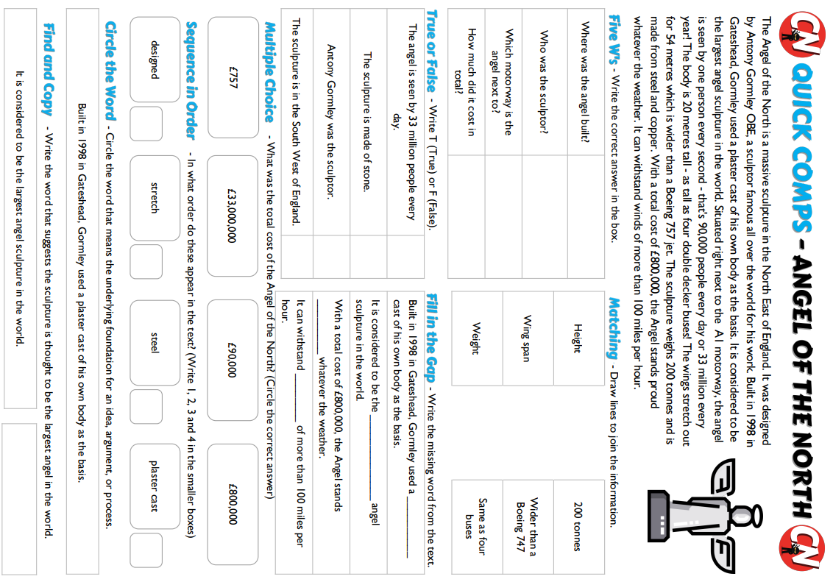
Lesson 2 Maths | Shape Puzzles Part ii:  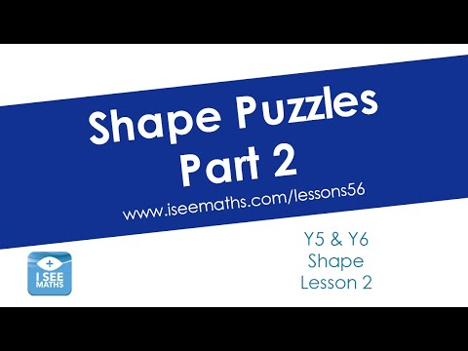  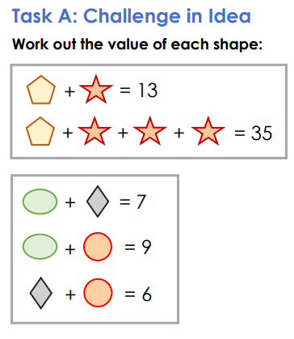  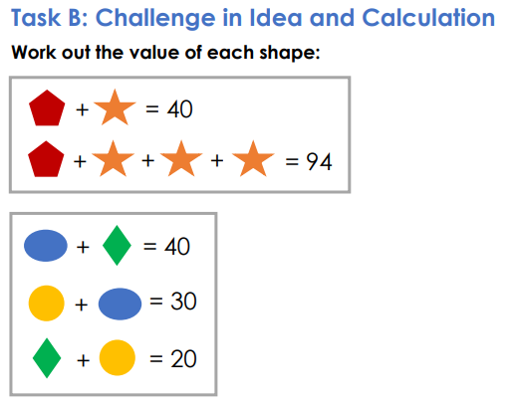  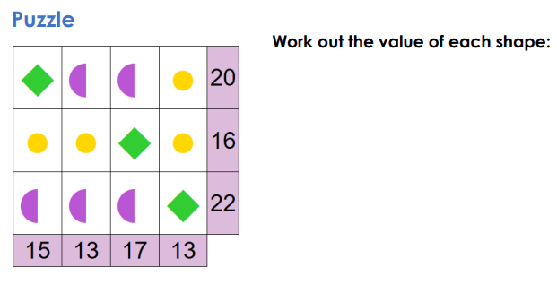  Answers:  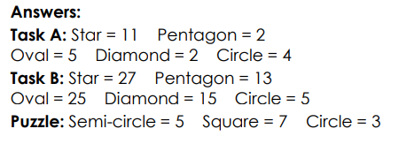
Lesson 3 English | 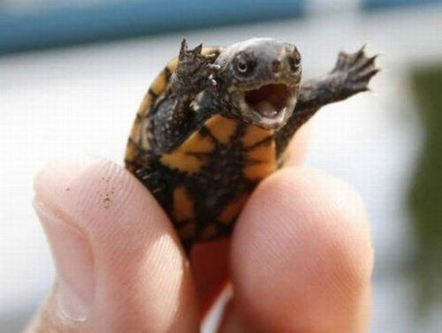  This turtle is making a speech to all the humans on Earth.  What is it persuading humans to do?  Why?  Think about persuasive techniques:  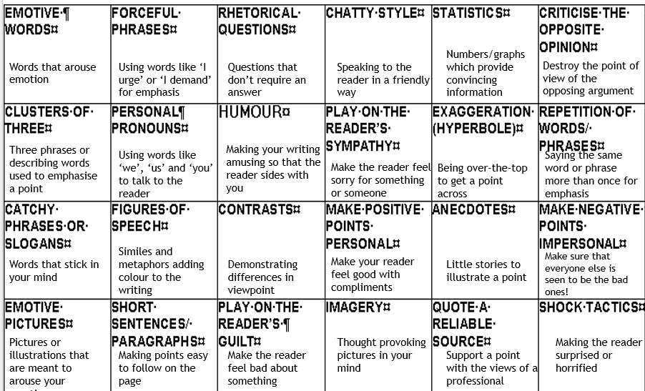
Lesson 4 RE | The art you make should be all about your own ideas on a big religious question. It can be 2D art, painting, drawing, pastel colours. It can be 3D, fabric or sculpture, video art, music or poetry.  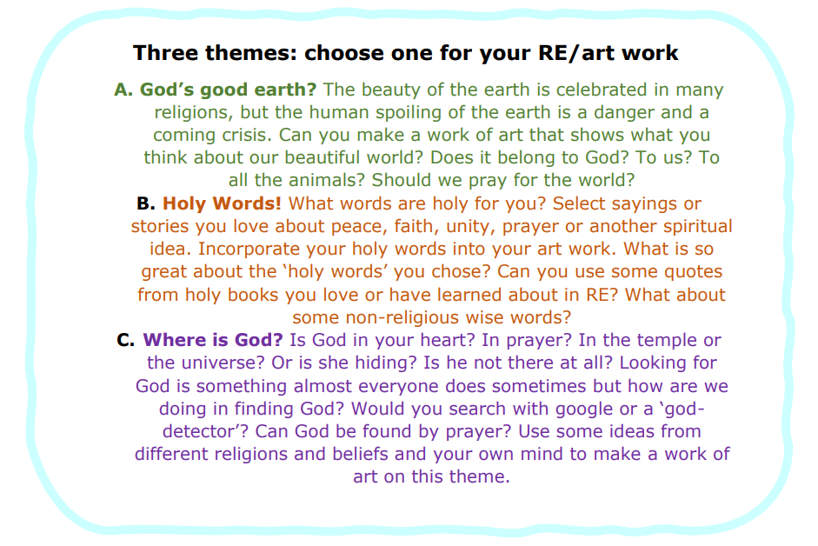

Day 3
Lesson 1 Guided Reading | 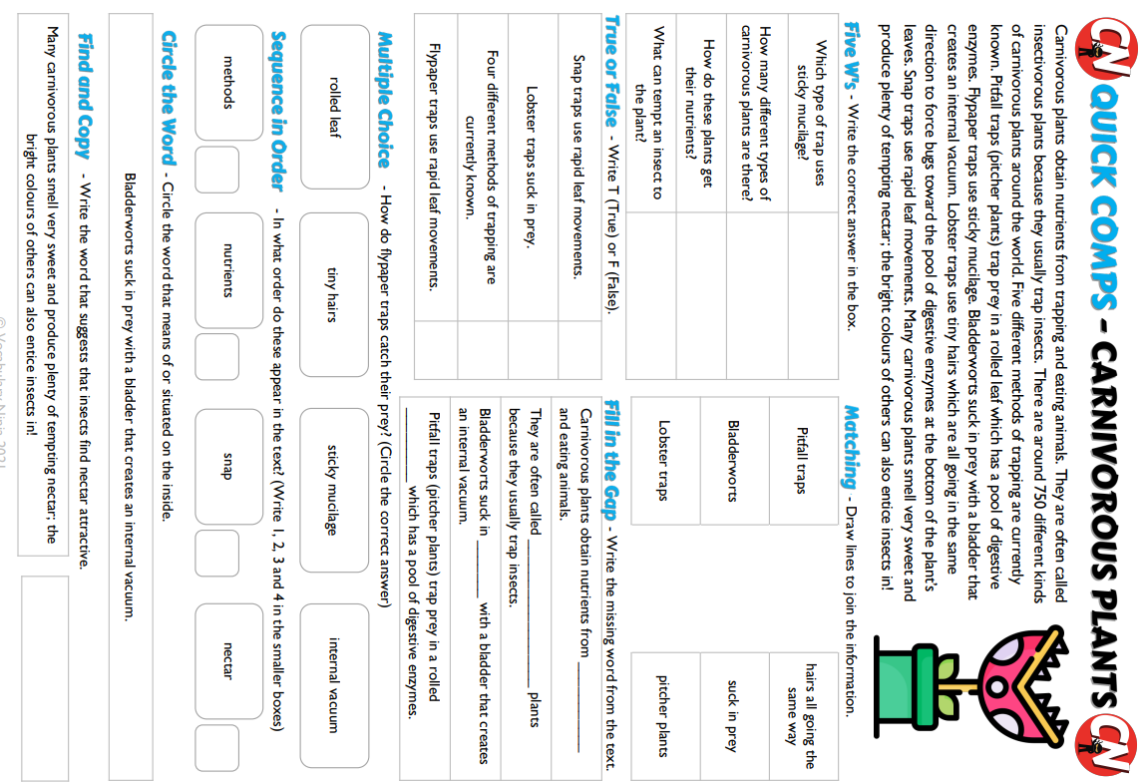
Lesson 2 Maths | Shapes and Stories: Watch the video to help with the challenges – don’t forget you do not need to send anything in.  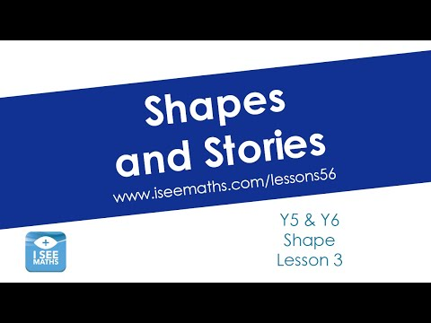  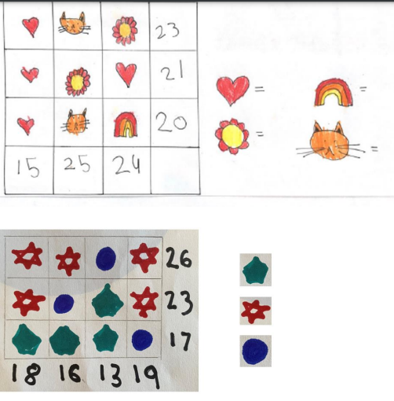  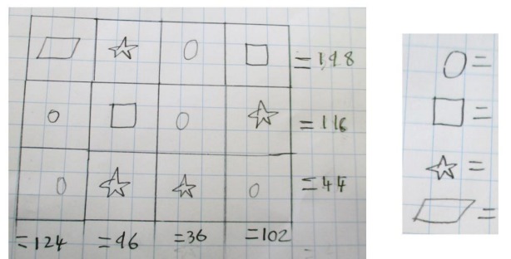  Answers are covered in the video.
Lesson 3 English | DREAMS  A shoe dreams of being worn by a princess.  A snowman dreams that the sun will never shine.  A keyboard dreams of never printing a wrong letter.  A teacher dreams of a quiet classroom.  Choose one of the following (or choose your own) to create your own poem about what they dream about.  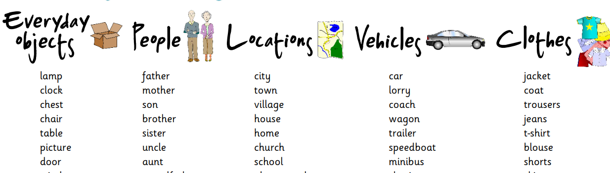
Lesson 4 Computing | Online Choices Compass:  Print off the compass points (statements) below, or write them out on paper.  Read each scenario and decide which point best describes how you feel about the scenario. Write down any thoughts and methods you might use for managing and protecting your online identity. Remember, if anything online upsets or worries you, speak to a trusted adult.  Scenarios:  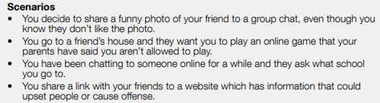  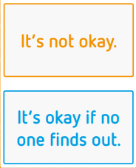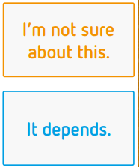

Day 4
Lesson 1 Guided Reading | 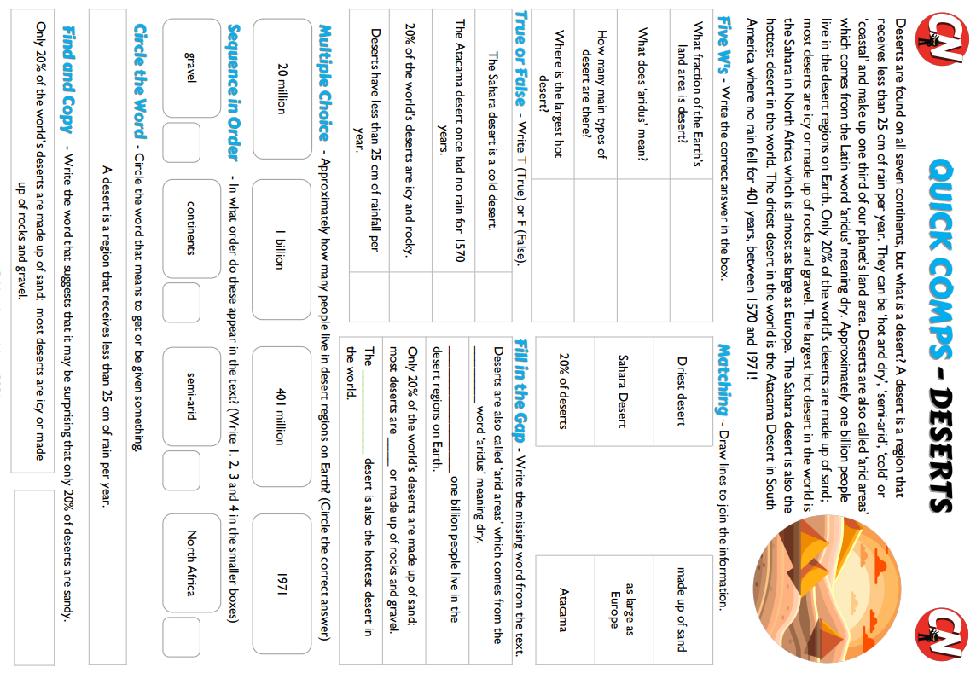
Lesson 2 Maths | Connecting Puzzles:  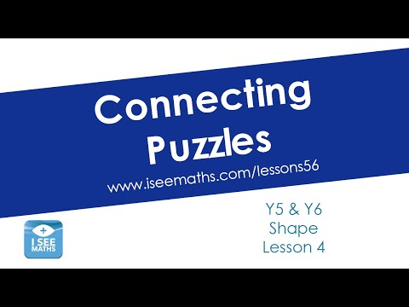  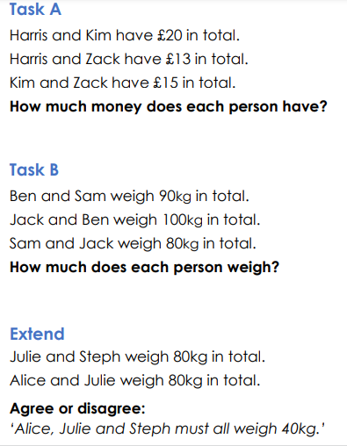  Answers:  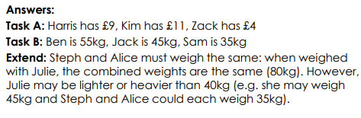
Lesson 3 English | 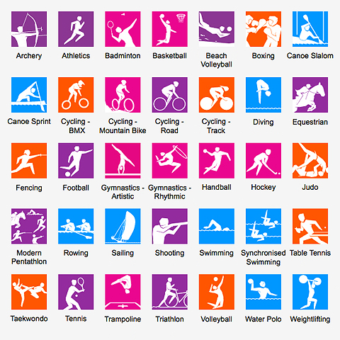  Invent a new Olympic Sport that would be fun to watch and play.  What equipment would you need?  How many people would play?  How would you win?  Where would you play it?  What would the rules be?
Lesson 4 Science | Living or Dead?  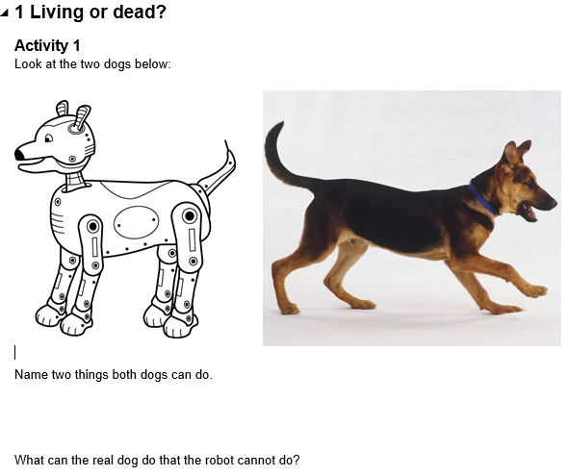  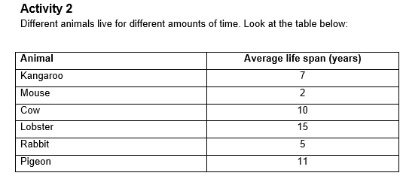  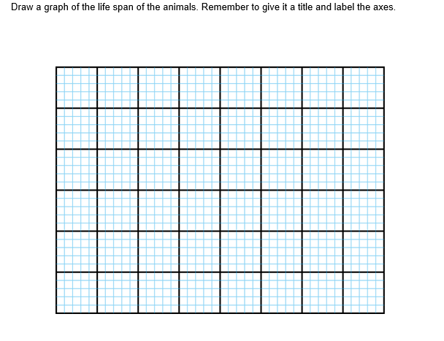  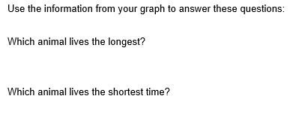  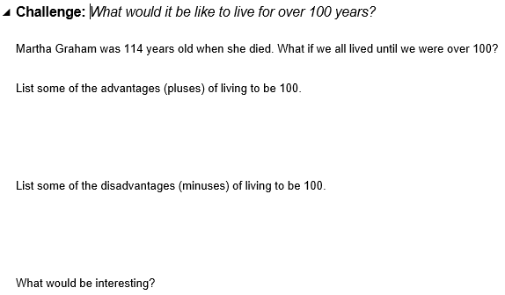

Day 5
Lesson 1 Spelling | 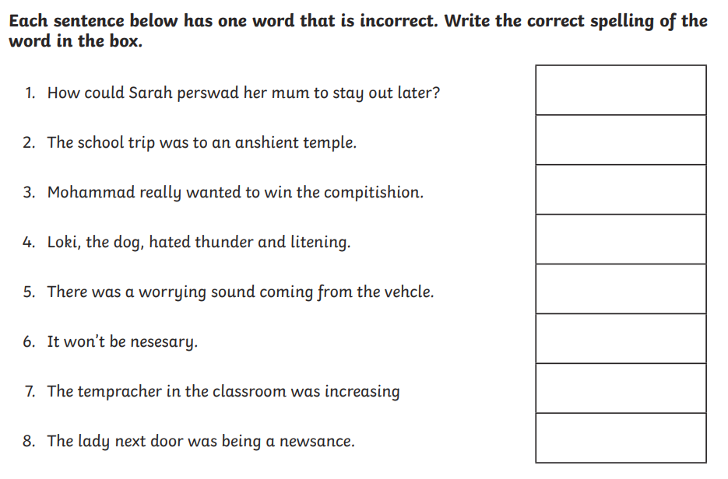
Lesson 2 Maths | More Shape Puzzles:  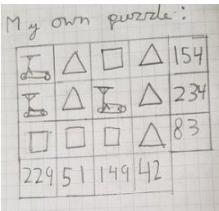  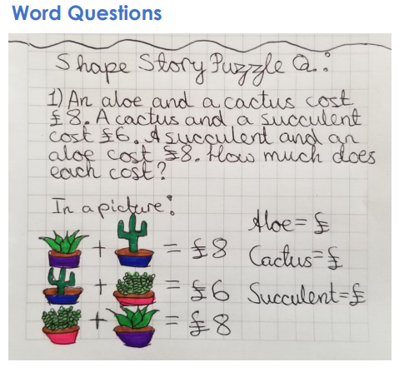  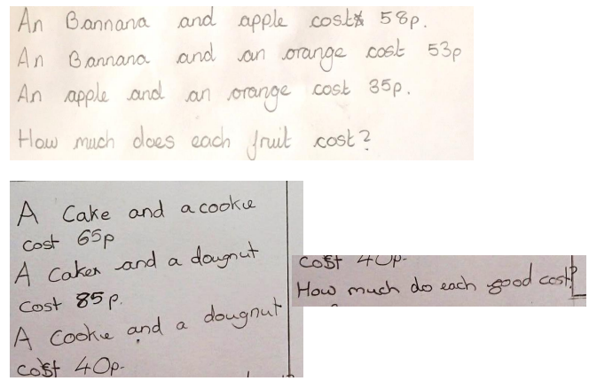  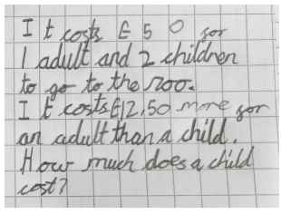  Answers:  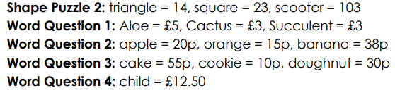  1
Lesson 3 English | Poetry:  IF I CHANGED PLACES.....  If I changed places with my teacher,  I'd sit in the staffroom and she'd have to run around outside.  If I changed places with my cat,  I'd sit by the radiator and she'd be puzzling over maths.  Write a poem thinking about who you would change places with. How many stanzas could you write?
Lesson 4 PE | 