Home learning week 1 Cuddington and Dinton School
Year 5 and 6 daily lesson plans 2022
Day 1
Lesson 1 Guided Reading | Choose a story to read this week or use the book you are reading at home:  Reader Response 1  - Where is your novel set? Think about the time and place.  - Name and describe the main character in the novel. Describe him/her physically and describe his/her personality (and history if known). Then give your impression of him/her.  - Name and describe a secondary character in the novel. Describe him/her physically and describe his/her personality (and history if known).  - Explain the relationship between the two characters.  - Describe one important event in the novel and explain why it is significant to the story (to the plot, the characters or ideas of the book.)  - What are your thought and feelings about the novel so far?
Lesson 2 Maths | This week’s Maths Challenges have come from I See Maths- The videos are included to help with the challenges. You don’t need to send in pictures etc as mentioned on the video. Enjpoy!  Five Consecutive numbers:  Have a watch of this video to help with the challenge.  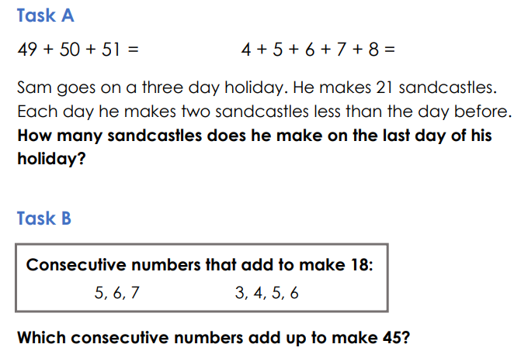  Answers:  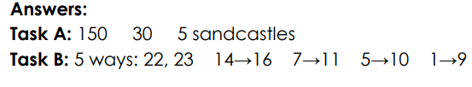
Lesson 3 English | Modal verbs are auxiliary verbs (they need a verbs to make sense). They indicate necessity or possibility.  Must, shall, will, should, would, can, could, may, might are all modal verbs.  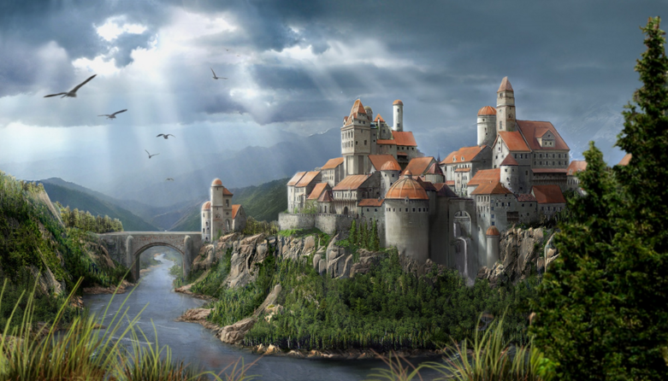  Identify the modal verbs in the passage below and then write a short setting description based on the picture above. You need to include modal verbs in your setting description.  Like beams of hope and joy, the sun’s ray break through the stubborn clouds and shine down upon the ancient castle. Birds, who will circle for hours in search of food, make proud noises in the air and shout to their fellow air-borne companions; the echo of their voices can be heard from miles away. Mountains and trees stand tall around the castle and protect it from any harmful weather that may come its way. Unchanged for hundreds of years, the walls of the castle must be strong and sturdy to keep out enemies and attackers. The scene might look peaceful, however precious jewels are hidden inside this fortress and they may be under threat at any moment.
Lesson 4 PE | 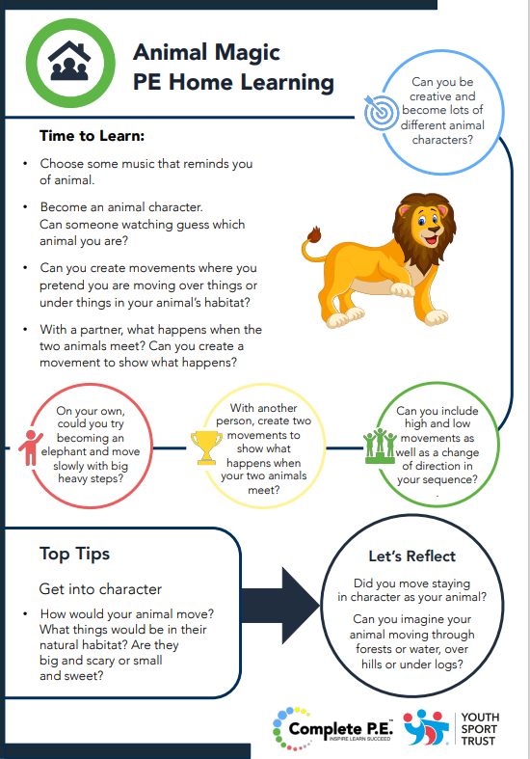

Day 2
Lesson 1 Guided Reading | Reader Response 2  a) If the time and place changes in the novel, explain how and give examples. Why does this change happen? How does it help the novel develop?  b) Who is the narrator in the story? Is he/she inside or outside the story? What is his or her relationship to the story?  c) What is the general theme or mood of the book? Give specific examples of how the author creates that idea or mood.  d) Give an example of conflict or conflicts between: i) two people ii) a person and his/her conscience (internal conflict) iii) a person and society/animal/nature/supernatural being.  e) What is your reaction to a relationship, event, behaviour or message/theme of the book. Be clear about what you are reacting to and exactly what makes you respond as you do.  f) Choose a sentence or phrase that appeals to you. Explain why you chose it, it’s relation/value to the book and its value to you.
Lesson 2 Maths | Numbers Challenge: Remember, you do not need to send in any pictures etc as mentioned on the video.  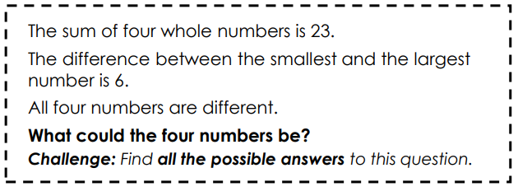  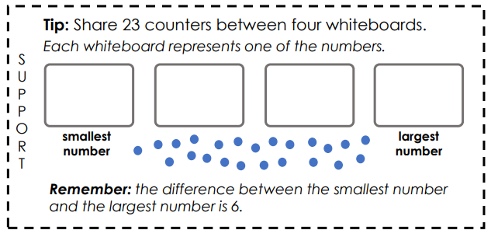  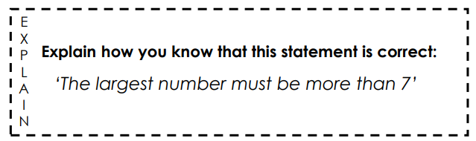  Answers:  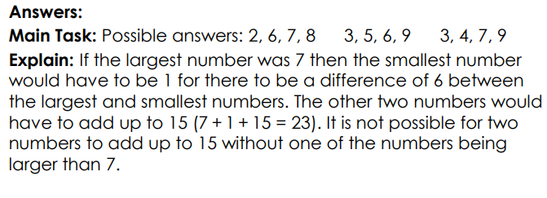
Lesson 3 English | Relative pronouns  A relative pronoun is used to connect a clause or phrase to a noun or pronoun. You see them used every day with the most common relative pronouns being: who, whom, which, whoever, where, when, and that.  Identify the relative pronouns in the passage below:  Stuart is a Minion of average height. His goggles, that cover his lone eye, are made of super strength metal and glass and protect his all-important vision. This Minion wears blue dungarees and stylish black gloves which match his comfortable footwear. When he wakes up in the morning, Stuart’s first thought is his hair; he hates how he can’t get it to stick up like his friend Kevin’s does. Stuart, who is the most creative and talented Minion in the group, often serenades his two friends; much to their dislike!  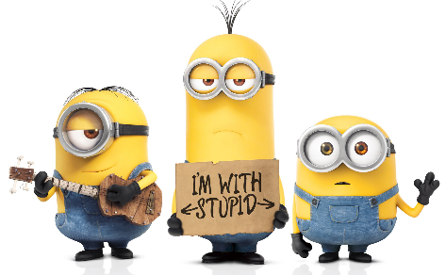  Write a character description based on one of the characters I’m about to show you. Your character description needs to be about 6 sentences long and you have to include at least 4 relative pronouns.
Lesson 4 RE | 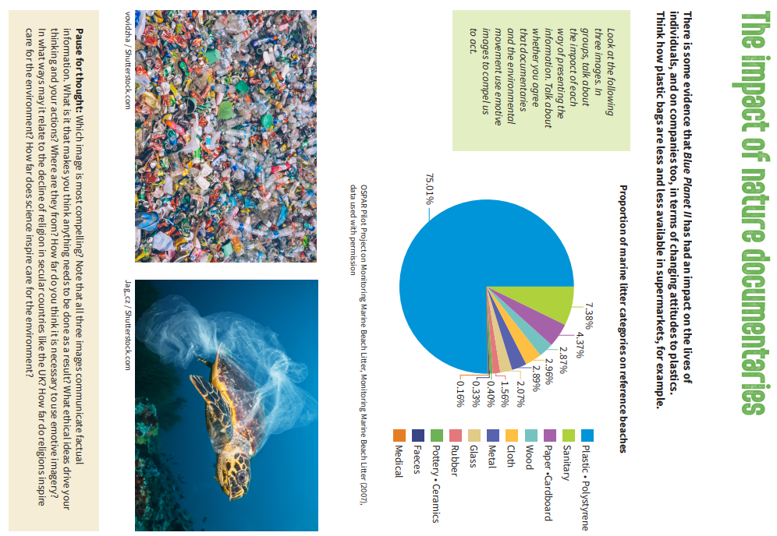

Day 3
Lesson 1 Guided Reading | Choose a character in the book you are reading that you do not like. Write a paragraph to explain why. Try to use examples of action and language from the book to support your answer.  E.g. Sebastian is not a likeable character, we can tell this when he decides to steal from his friends and enjoys doing it as well. When “he went through all the bags in the room and put all the money he could find into his pocket,” he was described as “smiling evilly.” This would suggest to the reader that Sebastian does not seem to care about how upset his friends will be feeling when they realise they have been robbed and also that he does not feeling guilty at all.
Lesson 2 Maths | The Same Difference: Number Sequences - Remember, you do not need to send in any pictures etc as mentioned on the video.  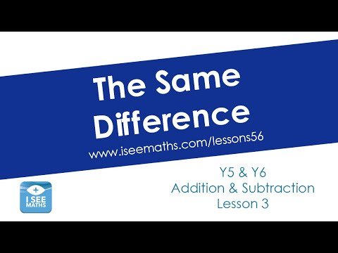  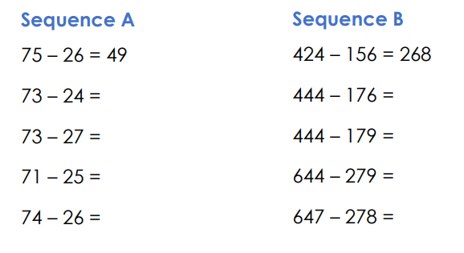  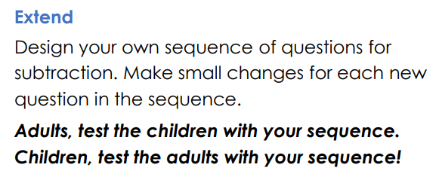  Answers: No peeking!  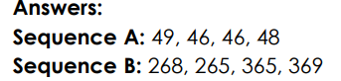
Lesson 3 English | Subject and Object  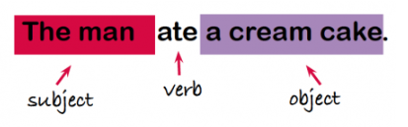  The subject is usually the thing or person who is carrying out an action. The object is the thing or person that is involved in an action, but does not carry it out.  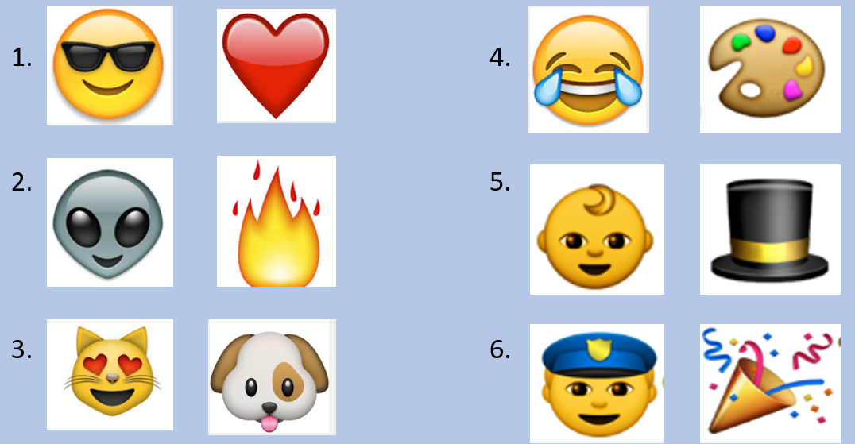  Use the pairs of emojis to write a sentence. The first emoji has to represent the subject, and the second has to represent the object of the sentence. For example: With a giggling laugh, the tiny baby placed the velvet top hat atop his head.
Lesson 4 Computing | Watch the video about online identity and then see below for questions and activity ideas:  https://www.bbc.com/ownit/its-personal/spoken-word-pupils?collection=your-online-identity  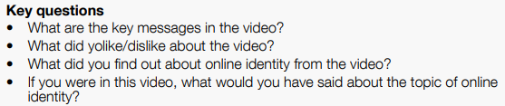  Now have a go at one of the following:  - Create your own story or rap about the theme ‘free to be me online’. It could have a clear focus (free to be kind, free to be me, or be more general)  - Draw a storyboard, a script, or a video like the one in the video

Day 4
Lesson 1 Guided Reading | 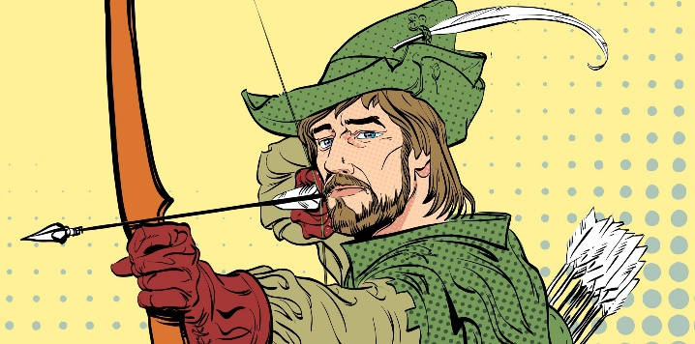  Robin Hood and Little John  They’d passed the graveyard on the edge of the village by the light of a full moon, and the hoot of an owl signalled their passage. They spent the next few hours trudging through the gloom of the forest on their way back to Nottingham. Mist hung about the ground at knee height, giving the forest an ethereal feel. Robin’s friend, Will, turned to him and confessed quietly he wasn’t happy about the uncomfortable silence which enveloped the woods. Usually, even at such an early hour, the woods were filled with noises, but tonight all was deathly silent.  They reached the river crossing just after dawn had broken and found a sun-dappled space to sit, eat and rest a while before crossing the water into the part of the forest inhabited by outlaws. Robin stood and stretched before retrieving his pack, his quiver and his bow. “Come on!” he said to Will, who lay napping on the heather and he nudged him with the toe of his boot. “How much longer is it?” said Will screwing up his face and shielding his eyes from the low hanging sun, “we’ve been walking all night!”  “Not much further,” said Robin, “but keep your wits about you now…you never know who is lurking in the woods on the Wester’ side.”  - Use a dictionary to find the word ‘ethereal’ can you write a definition for it in your own words?  - What do you think the word ‘enveloped’ means?  - Which word in the text tells you that outlaws lived in the forest?  - Outlaw is a compound word made of two smaller words. What do you think it means?  - What does the word trudging tell us about the way the two of them move through the forest?  - Which word in the second paragraph means someone is ‘lying in wait?’
Lesson 2 Maths | Boys, Girls, Children –  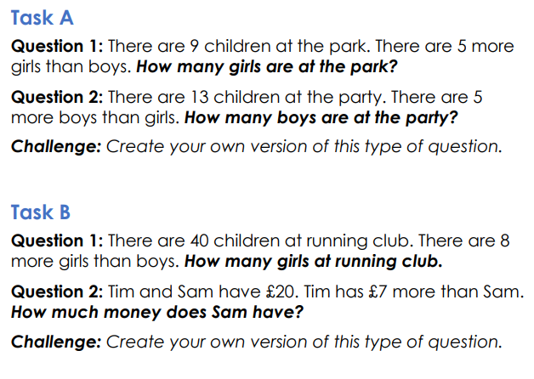  Answers:  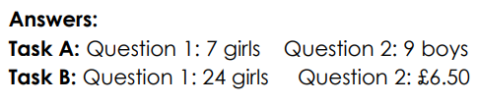
Lesson 3 English | Story starter  And so it began…  One accident, one collision and one fortuitous moment led to a series of unlikely events unfurling: the beginning of the world.  She couldn’t believe her eyes… Tiny little specks appeared on her kitchen table. On closer inspection, these little specks turned out to be people, tiny little people, all feverishly and tirelessly building their world on her table-top. Before long, tiny buildings had been constructed, forests and mountains had grown, and there were even little vehicles making their way across coffee-stained continents.  She had never even imagined in her wildest dreams that any of this had been possible, and little did she know, things were about to get even more extraordinary…  Continue the story.
Lesson 4 Science | 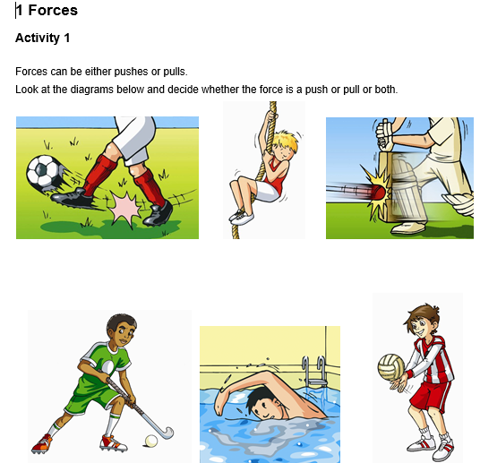  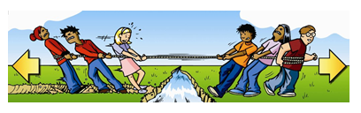  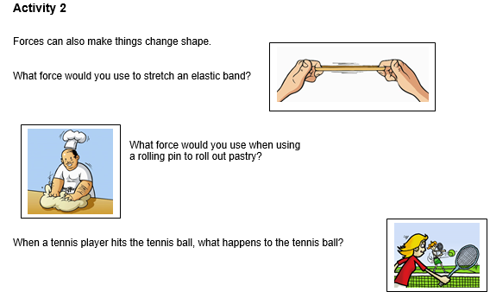  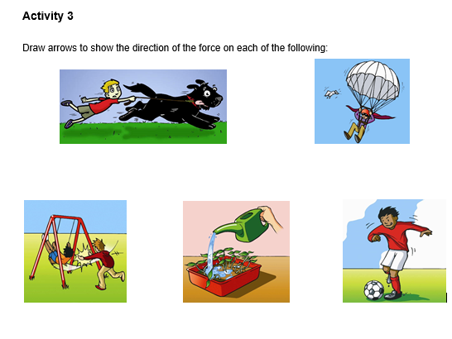  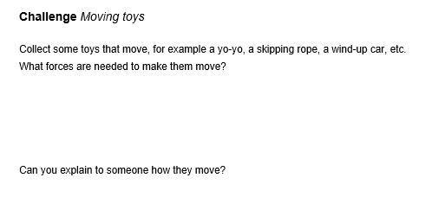

Day 5
Lesson 1 Spelling | 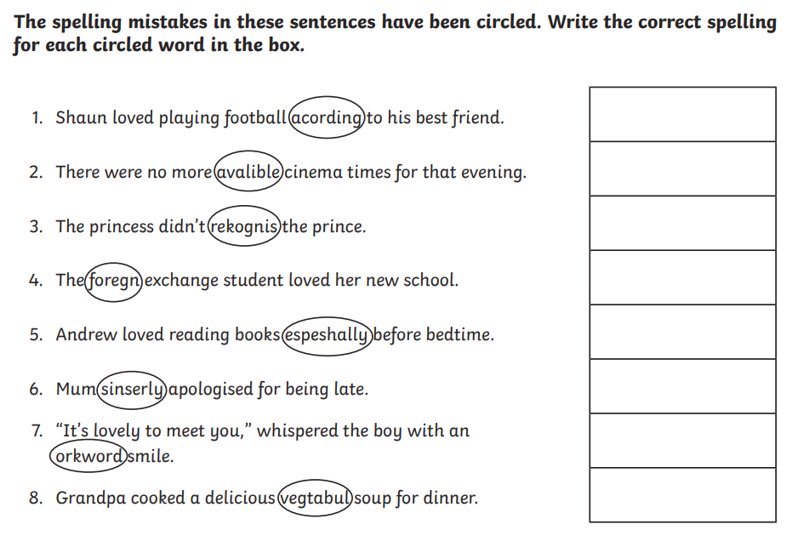
Lesson 2 Maths | Different Contexts:  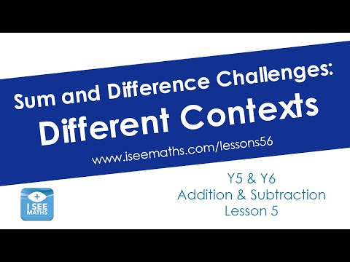  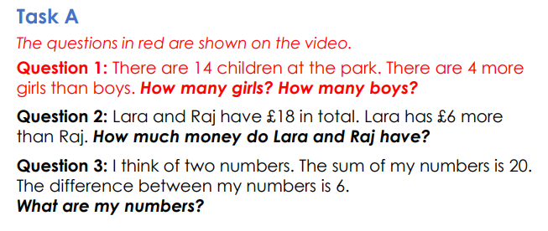  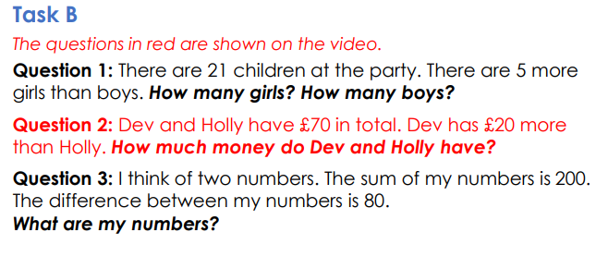  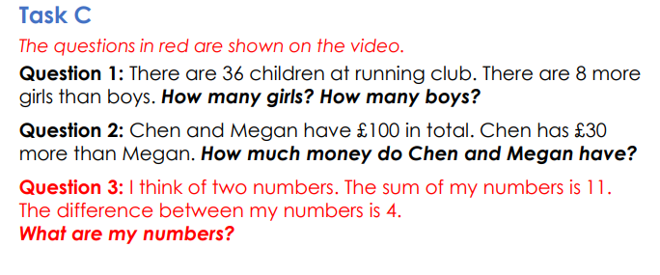  Answers:  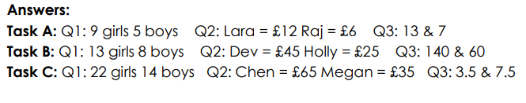
Lesson 3 English | 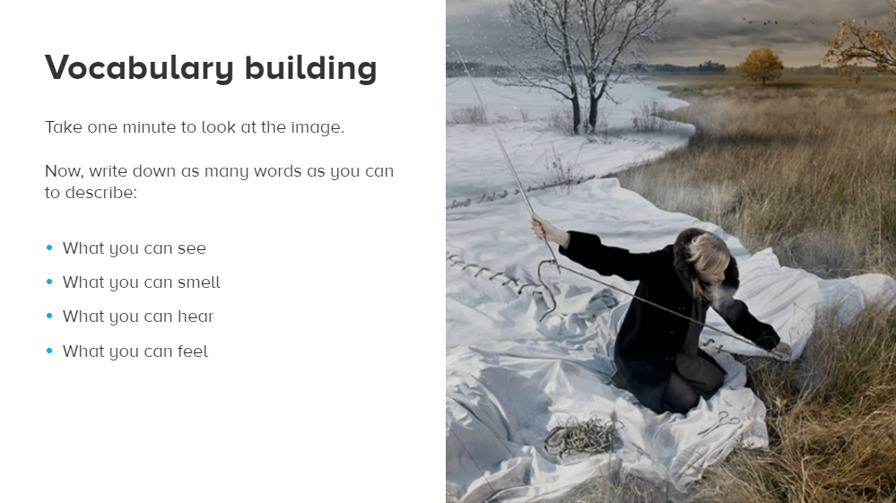  Write a paragraph using modal verbs and relative pronouns to expand your sentences and descriptive writing.
Lesson 4 PE | 