Home Learning – Cuddington and Dinton C of E Primary School
Year 1 – Remote Learning – Monday 13th December 2021
Lesson 1  Phonics and Reading | For phonics today, please log into Bug Club Phonics and play the Phase 4 assessment games.  They are titled:  Phase 4 Assessment: Real Words  Phase 4 Assessment: Alien Words  Please also spend some time reading your Phase 4 reading book. You can either read one online or the one in your book bag.
Lesson 2 Maths | LO: Can I confidently recognise bonds within and to 10?  Please follow the link below for this lesson.  Aut1.7.4 - Addition - using bonds on Vimeo  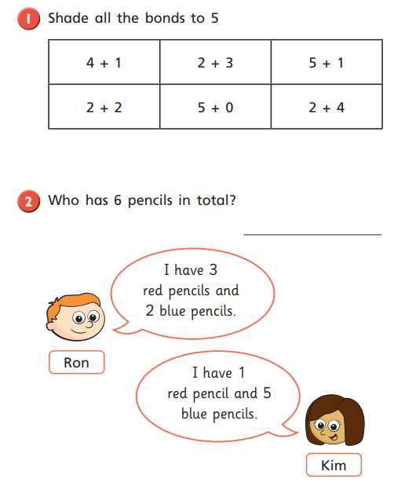  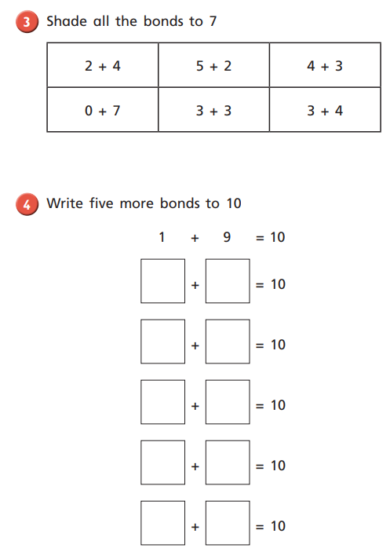  Challenge  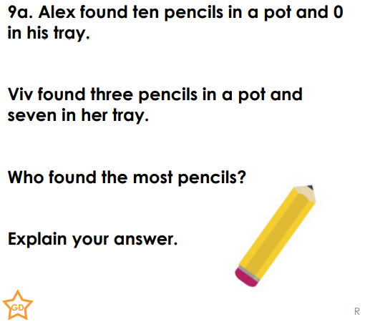  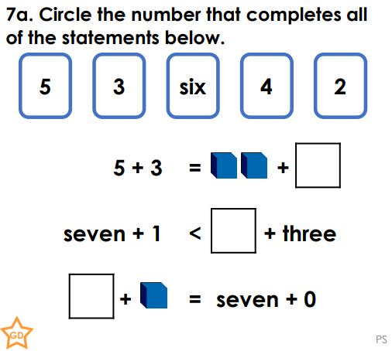  Can I compare number bonds?

Lesson 3  English | LO: Can I use adjectives in my sentences?  Please write at least 3 sentences about the picture below. Your sentences must include an adjective. Remember, an adjective is a describing word.  Sentence starters  I can see…  I can hear…  There is a….  There are…  Word bank  buildings people city busy loud noisy traffic  Christmas
Lesson 4  Learning Log  Project | If you haven’t spent time over the weekend on your learning log project, please use today as an opportunity to complete part or all of it.

