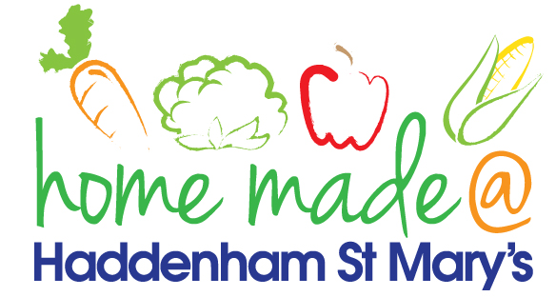

MENU – week commencing 8th November 2021
 | Meat Free Monday | Tuesday  Choose Day | Wednesday  Wonderful Roast | Thursday  Julie’s Jackets | Friday  Fish Friday
Lunch | Tomato pasta bake | Turkey escalope, potato rosti and vegetables | Roast beef with all the trimmings and gravy | Jacket potato with a choice of toppings | Cod bites, potato lattice and vegetables
Vegetarian option | Tomato pasta bake | Veggie escalope, potato rosti and vegetables | Falafel roast with all the trimmings | Jacket potato with a choice of toppings | Veggie burger, potato lattice and vegetables
Dessert | Bananas and custard | Jelly | Muffin | Fruit | Fairy cake
Free From  option | Tomato pasta bake  Bananas and custard | Patty, potato rosti and vegetables  Jelly | Roast beef with all trimmings and gravy  Biscuit | Jacket potato with a choice of toppings  Fruit | Fish fingers, potato lattice and vegetables  Biscuit
All meals will contain or be served with at least one portion of vegetables.
All hot puddings will be accompanied by custard or cream.
All roast dinners, sausage & mash and pie dishes will have the option of extra gravy.
All children will also be offered bread, a piece of fruit and a drink of milk or water with their main meal.

