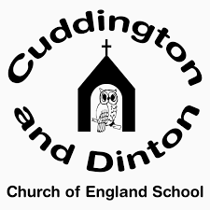 | Date: set 15/10/20 for test Thursday 21/10/20  Year 5 Spellings: Homophones and near homophones
farther
father
guessed
guest
heard
herd
led
lead
mourning
morning
average
awkward

Date:

Year 5 Spelling Test

1.

2.

3.

4.

5.

6.

7.

8.

9.

10.

11.

12.

