Home Learning – Cuddington and Dinton C of E Primary School
Years 5 and 6 – Daily Lessons Week 2
Day 1 Week 2
Lesson 1  Guided Reading | 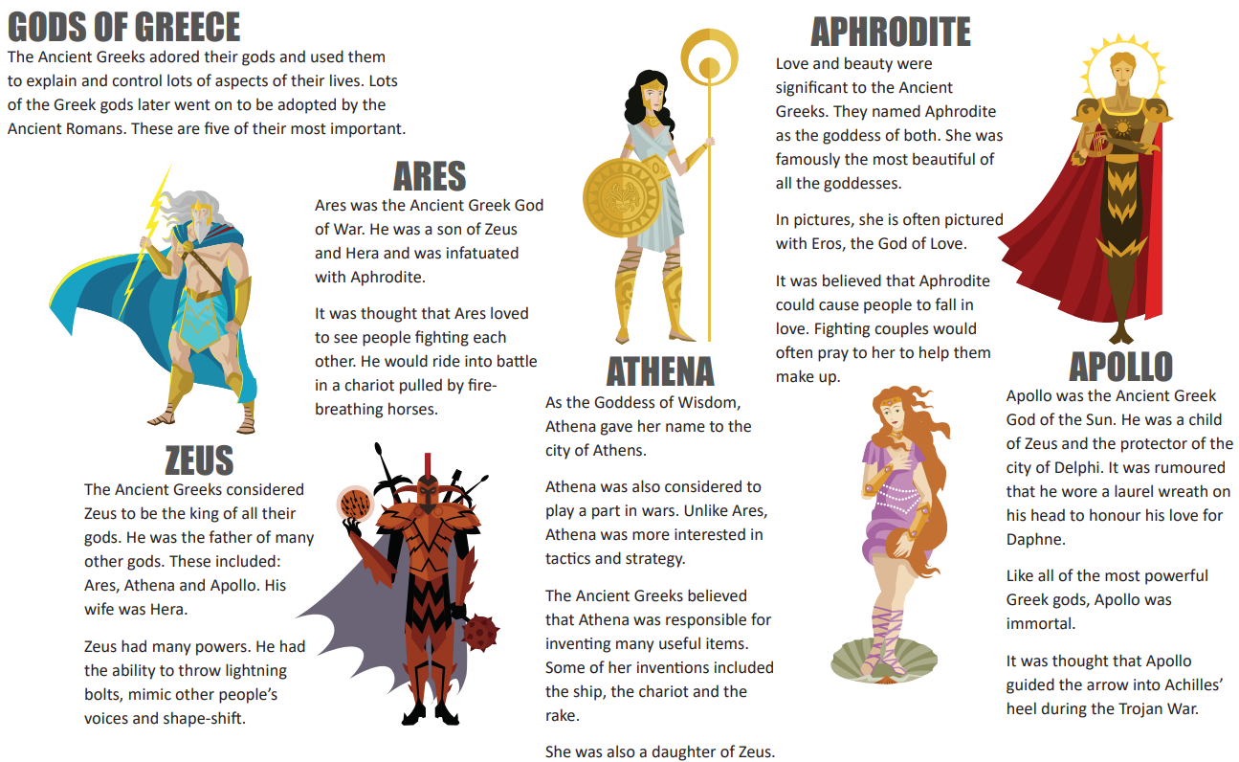  Vocabulary Focus  - Find a word of phrase that shows how the Ancient Greeks felt about their gods.  - Which word tells you that the Romans later took some of the Greek gods as their own?  - What does the word “infatuated” tell you about Ares’s feelings towards Aphrodite?  - Find a word or phrase that is close in meaning to “talked about without any evidence”.  - Copy a phrase that tells you how the Ancient Greeks felt about love.
Lesson 2 Maths | 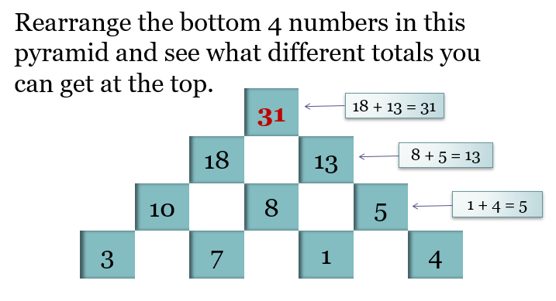  2. Put 4 consecutive numbers (numbers that are next to each other when put in order (e.g. 4, 5, 6 or 9, 10, 11 etc) in the bottom row of a pyramid like this and look for any patterns.  3. Use the 6 numbers 1, 3, 4, 8, 9, 12 in the base of a Number Pyramid to get a top number of 200.
Lesson 3  English | Drastic action needed  Taiwan is normally a very wet place. It gets a lot of rain at different times of the year, especially in its two monsoon seasons.  However, last year, Taiwan had very little rain and it wasn’t hit by a single typhoon. This has left the island nation struggling with its worst drought in at least 56 years.  The extreme dry weather has left many farmers unable to grow crops and is threatening many other businesses in the country.  Lakes and rivers in the central and southern part of the country are drying up. Many of the country’s reservoirs are only 20% full. Some, like the Baoshan No. 2 Reservoir, are less than 10% full.  In response to the shortage, the government has been limiting water. For example, people in the central city of Taichung only get water five days a week. For the other two days, they use water stored in buckets or bathtubs. Some businesses that use a lot of water, like swimming pools and car washes, have been forced to shut down.  The drought has forced the government to choose between the country’s two biggest users of water: farmers, and companies that make computer chips. The government has chosen to support the chip makers.  Your task: Choose one of the following:  - You are a farmer. Write a letter of complaint to the Government outlining the devastation they have caused by choosing the chip makers.  OR  - Write a speech on behalf of the Government outlining the reasons for choosing the chip makers.
Lesson 4  PE | 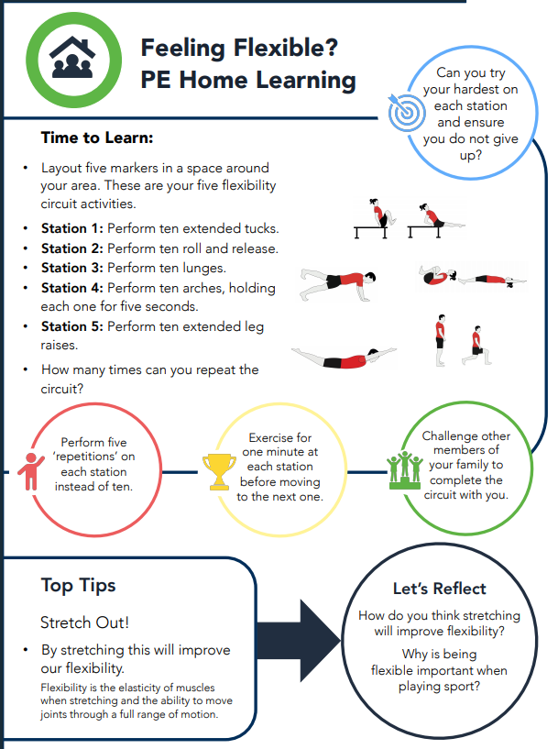

Day 2 Week 2
Lesson 1  Guided Reading | 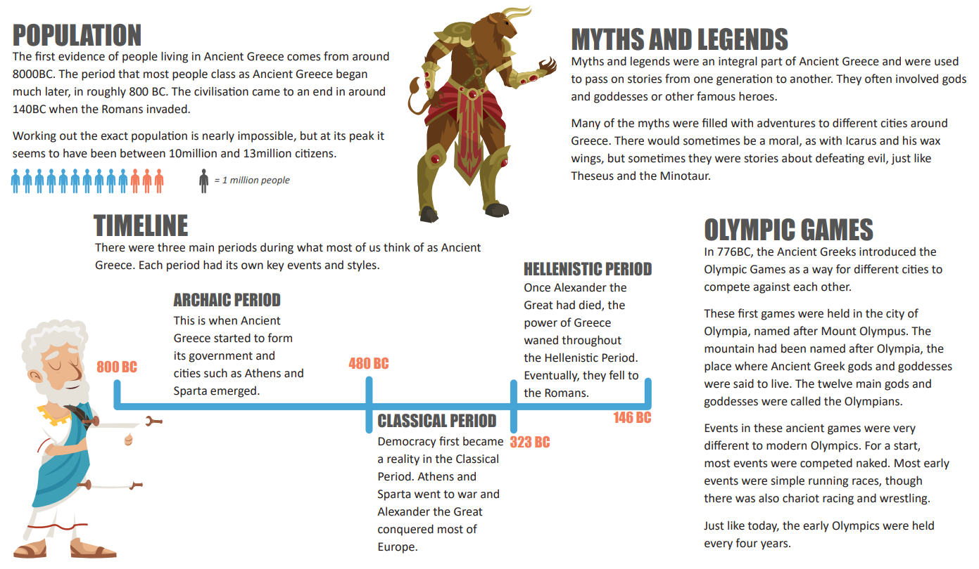  1. During which period in Greek history did Sparta and Athens go to war?  2. Who conquered most of Europe?  3. Where were the early Olympic games held?  4. According to evidence, when were the first people living in Ancient Greece?  5. Find an example of a Greek myth with a moral.  6. What were the three main periods of Ancient Greece?  7. Find a word that means “important” or “vital”.
Lesson 2 Maths | 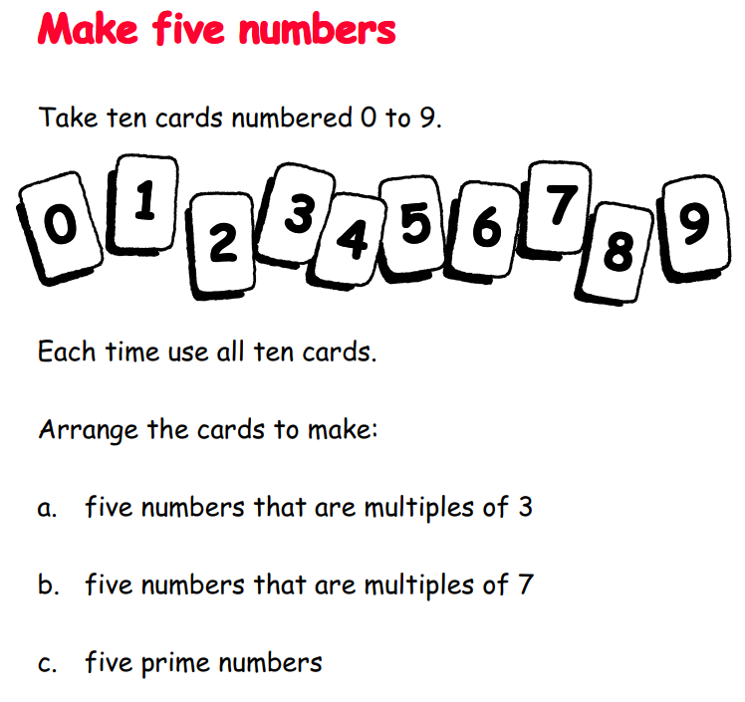
Lesson 3  English | Tour de France for women!  The Tour de France is a very difficult bike race. It lasts over three weeks and covers 2,082 miles (3,351 kilometres). Held in France in the summer heat, bikers race up and down mountains, on steep, winding, and dangerous roads.  Every day, the riders finish a different part of the race, called a “stage”. Every stage can have a different winner, and each day, the total time is added up. The person who is leading wears a yellow jersey (shirt), to show that they are winning.  But there are no women in the Tour de France, only men. For years, women have been trying to change that.  For years, women have been working to bring back a similar race for females. Now, the organizers have announced that the women's Tour de France will return next July (2022).  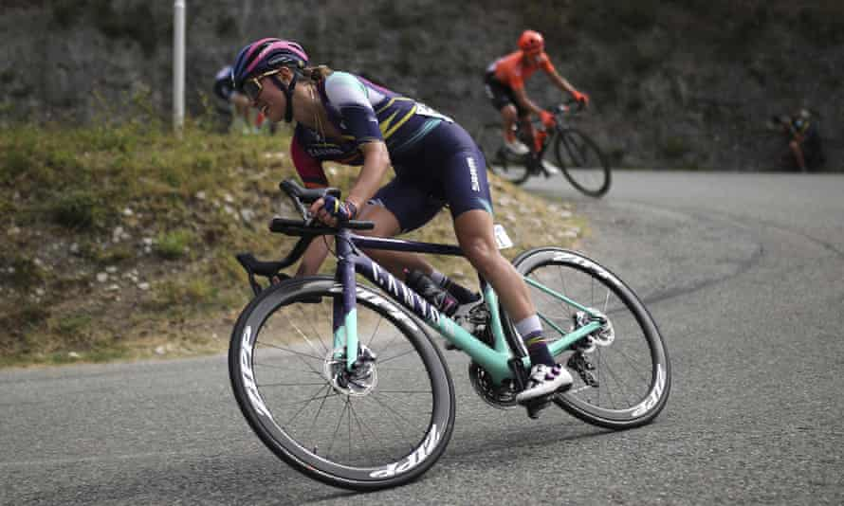  Your task: Create a persuasive poster to advertise the women's Tour de France 2022. Think about what might persuade people to watch and support the women’s Tour de France next year.
Lesson 4  PE | 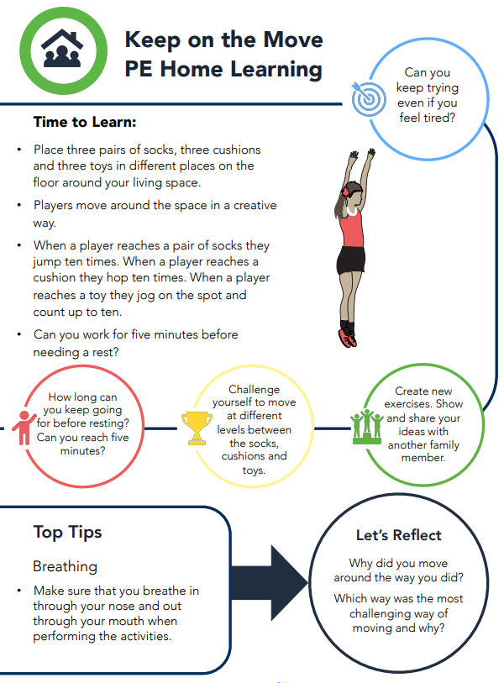

Day 3 Week2
Lesson 1  Guided Reading | 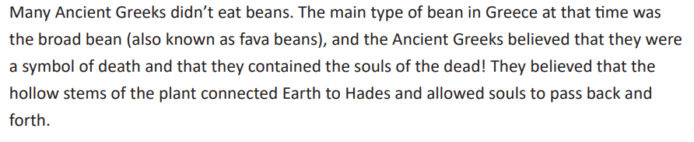  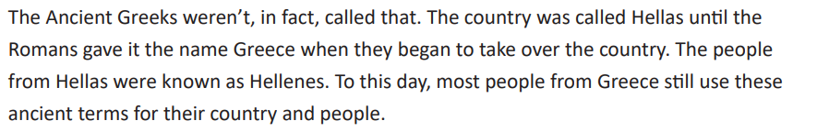  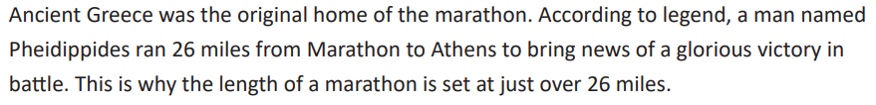  - What was another name for the broad bean?  - Why didn’t the Greeks eat broad beans?  - What do the Greeks call themselves today?  - How long is a modern marathon?  - Find and copy the word that has the meaning closest to ‘had inside them’.
Lesson 2 Maths | 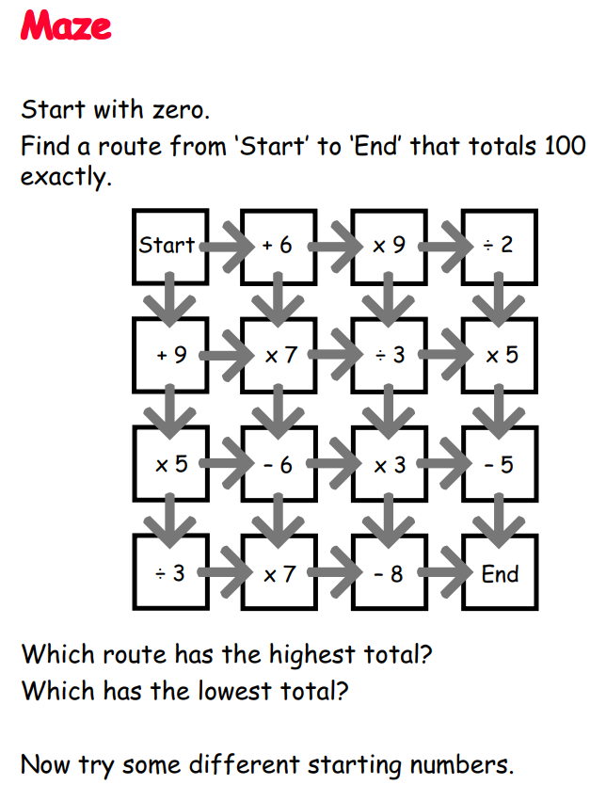
Lesson 3  English | 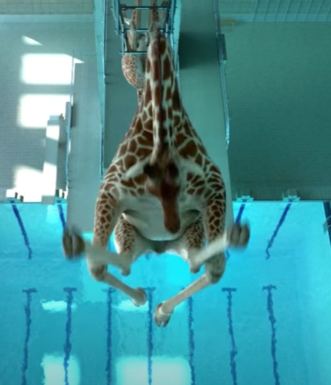  5 METERS 80 - Animation short film by Nicolas Deveaux - France - CGI 3D - Autour de Minuit - YouTube  Watch the video or imagine what it would be like to watch giraffes diving into a pool.  Use show not tell throughout describing all that happens as if it is a human and then reveal at the end that it is in fact a giraffe. How could you personify the giraffe’s movements so that it appears to be human? How will you reveal the giraffe to the reader at the end?
Lesson 4  Science | 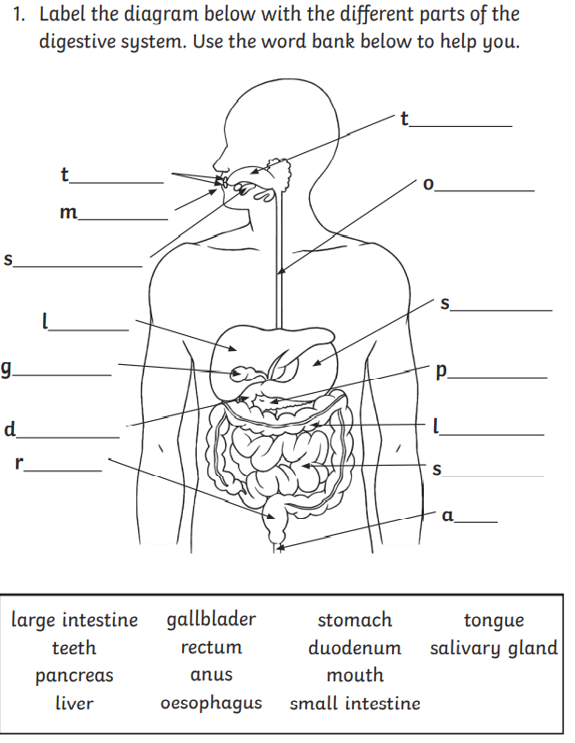
Day 4 Week 2
Lesson 1  Guided Reading | More Ancient Greek Facts  The Ancient Greeks were the first civilisation to show productions in theatres. Much like in Tudor Britain, only men and boys were allowed to act in the plays, and they wore masks to show their emotions, rather than acting. These masks could be turned around to show different emotions in the same scene. The genres of tragedy, comedy and satire all have their roots in Ancient Greek theatre. The symbol that most people associate with the theatre - the comedy and tragedy masks - are based on the masks that ancient Greek actors wore. The correct term for them is the sock and buskin; actors in tragic roles wore buskins, which were a type of boot, whereas actors in comedy roles wore thin-soled shoes called socks.  At its peak, the Greek civilisation was home to between 10 and 13 million people including slaves. To put that into perspective, the Roman Empire had somewhere between 50 and 90 million people, whereas the Ancient Egyptian population was never more than 7 or 8 million. Despite the difference in numbers, the Greeks were packed into a much smaller area than the Romans, whose empire stretched across most of Europe.  - What are the correct names of the two Greek masks in the symbol for theatres?  - Which of the civilisations mentioned had the biggest population?  - What is the link between the symbol for theatres and the Ancient Greeks?  - Why wouldn’t you have seen women in theatre roles in Ancient Greece?  - Write a definition for perspective that matches this context.
Lesson 2 Maths | 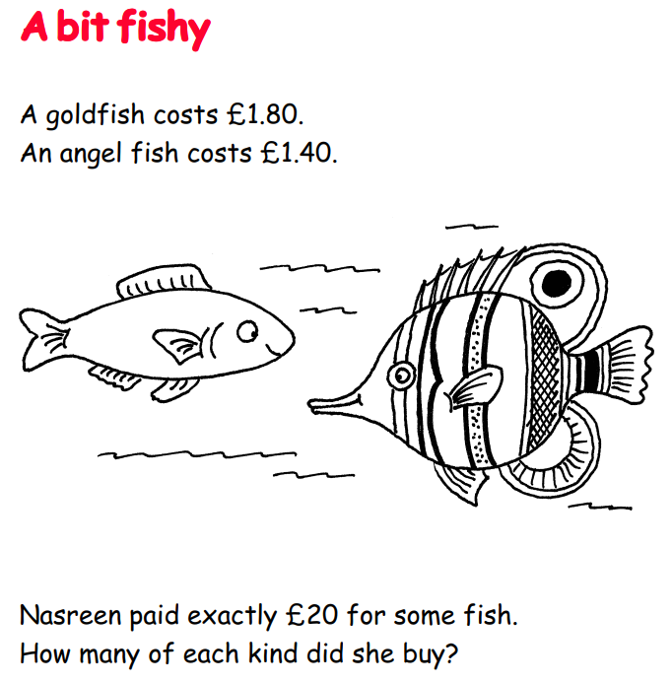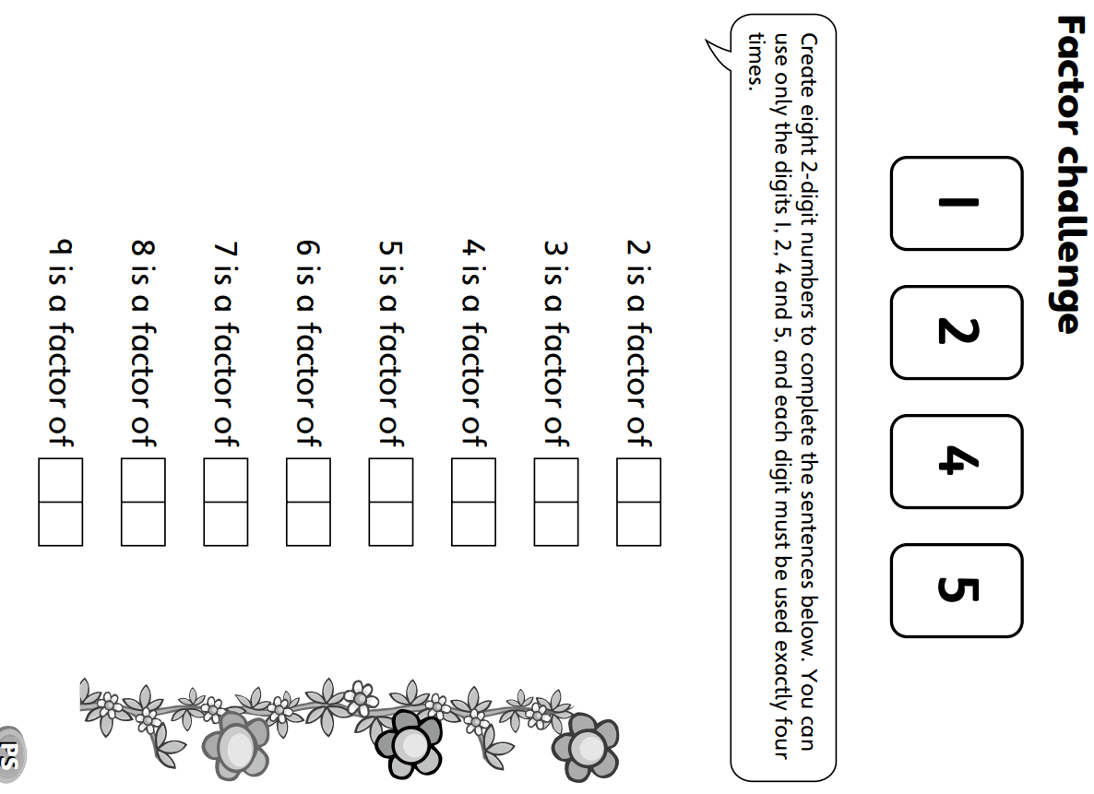
Lesson 3  English | 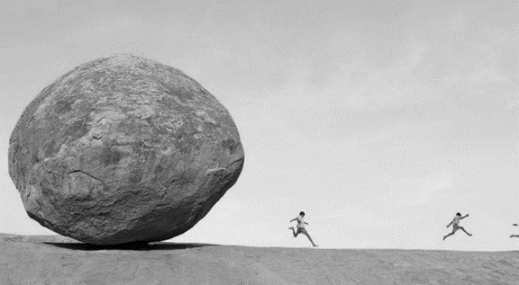  Story starter  Dad’s home science experiment had gone horribly wrong! He had zapped the kids in the garden with his new ELECTROZORBTASTICLASERJETBRAIN-GUN, which was supposed to make his three children the smartest children in the entire world. Instead, the zap had back-fired, making Dad even more brainy, but the children…Extremely tiny!  Stood in the middle of the garden path, they suddenly found themselves running as fast as they could away from a rolling pebble (which was actually tiny, but now seemed as big as a house).  Continue the story.
Lesson 4  PE | 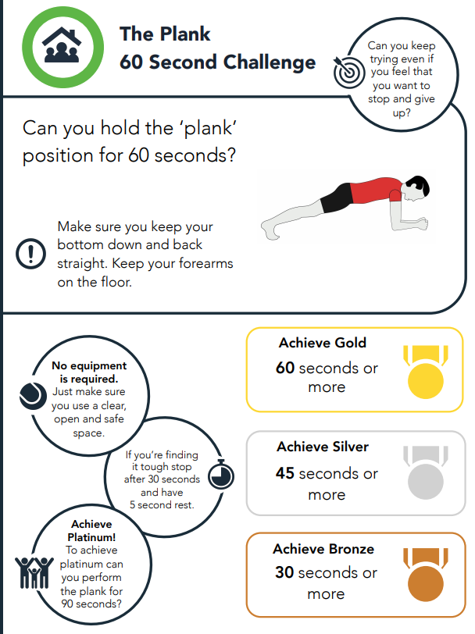

Day 5 Week 2
Lesson 1  Spelling | Use the clues to work out which word goes in the correct space. The words are all from the year 5 and 6 statutory world list:  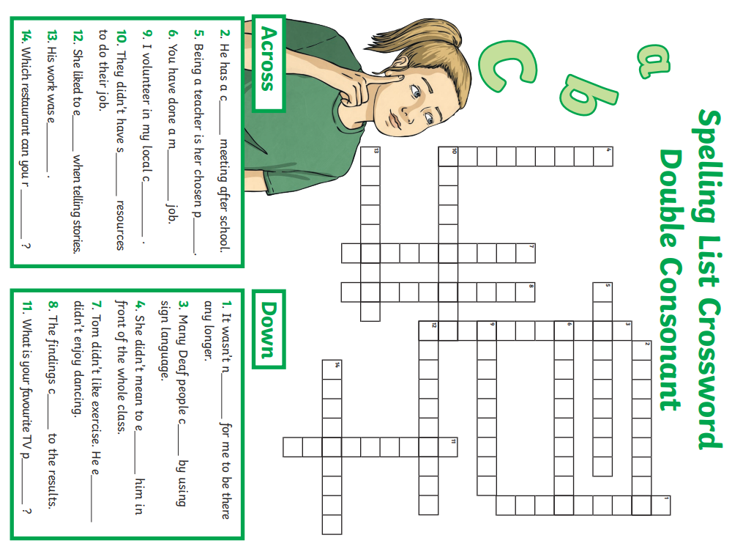
Lesson 2 Maths | Investigate: Planning a Journey on the Internet or using a road map  - Find an internet link to a trip planner or use a road map starting your journey at your house.  - Practise planning trips incorporating about 5 stops using your trip planner.  - Sketch a diagram below of a sample network of stops you could make on your ‘trip’  - Find out the distance travelled around all 5 stops in kilometres.  - Work out how much time it would take to complete your journey.  - If petrol costs 26p a kilometre, how much would petrol cost to complete your journey?
Lesson 3  English | Grammar:  - How could you correct these sentences?  - We was going swimming.  - If we was not at school, I’d stay in bed.  - Martha were at her friend’s house.  - I were on holiday in Spain.  - Put Brackets () into these sentences.  - My favourite book The Hobbit is a fantasy story.  - It was a rainy day a Monday when the fire alarm went off!  - The dog which was called Sid never stopped barking!  - Where should the apostrophe go in these sentences?  - Hannahs mum worked at the hospital.  - Barry, my sisters rabbit, was grey and white.  - Im going to the skatepark to see friends.  - Mum hasnt got time to go to the hairdressers.  - Put in the missing semicolon ;  - Sam worked hard he deserved to pass his exams.  - Kate opened the drawer it was empty.  - The rabbit was looking rather ill it needed taking to the vets.  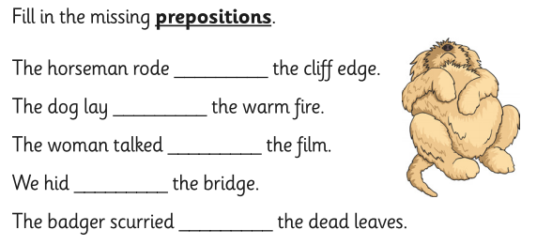
Lesson 4  PE | 