Home Learning – Cuddington and Dinton C of E Primary School
Years 5 and 6 – Daily Lesson Plans 2021
Day 1
Lesson 1  Guided Reading | 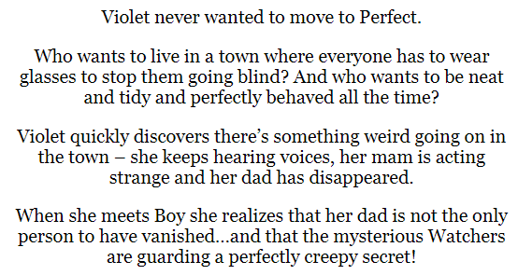  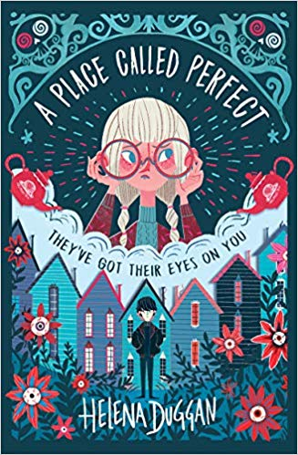  - Look at the front cover: make a prediction about the story by using the title and the images on the front of the book.  ___________________________________________________________________________________________________________________________________________________________________________________________________________________________________________________(2 marks)  - Read the blurb. Why do you think everyone goes blind in Perfect?  ___________________________________ (1 mark)  - Do you think that the place called Perfect is perfect? Explain your answer.  ________________________________________________________________________________________________________________________________________________________________________________________________________________________________________________________________________________________________________________________________________________________________________(3 marks)
Lesson 2  Maths  Number Differences | 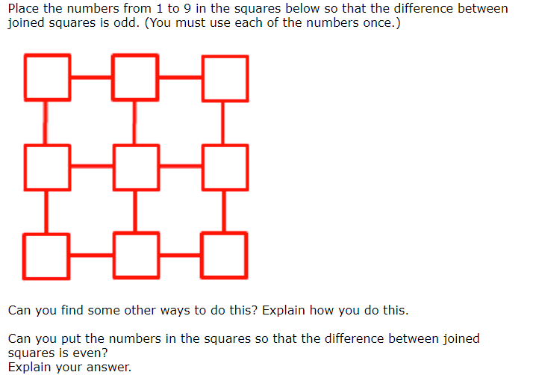
Lesson 3  English | Story Starters: "Follow me!" she whispered.  Using the picture and first line as inspiration, continue the story. Alternatively, write about how she came to find herself under the sea.  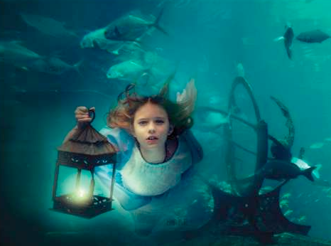
Lesson 4  PE | 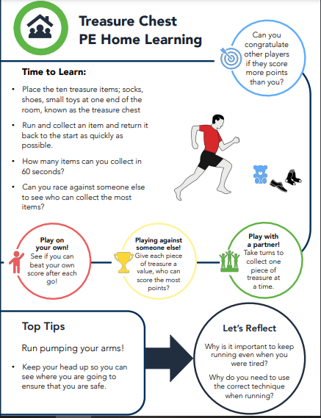

Day 2
Lesson 1  Guided Reading | Read the extract of chapter one, ‘Boy’.  1) Clarify what the phrase, ‘Perfect had been alive with the news…’ means._________________________________________________________________________________________________________________________(1 mark)  2) What do you think the Doctor will help with?__________________________________________________________________________________________________________________________(1 mark)  2) Find a word in the text which is similar in meaning to a risky manoeuvre. ____________________ (1 mark)  4) Why do you think the girl could be frightened?_______________________________________________________________________________________________________________________(1 mark)  5) Find an example of an adverbial phrase in the text. _______________________________________________ (1 mark)  6) Find an adverb in the text. __________________ (1 mark)  7) Find an example of parenthesis in the text. ____________________________________________________ (1 mark)  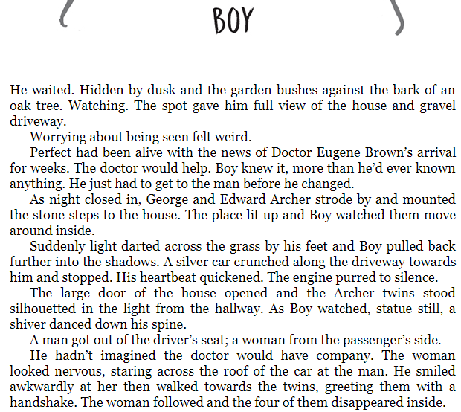  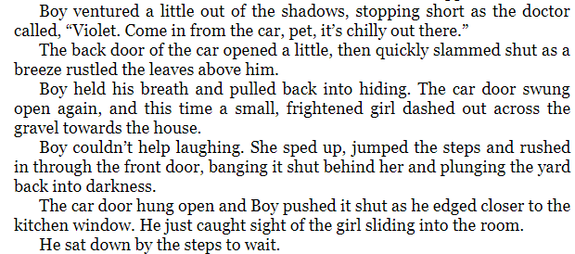
Lesson 2  English | 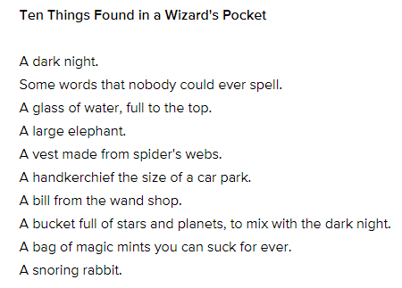  Think of a topic (it might be a week in the Antarctic or a trip to Mars) and then think of ten things that you would take with you or put into a bag for your journey there. Be adventurous and ambitious with your language!  Can you justify why you have chosen your items.?
Lesson 3  Maths | 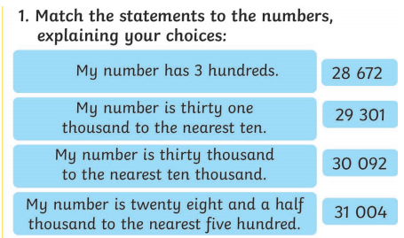  Once you have finished, explain how you solved this problem and then make up your own similar questions.
Lesson 4  Outdoor learning | 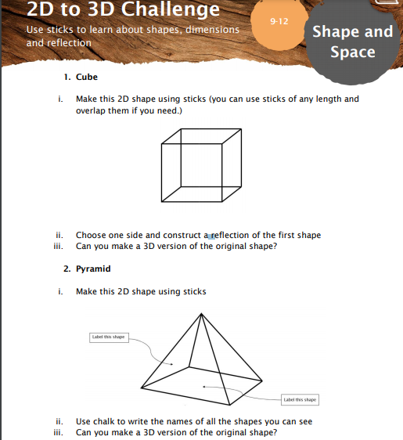

Day 3
Lesson 1  Guided Reading | 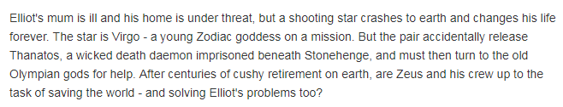  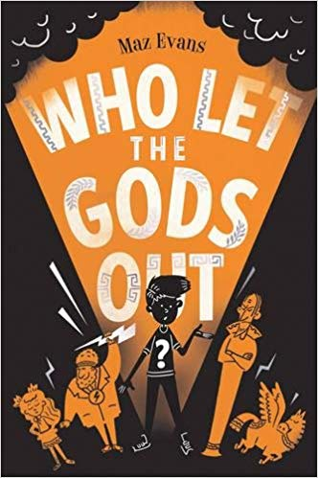  1) Look at the front cover: make a prediction about the story by using the title and the images on the front of the book.  __________________________________________________________________________________________________________________________________________________________________________________________________________________________________________ (2 marks)  2) Read the blurb. Clarify what a cushy retirement is.  ___________________________________ (1 mark)  3) What do you think Elliot’s problems are?  ______________________________________________________________________________________________________________________________________________________________________________________________________________________________________________________________________________________________________________________________________________________________ (2 marks)
Lesson 2  Maths | 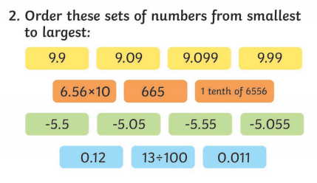
Lesson 3  English | Tiny Dragon  - Where is it from?  - Why is it so small?  - Are there more like him?  - Where does he live?  - How will you look after it?  - Will you keep it a secret or tell someone?  - What is it called?  - Is it magic? What magic can it do?
Lesson 4  Computing | We are going to use an online program to practise typing with two hands. The more we practise, the easier typing will become for us.  Please start with Level 1.  BBC Dance Mat Typing:  https://www.bbc.co.uk/bitesize/topics/zf2f9j6/articles/z3c6tfr  You may find it tricky but keep trying and, with practise, it will become easier for you. This is a skill that you will be able to use throughout your life.

Day 4
Lesson 1  Guided Reading | 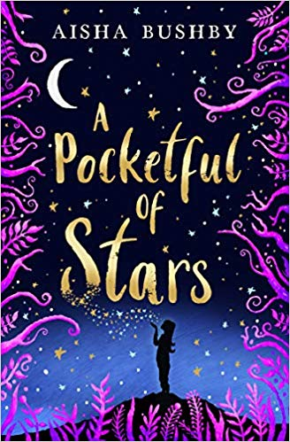  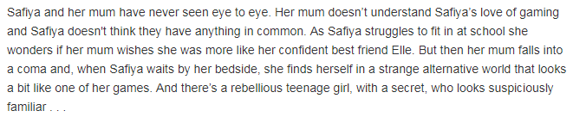  1) Look at the front cover: make a prediction about the story by using the title and the images on the front of the book.  __________________________________________________________________________________________________________________________________________________________________________________________________________________________________________ (2 marks)  2) Read the blurb. What does, ‘had never seen eye to eye’ mean? ____________________________________________________________________________ (1 mark)  3) What does it mean to fall into a coma? ______________________________________________________________________________ (1 mark)  4) What impression do you get of the character Safiya? _____________________________________________________________________________ (1 mark)
Lesson 2  English | 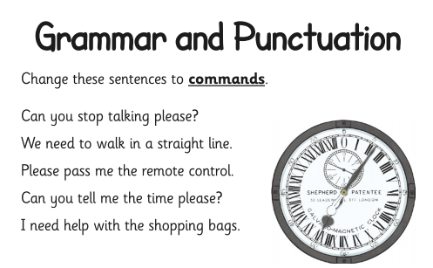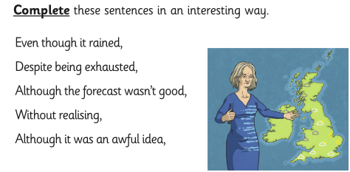
Lesson 3  Maths | 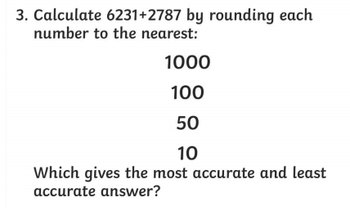  Make up your own similar questions.
Lesson 4  Science | 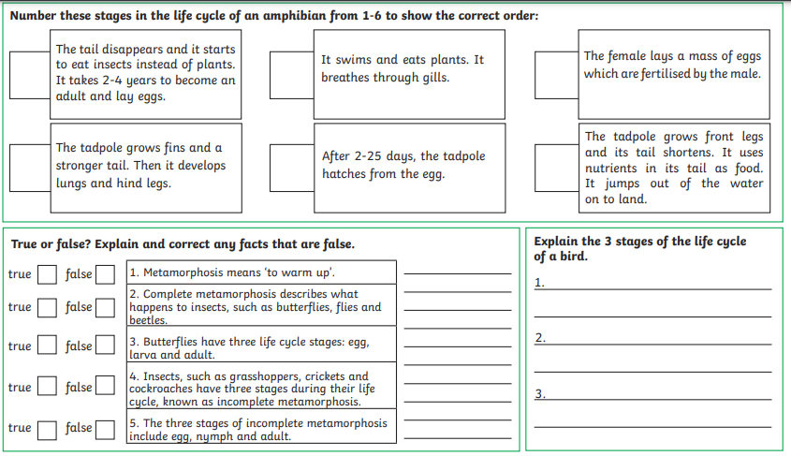

Day 5
Lesson 1  Spelling | 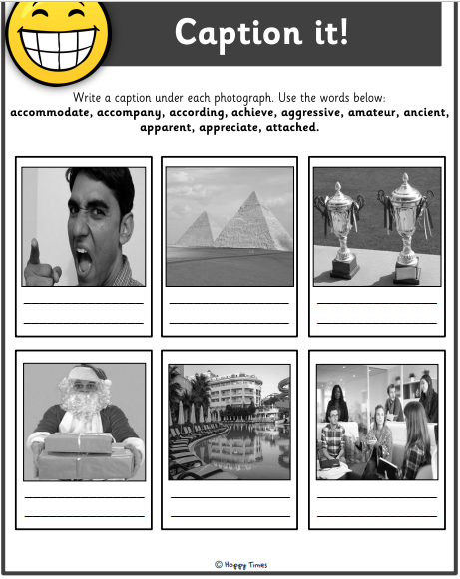
Lesson 2  Maths | 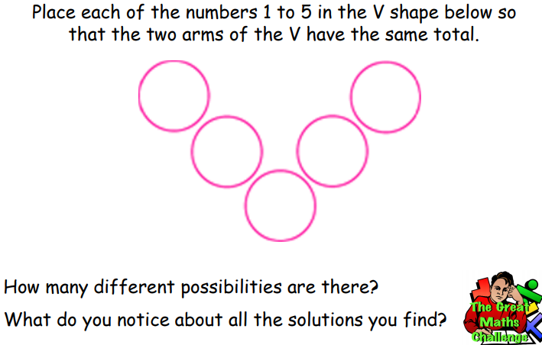  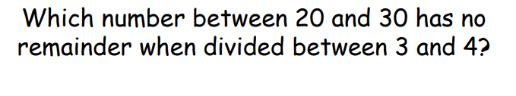
Lesson 3  English | 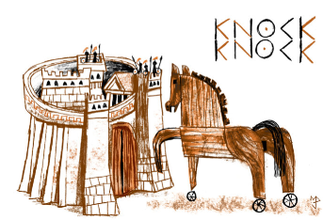  - What can you see? What do you think is happening?  - Does this remind you of any story you know?  - Do you know the saying ‘Beware of Greeks bearing gifts’? How could it apply to this picture?
Lesson 4  PE | 