Home Learning – Cuddington and Dinton C of E Primary School
Year 1 – Daily Lesson Plans – Week 2
Day 1
Lesson 1  Phonics and Spelling | - Please go through the Phase 3 speed sounds. A video link for these is provided below.  Phonics Phase 3 guided Speed Sounds - YouTube  - Today you will be recapping the phoneme /ar/ written as /ar/  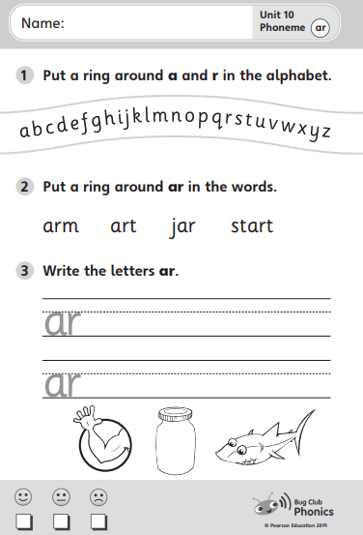  Please also practise your weekly spellings.
Lesson 2 Maths | LO: Can I use ordinal numbers correctly?  Please follow the link below for this lesson.  Aut1.4.3 - Ordinal numbers on Vimeo  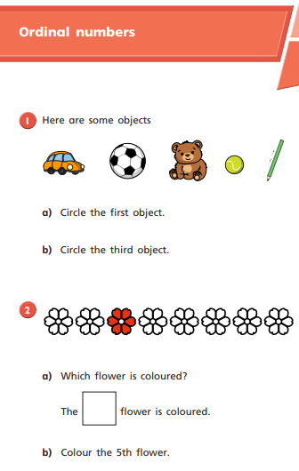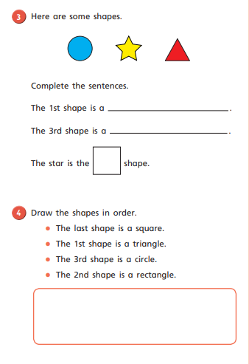
Lesson 3  English | LO: Can I use my phonics to spell?  During the Autumn term, we are practising our sentence writing and ensuring we are using capital letters, full stops and spelling using our phonics knowledge. For today’s lesson, I would like you to write sentences using the words from your spelling list.  You must write at least 3 sentences and ensure you have included a capital letter, full stop and sounded out the words whilst spelling.
Lesson 4  PE | 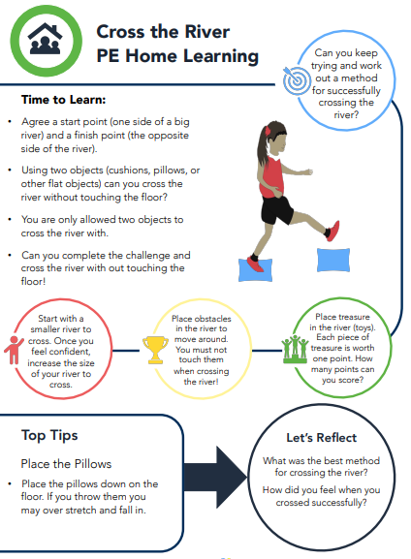

Day 2
Lesson 1  Phonics and spelling | - Please go through the Phase 3 speed sounds. A video link for these is provided below.  Phonics Phase 3 guided Speed Sounds - YouTube  - Today you will be recapping the phoneme /or/ written as /or/  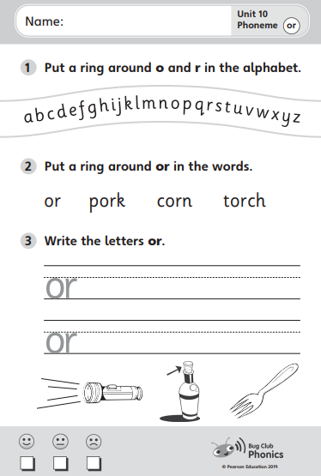  Please also practise your weekly spellings.
Lesson 2  English | LO: Can I use adjectives within my writing?  Last week, you identified nouns and then described them. Today, I would like you to focus on adjectives again.  Walk around your house and label different nouns with adjectives that describe them. For example, on your sofa you could label it as ‘comfy’, ‘soft’, ‘cosy’ etc. You can have help writing these word from an adult if you need to.
Lesson 3  Maths | LO: Can I use a number line?  Please follow the link below for this lesson.  Aut1.4.4 - The number line on Vimeo  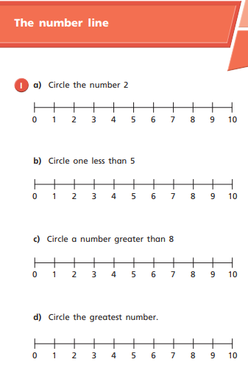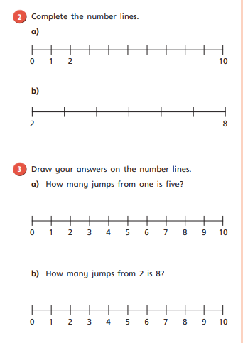
Lesson 4  Outdoor learning | LO: Can I tie a knot?  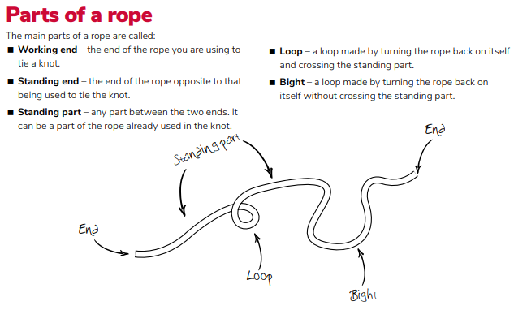  Task: please practise the knot below.  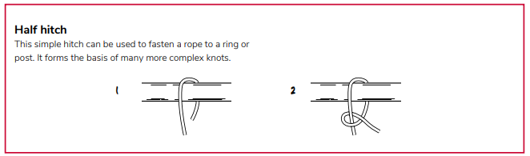

Day 3 – start adding work from this day
Lesson 1  Phonics and Spelling | - Please go through the Phase 3 speed sounds. A video link for these is provided below.  Phonics Phase 3 guided Speed Sounds - YouTube  - Today you will be recapping the phoneme /ur/ written as /ur/  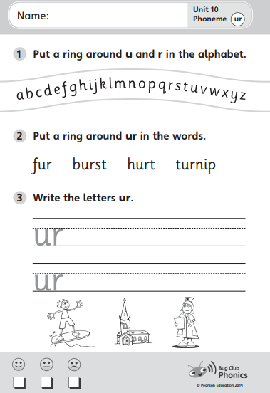  Please also practise your weekly spellings.
Lesson 2  Maths | LO: Can I discuss maths problems?  Please answer the following questions. The answers can either be discussed or written down.  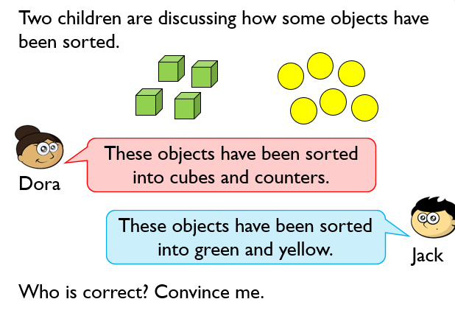  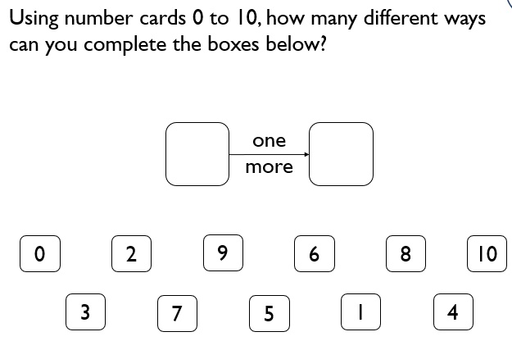  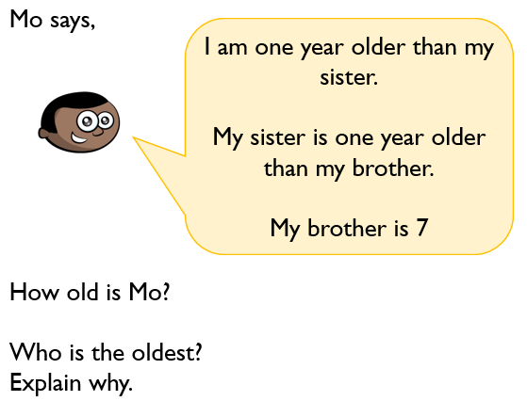
Lesson 3  English | LO: Can I read sentences using my phonics knowledge?  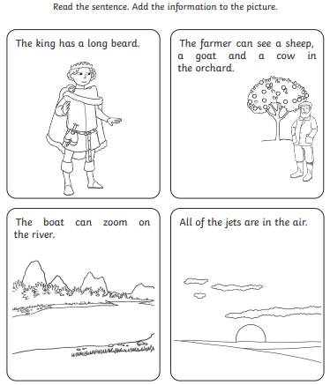
Lesson 4  Computing | LO: Can I practise my typing skills?  Please practise level one from the website below.  Dance Mat Typing - BBC Bitesize
Day 4
Lesson 1  Phonics and Spelling | - Please go through the Phase 3 speed sounds. A video link for these is provided below.  Phonics Phase 3 guided Speed Sounds - YouTube  - Today you will be recapping the phoneme /ow/ written as /ow/  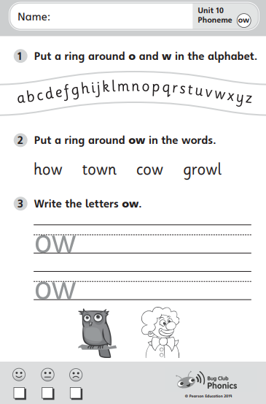  Please also practise your weekly spellings.
Lesson 2  English | LO: Can I read sentences using my phonics knowledge?  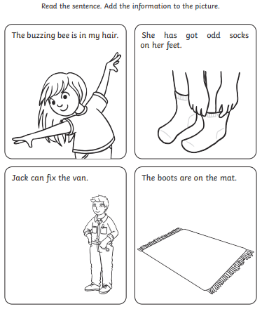
Lesson 3  Maths | LO: Can I discuss maths problems?  Please  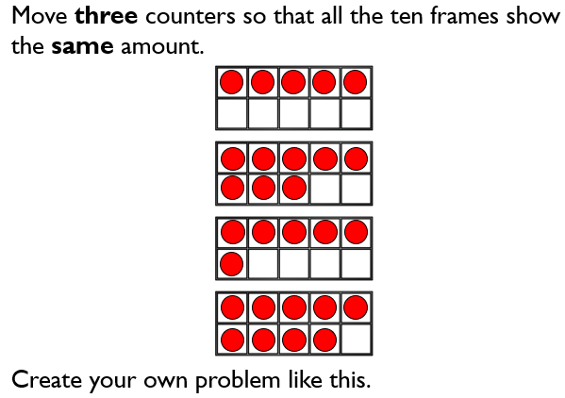  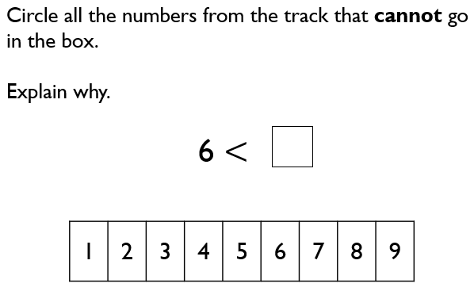  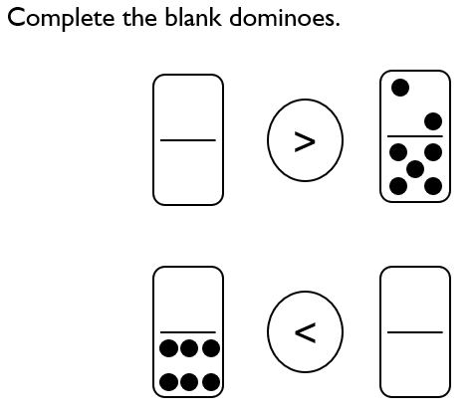
Lesson 4  Art | LO: Can I construct a model out of 2D shapes?  For this lesson, please start by naming the shapes below.  Task: draw your own 2D shapes, like above, then try to create a model with them. You can add other features but you must include some 2D shapes.

Day 5
Lesson 1  Phonics and Spelling | - Please go through the Phase 3 speed sounds. A video link for these is provided below.  Phonics Phase 3 guided Speed Sounds - YouTube  - Today you will be recapping the phoneme /oi/ written as /oi/  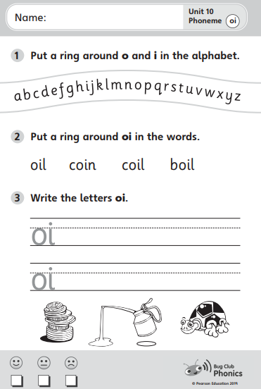  Please also practise your weekly spellings.
Lesson 2  Maths | LO: Can I show my knowledge of the < > and = symbols?  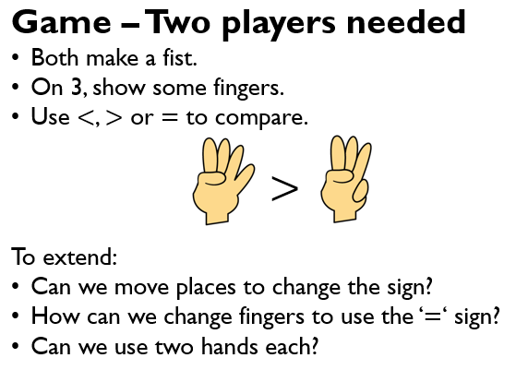
Lesson 3  English | LO: Can I discuss and write ideas about an image?  Task 1: Discuss the questions below.  - What can you see here?  - Where are they? How do you know?  - Where did they come from?  - Why did they come to the moon?  - What equipment does the man have? Why does he need it?  - Do you think the dog enjoys being on the moon? Why? What about the man?  - How long do you think they’ll stay?  - What will they do here?  - Will anyone else join them?  Task 2: Can you write some of your ideas down? You could write key words or you could write sentences.
Lesson 4  PE | 