Year 4 Timetable Autumn 2021
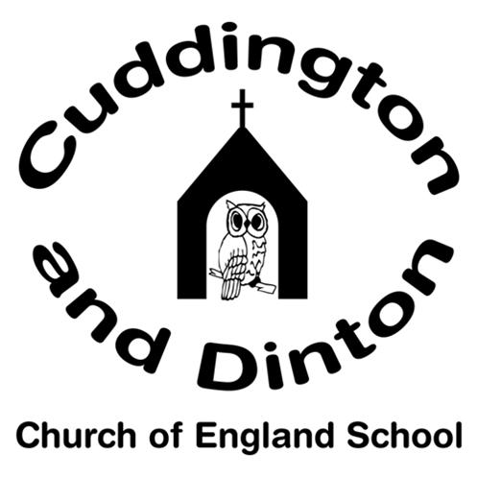 | 8.50- 9.10 | 9.10- 9.30 | LESSON 1  9.30-10.20 | 10.20-  10.40 | LESSON 2  10:40-11:40 | 11:40- 12.00 | 12.00- 1.00 | LESSON 3  1-1:40 | LESSON 4  1:40-2:30 | LESSON 5  2:30-3:15
MON | Reading/Registration/ TTR/ Spelling Test | Collective Worship | English | BREAK | Maths | Reading for Pleasure | LUNCH | (Reciprocal Reading) Guided Reading | RE | Music
TUE |  | Collective Worship | English |  | Maths | Reading for Pleasure |  | (Reciprocal Reading) Guided Reading | PE | French
WED |  | Spellings / Handwriting | English |  | Maths | Reading for Pleasure |  | PSHE | Science | Science
THUR |  | Singing Assembly | English |  | Maths | Reading for Pleasure |  | Guided Reading – paired and 1-1 reading | Y4 PE (OC)  Y3 Topic (KC) | Y4- Topic (KC)  Y3- PE (OC)
FRI |  | Collective Worship | English |  | Maths | Golden Time |  | Whole Class Guided Reading | Topic | Topic

