Home Learning – Cuddington and Dinton C of E Primary School
Year 4 – Daily Lesson Plans Week 1
_____________________________________
Day 1
Lesson 1  Phonics, Spelling and/or Guided Reading | - Practise learning these spellings of the months of the year and days of the week. See if you can spot patterns. Make word pyramids, write vowels in red and consonants in blue, write in bubble writing.  Monday, Tuesday, Wednesday, Thursday, Friday, Saturday, Sunday  January, February, March, April, May, June, July, August, September, October, November, December  - Choose a book that you have read before and find a page where one of the characters is described. Read the description carefully then draw the character, paying attention to any distinguishing features, particular clothing or items the character may hold or use. Label your drawing.
Lesson 2 Maths

Lesson 3  Geography/ English | This work can take you a few days or even the whole week.  Research a famous volcano – make sure you know where it is located and can find the place on a world map. You could find out how it was created and when it last erupted. Next, jot down all the information you have found out and make a plan for a non-chronological report (remember, last year we compiled a report on the Wandering Albatross).  You will need to think about these features:  Heading and Sub-headings  Paragraphs - a new paragraph for each topic/idea  Facts  Interesting sentence starters such as ‘curiously, you may like to know, importantly)  An introduction and a conclusion  A picture with a caption  A map or diagram  The next step is to draft the paragraphs. Keep reading your writing back to yourself and make sure you have included our non-negotiables (capital letters, commas, full stops). Use a dictionary or ask an adult to help you check your spellings of key words. Try not to repeat yourself.  After that, read your writing out loud to an adult and make any further corrections or improvements.  Finally, find a piece of lined paper and draw some boxes for your paragraphs. Write up your report neatly then finish off with pictures, a diagram and/or a map.
Lesson 4  PE | 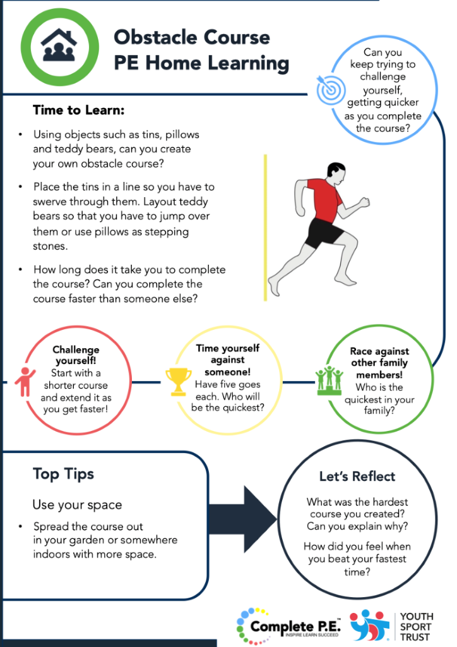

Day 2
Lesson 1  Phonics, Spelling or Guided Reading | Reading comprehension activity
Lesson 2  English | See above for this week’s Geography/English activity
Lesson 3
Maths
Lesson 4  RE | Follow this link to the Lego Bible version of the parable of Jesus healing a leper. Watch and listen carefully. Try to explain the story to another member of your family then write a short paragraph explaining what you think Jesus was trying to teach us in this parable.  Jesus Heals a Paralytic in LEGO - Bing video  You could even use lego to create your own scene from the story.

Day 3
Lesson 1  Phonics, Spelling or Guided Reading | Look again at this week’s spellings: choose six of the words that you find most tricky to spell and write a super sentence for each of them; make sure you include an interesting verb, an exciting adjective or an ambitious adverb as well as the spelling word. Check your sentence makes sense.
Lesson 2
Maths

Lesson 3  English | See Monday’s English – non-chronological report
Lesson 4  Computing | BBC Dance Mat Typing  Follow the link to this online program to practice your typing skills. If you make an account, you will be able to save your work and move up the levels.  https://www.bbc.co.uk/bitesize/topics/zf2f9j6/articles/z3c6tfr

Day 4
Lesson 1  Word Games, Spelling or  Guided Reading | Have fun writing lists; try to be imaginative and make your lists as interesting and unusual as possible. Include powerful vocabulary to bring your lists to life. Choose from these ideas or make up your own.  - 5 things you would find in the Queen’s handbag  - 5 things you would do if you were Prime Minister  - 5 ways to reach the top of a mountain  - 5 animals you would take onto the Ark and why  - 5 world landmarks you would like to visit and why  This is my list for number 3.  - Sprout golden wings and swoop up elegantly like a giant eagle  - Jump onto a passing t-rex and hold on tight  - Pilot a hot air balloon and float gently to the summit  - Attach a pair of wooden snow shoes and trudge with determination  - Borrow a pogo stick and hop crazily all the way up
Lesson 2  English | See Monday’s instructions – non-chronological report
Lesson 3  Maths | Log onto Times Table Rockstars and practise your times tables
Lesson 4  Art | Follow this link to the Tate Gallery site where you will find all sorts of interesting information about the artist, Vincent Van Gogh. Read about his life and works and then pick one of the various art activities to complete.  Create Art Like Van Gogh – Paint and Draw | Tate Kids

Day 5
Lesson 1  Spellings | 1)Ask an adult at home to test you on this week’s spelling words.
Lesson 2  Maths | Today’s number is 3150  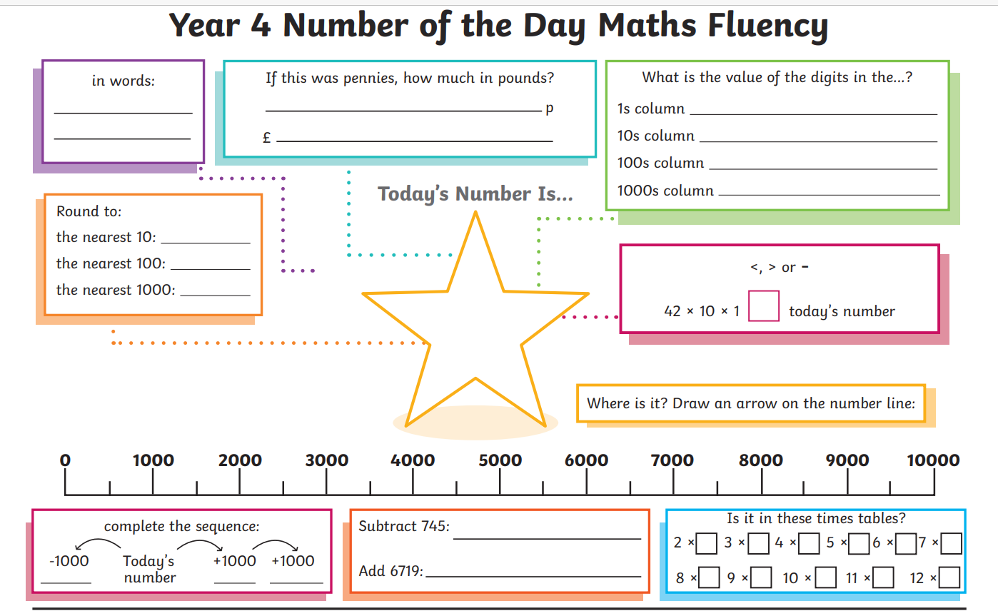
Lesson 3  English | See Monday’s instructions - Publish your non-chronological report
Lesson 4  Cooking | Apple Crumble with oaty topping  (serves 2-3)  2 large bramley apples  Optional - 1 tbsp sultanas or a sprinkling of sugar if the apples are very tart  1 tbsp water or apple juice  70g plain flour  50g butter  30g rolled oats  70g demerara sugar  Preheat the oven to 200 degrees/ Gas Mark 6  Peel the apples and cut into quarters then remove the core. Slice each quarter into three then place in a pan. (Add sultanas or a sprinkling of sugar to taste.)  Add a tbsp water or apple juice and cook over a medium heat for 5 mins until the apples start to soften.  Transfer the apples to a shallow oven-proof dish.  Cut the butter into small chunks then add to the flour and rub together until the mixture looks like breadcrumbs. (You can do this in a food processor, if you have one.)  Stir in the oats and demerara sugar.  Sprinkle the crumble topping over the apples. Bake for 30 mins or until crisp and golden brown on top.  This is delicious served with vanilla ice cream or custard.

