Autumn Home Learning – Cuddington and Dinton C of E Primary School
Week One Foundation – Daily Lesson Plans
Day 1
Lesson 1  Phonics, | Sing the alphabet song, what letters do you recognise the name of? Can you recognise the first letter of your name and the sound it makes? Can you recognise any of the phonemes we have been learning, e.g., s, a, t, p, i, n, c, k, e, h, r.
Lesson 2 Maths | 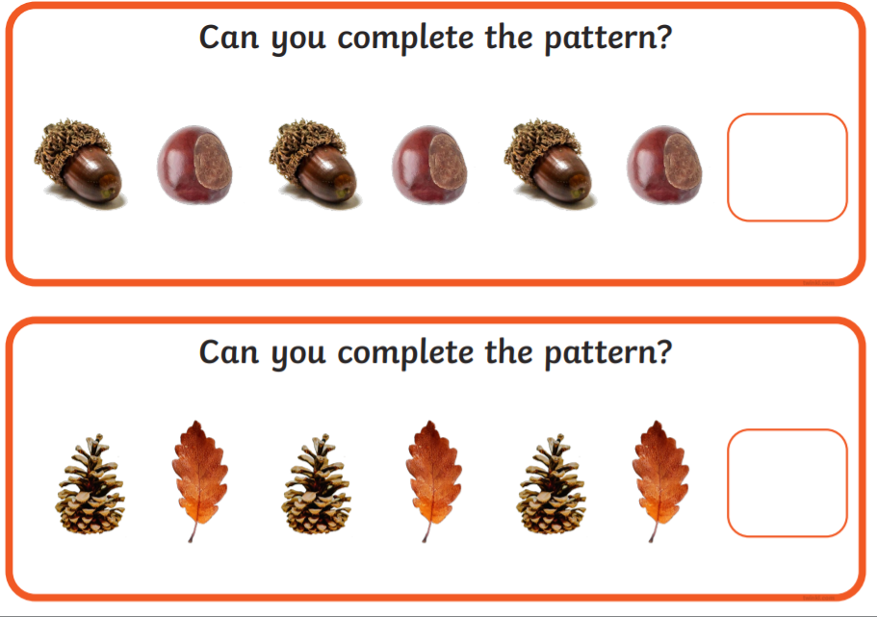
Lesson 3  Writing | Use a paint brush to paint with water on a fence, wall, or the ground. Practice your letter formation.
Lesson 4  PE | 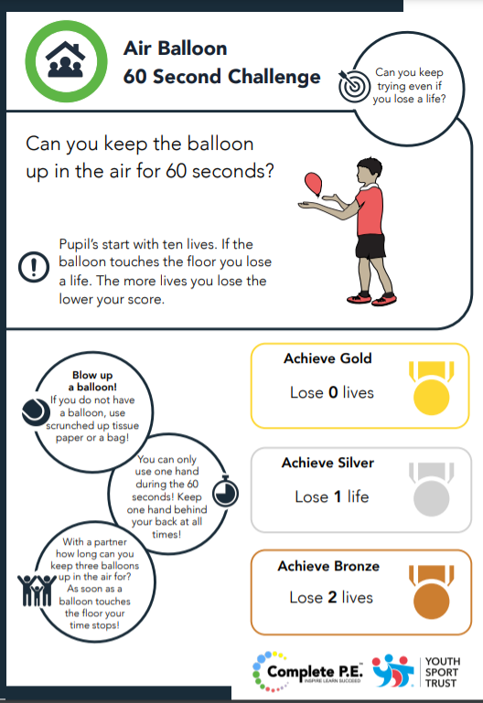

Day 2
Lesson 1  Phonics, | Have a go at writing the graphemes we have been learning. s, a, t, p, i, n, c, k, e, h, r. Play bingo with the phonemes. Choose 8 in total to play the game.
Lesson 2  Writing | Practice writing the curly caterpillar letters c, o, a, d, g, q, e, s, f.
Lesson 3  Maths | 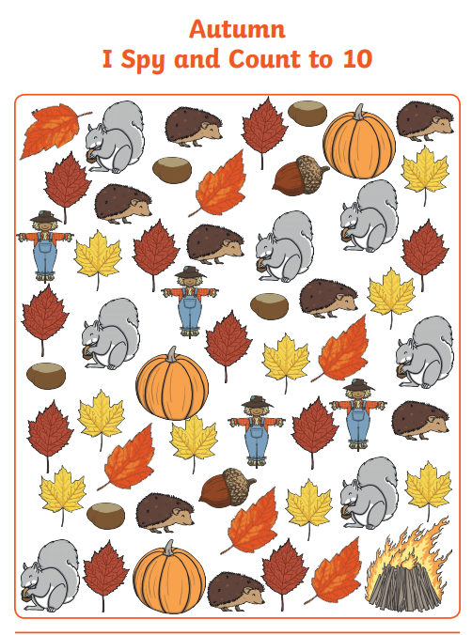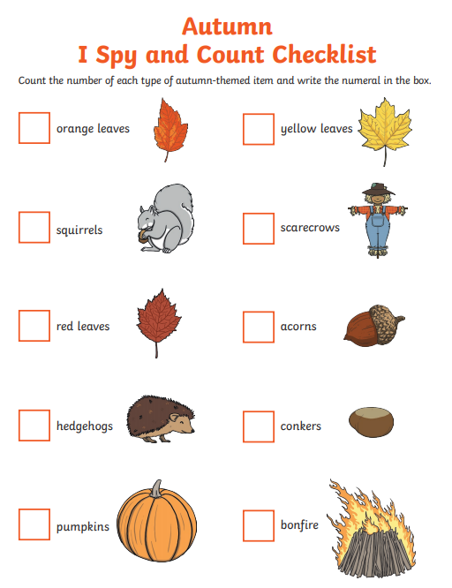
Lesson 4  Outdoor learning | 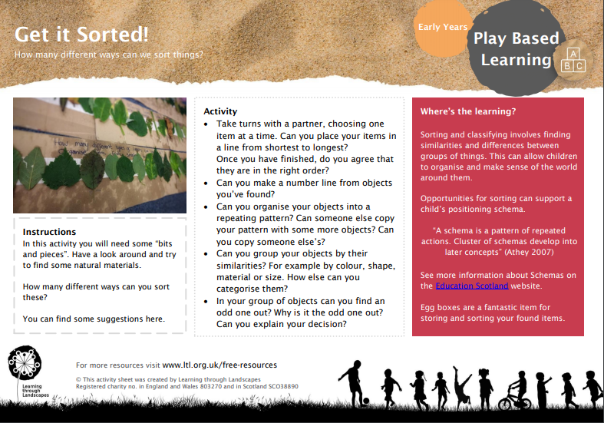

Day 3
Lesson 1  Phonics, | What words can you make with the phonemes s, a, t, p, i, n, c, k, e, h, r. E.g., at, it, sit, sat etc.
Lesson 2  Maths | 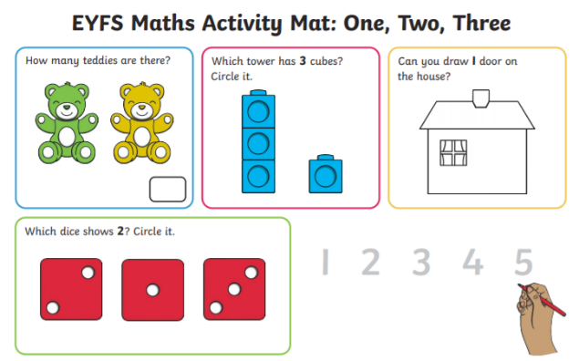
Lesson 3  Writing | Practice writing the long ladder letters l, i, t, u, j, y
Lesson 4  Reading | Read your favourite stories with an adult.

Day 4
Lesson 1  Phonics, | Re-cap all the phonemes we have been learning saying the sounds and try naming the letters. Hide the phonemes around the house and set a timer to find them
Lesson 2  Writing | Practice writing the one-armed robot letters r, b, n, h, m, k, p.
Lesson 3  Maths | 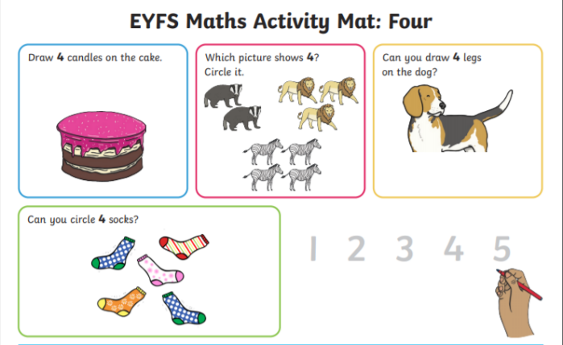
Lesson 4  Outdoor Learning | 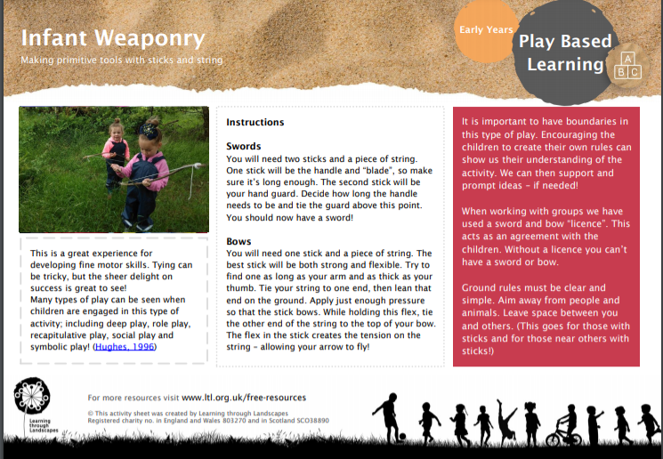
Day 5
Lesson 1  Phonics, | Have two sets of phonemes. Hide one set around the house and go on a treasure hunt to find them and match them to the second set.
Lesson 2  Maths | 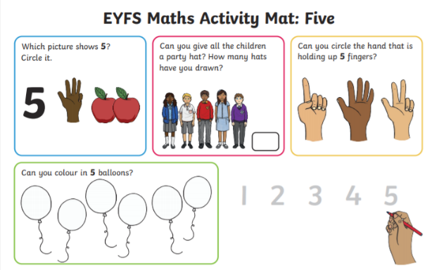
Lesson 3  Writing | Practice writing the zig-zag letters z, x, v, w, y, k
Lesson 4  PE | 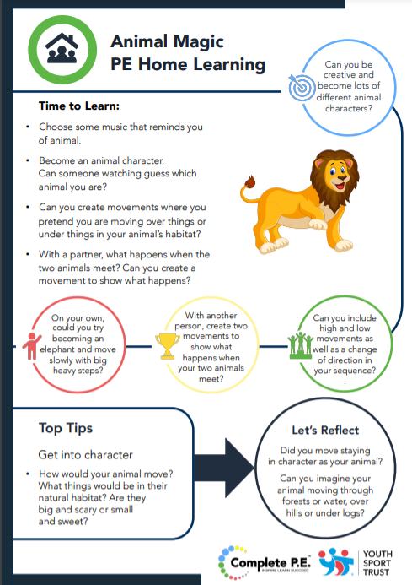

Autumn Home Learning – Cuddington and Dinton C of E Primary School
Week 2 Foundation – Daily Lesson Plans
Day 1
Lesson 1  Phonics, | Can you write a word with each phoneme we have been learning (s, a, t, p, i, n, c, k, e, h, r) at the beginning of your word, e.g., sit, pin, tap, etc.
Lesson 2 Maths | 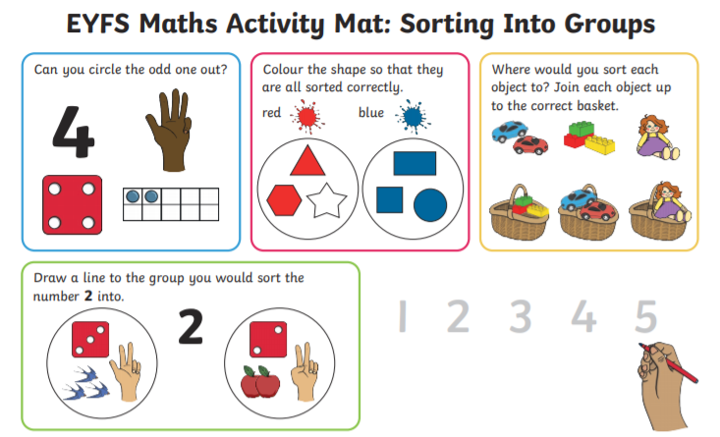
Lesson 3  Music | 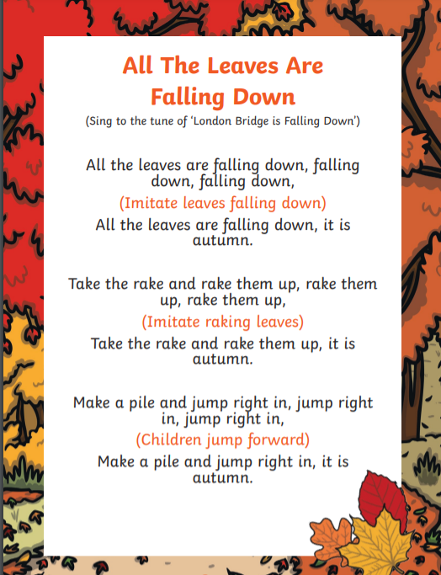Learn this song with the actions.
Lesson 4  PE | 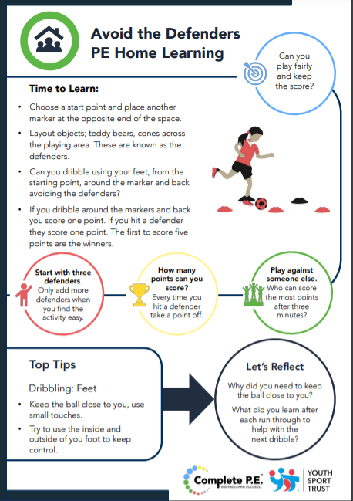

Day 2
Lesson 1  Phonics, | Can you write a word with each phoneme we have been learning (s, a, t, p, i, n, c, k, e, h, r) in the middle of your word, e.g., step, spin, snip etc.
Lesson 2  Writing | 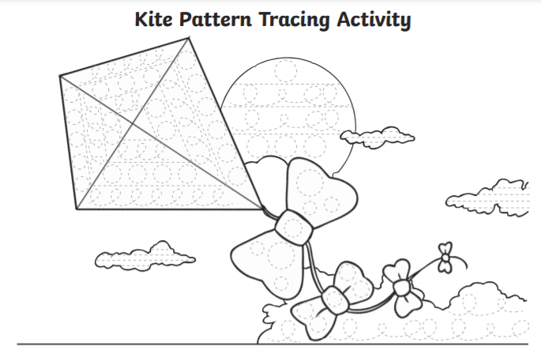
Lesson 3  Maths | 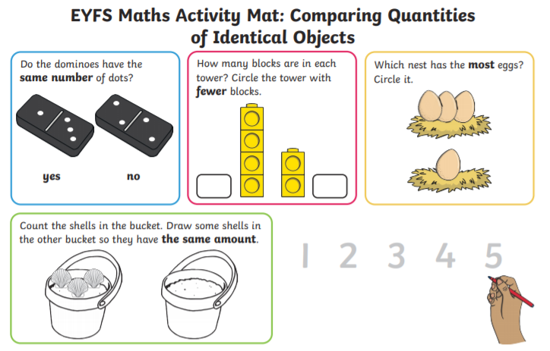
Lesson 4  Outdoor learning | 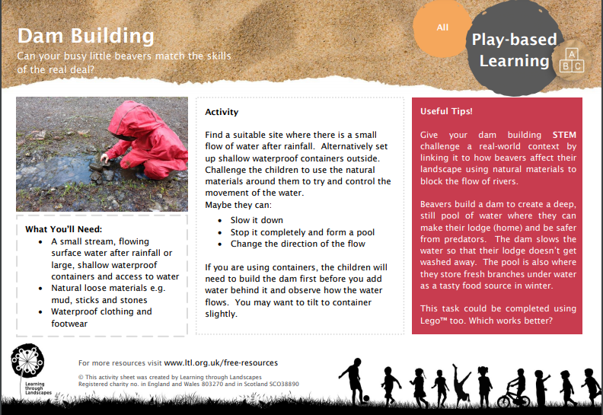

Day 3
Lesson 1  Phonics, | Can you write a word with each phoneme we have been learning (s, a, t, p, i, n, c, k, e, h, r) at the end of your word, e.g., his, pin, sink, sick etc.
Lesson 2
Maths

Lesson 3  Writing | 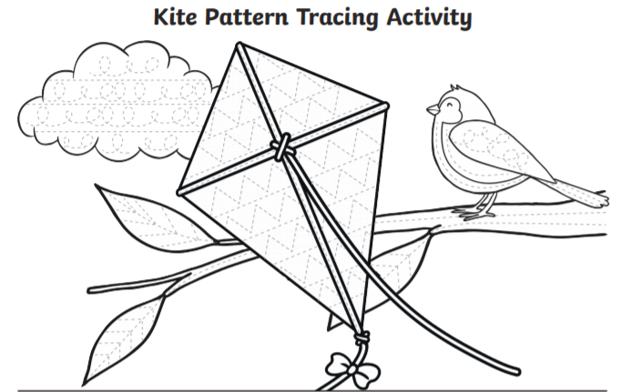
Lesson 4  Fine Motor | Can you build a bridge strong enough to carry a dinosaur? You can use lego, duplo, junk modelling or sticks.

Day 4
Lesson 1  Phonics, | Practice writing the letters in your name.
Lesson 2  Creating | Draw a picture of your favourite animal. What is its name?
Lesson 3  Maths | 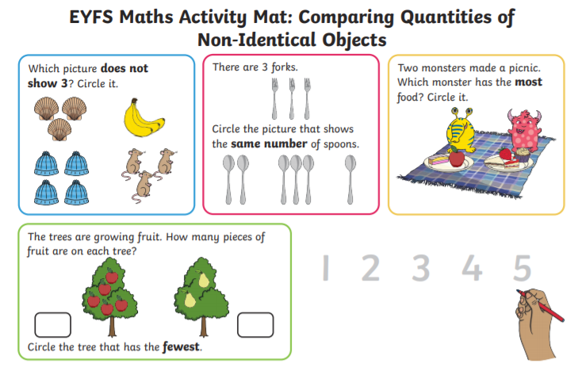
Lesson 4  Outdoor Learning | 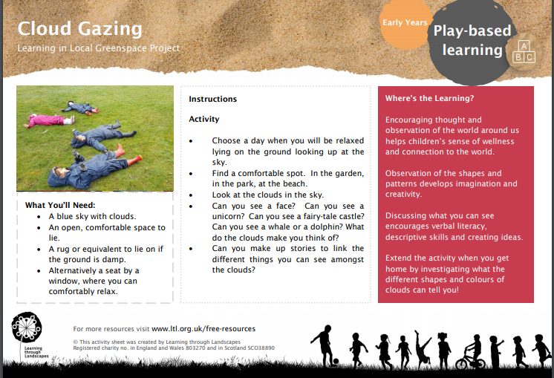

Day 5
Lesson 1  Phonics, | Play full circle. Write the each of the phoemes s,a,t,p,i,n on separte pieces of paper or post-it notes. Start by making the word sat. Then change one phoneme to make the word sit then sip, tip, tap, sap and finally coming back to sat which is full circle.
Lesson 2  Maths | 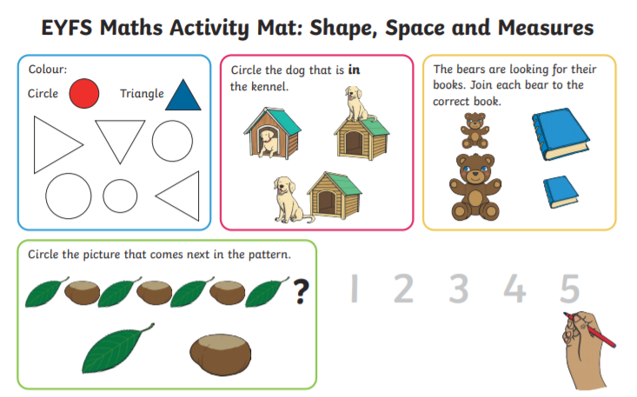
Lesson 3  Science | Can you make a potion? What ingredients did you use? Did it have a nice scent? What colour was it?
Lesson 4  PE | 