Cuddington and Dinton C of E School Curriculum Framework Year 3 and 4 Year A 2021-2022

 | Autumn  Fire and Ice  To begin this exciting year the children will be taken on a journey to the frozen north. We will investigate the physical geography of our world, including volcanoes and earthquakes and investigate climate change. We hope to visit The Science Oxford centre to take part in an exciting workshop to enrich the science and technology of our topic. In order to inspire a curiosity and fascination with the world, our key text will be The Last Bear by Hannah Gold – a story absorbing animal adventure, subtle commentary on climate change and the plight of endangered species, demonstrating that no one is too young or insignificant to make a difference. We will use the text to inspire creativity in English, Geography and Art. We will research famous arctic explorers and investigate their skills and knowledge needed to undertake such epic adventures. In Art, we will explore with a variety of different materials and techniques to create a volcano collage. |  | Spring  Anglo Saxons  The great Roman empire has withdrawn from Britain leaving her shores open for invasion. Would this be a mere bump in the road for her people – or a disastrous descent into chaos? It is here that the children will start their journey through the Anglo-Saxon invasion of Britain. Children will immerse themselves in what life was like in a British settlement, studying Anglo-Saxon art and culture and discover the great treasures of Sutton-Hoo.  Having learnt about the Anglo-Saxons the children will begin to find themselves in the age of the Vikings! Children will learn about the Viking and Anglo-Saxon struggle for the Kingdom of England to the time of Edward the Confessor. Our main text will focus on the great warrior Beowulf and his epic exploits including battling the monstrous creature Grendel. Children will find themselves writing character descriptions, newspaper reports and playscripts inspired by Beowulf.  Art and DT will be influenced by the Anglo-Saxons and Vikings. The children will be designing and building their own long boat and using a range of art media to create different collages and prints.  Let our journey through the age of the Anglo-Saxons and Vikings begin! |  | Summer  Across the seas  Using the stunning pictures in The Arrival, we will consider ‘big questions’ such as what drives people to leave their country of birth and travel across the world to set up home elsewhere. The children will use drama to imagine the thoughts and feelings of a refugee arriving in an unknown land and write poetry inspired by this learning. We will study explanation text writing and have the opportunity to write our own fictional narratives. In our topic work, we will consider the geographical similarities and differences between the UK and a Caribbean locality linking the learning to Windrush.
 | Autumn 1 | Autumn 2 | Spring 1 | Spring 2 | Summer 1 | Summer 2
Value + key questions linked to topic | Love | Integrity | Trust | Resilience | Belief | Respect
Hook |  |  | Architecture Longship workshop
Visit | Possible visit to Science Oxford |  |  |  | Residential
Topic Finale
History/  Geog | Geography - Volcanoes, earthquakes and climate change | History -  Famous explorers and climate activists | History -  Sutton Hoo  Influence of Anglo Saxons | History -  Sutton Hoo  Influence of Anglo Saxons | Geography –  Case study of non-European locality (Windrush) | Case study of non-European locality (Windrush)
Core text | The Last Bear  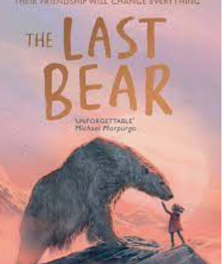  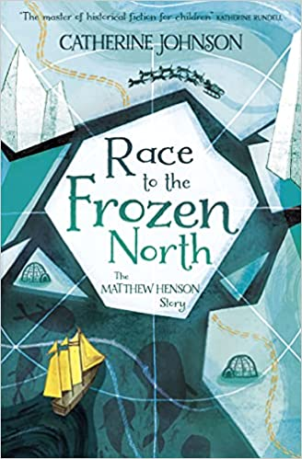 | The Last Bear  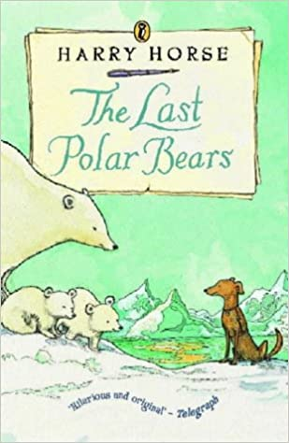  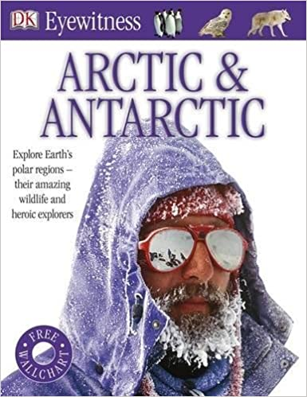 | Beowulf  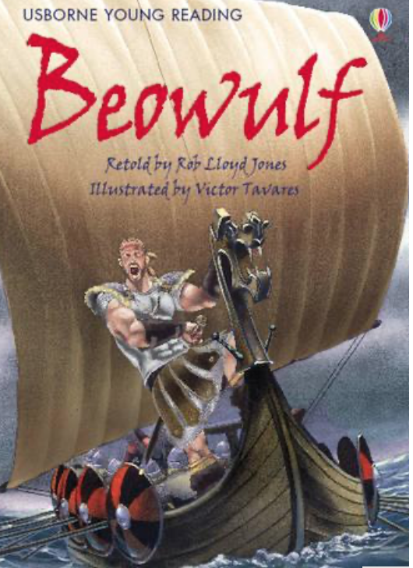  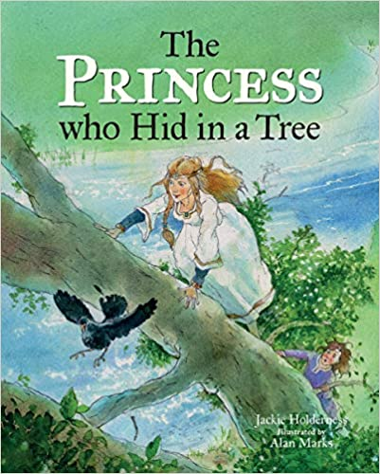 | Beowulf | The Arrival  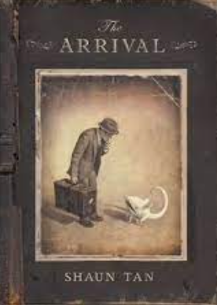  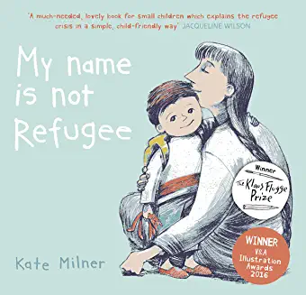  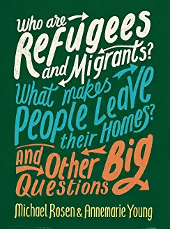  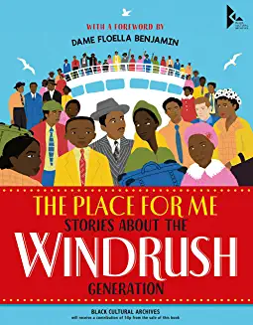 | The Arrival
English | - Setting Description  - Poetry (4th Oct)  - Non- Chron Report | - Diary Writing  - Letter to persuade (To join an expedition) | - Newspaper Report  - Character Description | - Recount  - Writing and performing – playscripts | - Narrative  - Instruction/  Explanation Text | - Persuasive  Advert  - Poetry
Maths  Year 3 | Number and Place Value  Addition and Subtraction | Addition and Subtraction  Multiplication and Division | Multiplication and Division  Money  Statistics | Measurement – Length and Perimeter  Fractions | Fractions  Time | Geometry  Capacity and Mass
Maths  Year 4 | Number and Place Value  Addition and Subtraction | Measurement – Length  Multiplication and Division | Multiplication and Division Measurement – Perimeter and Area | Fractions and Decimals | Decimals, Measurement – Money and Time  Statistics | Geometry, Properties of Shape and Position and Direction
Science  Year 3 | Rocks and Fossils  Identify, investigate and describe the three types of rocks and their properties; describe how fossils are formed and recognise that soils are made from rocks and organic matter. | Forces  Identify, describe and investigate the forces acting upon objects and compare how things move on different surfaces. Recognise the difference between contact and non-contact forces and observe how magnets attract and repel. | Light  Investigate and make predictions about reflection, explain why light from the sun can be dangerous and explain how shadows are formed  Link to English writing – persuasive advert for sun protection product | Plants  Identify and describe the functions of the parts of a flowering plant and explore the requirements for life and growth. Investigate how water is transported within plants and explore the part played by the flower in the life cycle of a plant including pollination, seed formation and seed dispersal. | Animals including humans  Understand that humans need nutritious food to survive and grow. Investigate and identify the role played by the skeleton, bones and muscles in our body. | RSE  Describe the differences between male and female animals and understand that making a new life needs a male and a female.
Science  Year 4 | Electricity  Links to DT We are electricians | States of Matter | Sound | Living Things and their Habitats | Animals including Humans | RSE
Computing  Year 3 | Creating, editing and saving a document in a folder  Using the internet as a research tool | Internet safety | Internet safety  Childnet | Keyboard skills | KODU – Algorithms and coding | Using the internet as a research tool
Computing Year 4 | Choosing an appropriate programme with support  Can I understand that work can be saved in different places? |  | Internet safety  Childnet | Using word and picture/word art to create a non-chronological report. | KODU – Algorithms and coding | Social Media safety
Art | Sketching | Collage Volcano  Christmas Fair craft |  | Painting | Photography (Clouds)
DT |  |  | We are architects  Architecture Longship workshop  Build a Longboat |  |  | We are cooks  Cooking
RE Year 3 | Is light a good symbol for celebration? (OD) | What is the trinity? (UC) | Is a Hindu child free to choose how they live? (OD) | Why do Christians call the day Jesus died, ‘Good Friday’? (UC) | What is it like to follow God? (UC) | What do Christians learn from the Creation story? (UC)  Link to Year 3 Art
RE Year 4 | Gospel: What kind of world did Jesus want? | What is the Trinity? - digging deeper | Is a holy journey necessary for believers? | Is a holy journey necessary for believers? Continued  People of God: What is it like to follow God? | People of God: What is it like to follow God? Continued  Do Murtis help Hindus understand God? | Do Murtis help Hindus understand God? continued
By the end of lower key stage 2, pupils should be taught to sing and play musically with increasing confidence and control. They should develop an understanding of musical composition and reproducing sounds from aural memory. Pupils should be taught to: Play and perform in solo and ensemble contexts, with increasing accuracy, fluency, control and expression. Improvise and compose music for a range of purposes using the inter-related dimensions of music. Listen with attention to detail and recall sounds with increasing aural memory. Use and understand staff and other musical notations. Develop an understanding and appreciation of a range of composers and the history of music.
Music Year 3 | Ten Pieces –  Igor Stravinsky - The Firebird — suite (1911) (Finale) | Tudor Music | Charanga - Dragon Song | Charanga - Glockenspiel 1 and 2 | Ten Pieces - John Adams Short Ride in a Fast Machine | Charanga - Three Little Birds
Music Year 4 | Mamma Mia - Charanga | Finlandia – Ten Pieces | Glockenspiel 2 - Charanga | In the Hall of the Mountain King – Ten Pieces | Mambo – Ten Pieces | Benjamin Brittain ‘Storm’  Interlude from Peter Grimes  - Ten Pieces
French  Year 3 | Introducing France  Simple greetings  Introducing yourself | J’apprends le francais | Phonetics | Je peux... | Les animaux | Cher Zoo  La chenille qui fait des trous
Count to 10, read and write these numbers; be familiar with days of the week; use simple greetings; ask and answer simple questions about name and age; understand and communicate some familiar nouns (animals, family, sports); use simple adjectives (colours, size); use some simple verbs in the first person (Je suis/ J’ai/ Je peux; begin to understand the sounds of individual letters and groups of letters and speak them aloud.
French  Year 4 | Je me presente | Weather | Quelle est la date aujourd’hui? | Les vetements | Le corps | En famille
By the end of year 4: Understand numbers to 100 in multiples of 10; write today’s date and the date of your birthday; understand and say the days of the week and months of the year; use a wider range of questions and answers in the classroom (ask for help, ask the time); use a wider range of familiar nouns (weather, animals, sports, hobbies) including the correct article; use adjectives to describe people and places; Use verbs in the first person (Je joue, J’aime, Je prefere, Je fais); write longer phrases and short sentences using a verb in the first person.
PE  Year 3 | Tag Rugby  Swimming | Swimming  Gym | Basketball  Dance | OAA – Problem solving  Tennis | Striking and Fielding (cricket)  Athletics - Throwing  Swimming | Athletics  Rounders
PE  Year 4 | Tag Rugby  Dance | Invasion Games - Football  Gym | Basketball  Dance | Handball  OAA - Communication | Striking and fielding – Cricket  Tennis | Athletics  Rounders
PSHE  Year 3 | Recognising emotions  My special pet  Friends are special  Looking after special people  Finding a solution to a problem  Helping people who feel different | Recognising emotions  What is integrity?  Celebrating difference  Family and Friends  To be welcoming | None of your business!  Raisin challenge  Emotional literacy | I am fantastic!  Top talents  Growth mindset  Looking after my brain  How can difference effect someone?  Valuing difference | Growth mindset  Keeping myself safe  Recognising risks | Being my best  Growing and Changing  My changing body  Healthy Eating
PSHE  Year 4 | Me and my relationships  OK or not OK  When feelings change  Under pressure  Taking responsibility for our actions Recognising other’s feelings.  Dealing with conflict | Valuing Difference Islands  Friend or Acquaintance?  That is such a stereotype!  Stonewall resources: Issues with using the word ‘gay’  Why do people get married? - King and King  Valuing difference Listening to views of others | Keeping myself safe Raisin challenge 2  Overcoming language barriers - The way back home  Cyber safety Recognising unwanted influence and pressure  Saying NO | Rights and responsibilities  Who helps us keep healthy and safe?  To know when to be assertive- Dogs don’t do ballet  Recognising that actions have consequences | Being my best  What makes me!  To be who you want to be – Red, a Crayons Story  Growth mindset Thinking, Feeling, Doing | Growing and Changing  My feelings are all over the place!  All change!  Period positive  Secret or surprise Together  To ask questions- The Flower  Human life cycle Puberty Reproduction Body Parts

