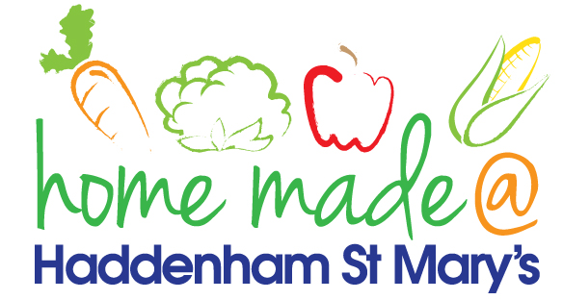

MENU – week commencing 20th September 2021
 | Meat Free Monday | Tuesday  Choose Day | Wednesday  Wonderful Roast | Thursday  Julie’s Jackets | Friday  Fish Friday
Lunch | Vegetable chilli, rice and nachos | Meatballs and spaghetti | Roast turkey with all the trimmings and gravy | Jacket potato with a choice of toppings | Fish cake, potato rosti and vegetables
Vegetarian option | Vegetable chilli, rice and nachos | Veggie meatballs and spaghetti | Quorn roast with all the trimmings | Jacket potato with a choice of toppings | Vegetable fingers, potato rosti and vegetables
Dessert | Mandarin segments | Sponge and custard | Flapjack | Fruit | Cake
Free From  option | Vegetable chilli, rice and nachos  Mandarin segments | Meatballs and spaghetti  Custard | Roast turkey with all trimmings and gravy  Biscuit | Jacket potato with a choice of toppings  Fruit | Fish fingers, potato rosti and vegetables  Biscuit
All meals will contain or be served with at least one portion of vegetables.
All hot puddings will be accompanied by custard or cream.
All roast dinners, sausage & mash and pie dishes will have the option of extra gravy.
All children will also be offered bread, a piece of fruit and a drink of milk or water with their main meal.

