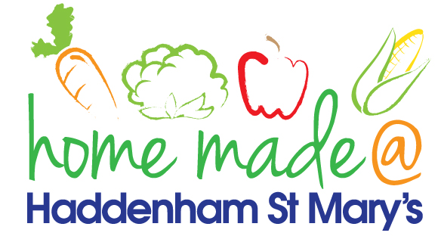

MENU – week commencing 18th October 2021
 | Meat Free Monday | Tuesday  Choose Day | Wednesday  Wonderful Roast | Thursday  Julie’s Jackets | Friday  Fish Friday
Lunch | Vegan sausage roll, hash brown and vegetables | Meatballs and spaghetti | Roast turkey with all the trimmings and gravy | Jacket potato with a choice of toppings
Vegetarian option | Vegan sausage roll, hash brown and vegetables | Veggie meatballs and spaghetti | Quorn roast with all the trimmings | Jacket potato with a choice of toppings
Dessert | Mandarin segments | Sponge and custard | Muffin | Fruit
Free From  option | Vegan sausage roll, hash brown and vegetables  Mandarin segments | Meatballs and spaghetti  Custard | Roast turkey with all trimmings and gravy  Biscuit | Jacket potato with a choice of toppings  Fruit
All meals will contain or be served with at least one portion of vegetables.
All hot puddings will be accompanied by custard or cream.
All roast dinners, sausage & mash and pie dishes will have the option of extra gravy.
All children will also be offered bread, a piece of fruit and a drink of milk or water with their main meal.

