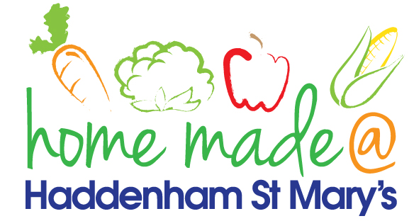

MENU – week commencing 2nd September 2021
 | Meat Free Monday | Tuesday  Choose Day | Wednesday  Wonderful Roast | Thursday  Julie’s Jackets | Friday  Fish Friday
Lunch |  |  |  | Jacket potato with a choice of toppings | Breaded plaice goujons, chips and vegetables
Vegetarian option |  |  |  | Jacket potato with a choice of toppings | Vegetable fingers, chips and vegetables
Dessert |  |  |  | Fruit | Muffin
Free From  option |  |  |  | Jacket potato with a choice of toppings  Fruit | Fish fingers, chips and vegetables  Biscuit
All meals will contain or be served with at least one portion of vegetables.
All hot puddings will be accompanied by custard or cream.
All roast dinners, sausage & mash and pie dishes will have the option of extra gravy.
All children will also be offered bread, a piece of fruit and a drink of milk or water with their main meal.

