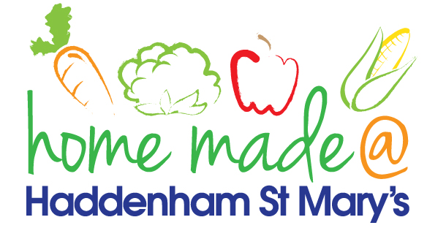

MENU – week commencing 19th July 2021
 | Meat Free Monday | Tuesday  Choose Day | Wednesday  Wonderful Roast | Thursday  Julie’s Jackets | Friday  Fish Friday
Lunch | Vegan sausage roll, potato rosti and beans | Chicken goujons, potato wedges and salad
Vegetarian option | Vegan sausage roll, potato rosti and beans | Veggie fingers, potato wedges and salad
Dessert | Fruit | Ice lolly/ice cream
Free From  option | Vegetable patty, potatoes and beans  Fruit | Chicken, potato wedges and salad  Ice lolly
All meals will contain or be served with at least one portion of vegetables.
All hot puddings will be accompanied by custard or cream.
All roast dinners, sausage & mash and pie dishes will have the option of extra gravy.
All children will also be offered bread, a piece of fruit and a drink of milk or water with their main meal.

