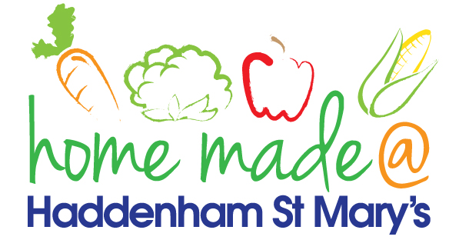

MENU – week commencing 14th June 2021
 | Meat Free Monday | Tuesday  Choose Day | Wednesday  Wonderful Roast | Thursday  Julie’s Jackets | Friday  Fish Friday
Lunch | Spring roll, rice and vegetables | Breaded chicken, potato croquettes and vegetables | Turkey roast with all the trimmings | Jacket potato with a choice of toppings | Fish cake, potato rosti and vegetables
Vegetarian option | Spring roll, rice and vegetables | Quorn fillet, potato croquettes and vegetables | Veggie sausage roast with all the trimmings | Jacket potato with a choice of toppings | Vegetable fingers, potato rosti and vegetables
Dessert | Mandarin segments | Mousse | Blueberry muffin | Fruit | Homemade biscuit
Free From  option | Falafels and rice  Mandarin segments | Chicken, potato wedges and vegetables  Custard | Turkey roast with all the trimmings  Biscuit | Jacket potato with a choice of toppings  Fruit | Fish fingers, potato rosti and vegetables  Biscuit
All meals will contain or be served with at least one portion of vegetables.
All hot puddings will be accompanied by custard or cream.
All roast dinners, sausage & mash and pie dishes will have the option of extra gravy.
All children will also be offered bread, a piece of fruit and a drink of milk or water with their main meal.

