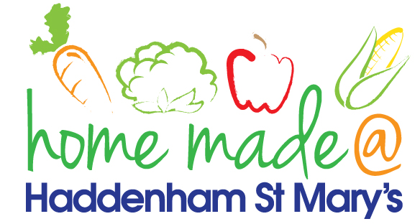

MENU – week commencing 7th June 2021
 | Meat Free Monday | Tuesday  Choose Day | Wednesday  Wonderful Roast | Thursday  Julie’s Jackets | Friday  Fish Friday
Lunch | Mixed bean chilli, rice and nachos | Hotdogs, potato wedges and salad | Roast beef with all the trimmings | Jacket potato with a choice of toppings | Fishburger, chips and vegetables
Vegetarian option | Mixed bean chilli, rice and nachos | Veggie hotdogs, potato wedges and salad | Quorn roast with all the trimmings | Jacket potato with a choice of toppings | Vegetable fingers, chips and vegetables
Dessert | Tinned peaches | Yoghurt | Carrot cake | Fruit | Chocolate muffin
Free From  option | Mixed bean chilli and rice  Tinned peaches | Sausages, potato wedges and salad  Vanilla pudding | Roast beef with all the trimmings  Biscuit | Jacket potato with a choice of toppings  Fruit | Fish fingers, chips and vegetables  Biscuit
All meals will contain or be served with at least one portion of vegetables.
All hot puddings will be accompanied by custard or cream.
All roast dinners, sausage & mash and pie dishes will have the option of extra gravy.
All children will also be offered bread, a piece of fruit and a drink of milk or water with their main meal.

