DISHES AND THEIR ALLERGEN CONTENT – Homemade@Haddenham St Mary’sMAIN DISHES – Summer 2 2021
All free from menu options are free from gluten and dairy products – for further information please email homemade@haddenham-st-marys.bucks.sch.uk
All plant based dishes are free from meat, egg and dairy products
DISHES | 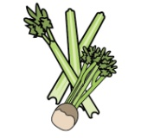 | 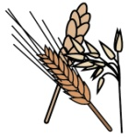 | 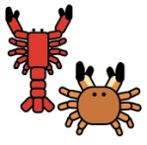 |  | 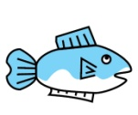 | 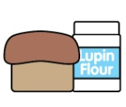 |  |  | 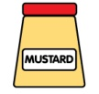 | 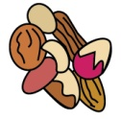 | 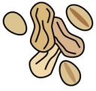 | 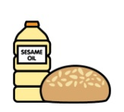
 | Celery | Cereals containing gluten | Crustaceans | Eggs | Fish | Lupin | Milk | Mollusc | Mustard | Nuts | Peanuts | Sesame seeds | Soya | Sulphur Dioxide
‘Free from’ fish fingers, new potatoes/chips/  wedges and vegetables |  |  |  |  | ✓
Breaded chicken, potato croquettes and vegetables |  | ✓ |  | ✓ |  |  | ✓
Breaded fish, chips and vegetables |  | ✓ |  | ✓ | ✓ |  | ✓
Chicken goujons, potato rosti/wedges and vegetables/salad |  | ✓ |  | ✓ |  |  | ✓
Fish burger, chips and vegetables |  | ✓ |  | ✓ | ✓ |  | ✓
Fish cake, potato rosti and veg |  | ✓ |  | ✓ | ✓ |  | ✓
Hotdogs, potato wedges and salad |  | ✓ |  | ✓ |  |  | ✓ |  |  |  |  |  |  | ✓
Jacket potato with a choice of fillings |  |  |  |  | ✓ |  | ✓
Jumbo fish fingers, potato lattice and vegetables |  | ✓ |  | ✓ | ✓ |  | ✓
Macaroni cheese |  | ✓ |  | ✓ |  |  | ✓
Mixed bean chilli, rice and nachos |  | ✓ |  | ✓ |  |  | ✓
Pizza, potato wedges and vegetables |  | ✓ |  | ✓ |  |  | ✓
Quorn fillet, potato croquettes and vegetables |  | ✓ |  | ✓ |  |  | ✓ |  |  |  |  |  | ✓
Quorn roast with all the trimmings |  | ✓ |  | ✓ |  |  | ✓ |  |  |  |  |  | ✓
Roast beef with all the trimmings |  | ✓ |  | ✓ |  |  | ✓
Sausage, chips and vegetables |  | ✓ |  | ✓ |  |  | ✓ |  |  |  |  |  |  | ✓
Spaghetti Bolognese |  | ✓ |  | ✓ |  |  | ✓
Spring roll, rice and vegetables |  | ✓ |  | ✓ |  |  | ✓
Turkey roast with all the trimmings |  | ✓ |  | ✓ |  |  | ✓
Vegan sausage roll, potato rosti and baked beans |  | ✓ |  |  |  |  | ✓ |  |  |  |  |  | ✓
Vegetable fingers, new potatoes/chips/ croquettes/rosti and vegetables |  | ✓ |  | ✓ |  |  | ✓
Vegetable slice, potato lattice/chips and vegetables |  | ✓ |  | ✓ |  |  | ✓
Veggie Bolognese |  | ✓ |  | ✓ |  |  | ✓ |  |  |  |  |  | ✓
Veggie hotdogs, potato wedges and salad |  | ✓ |  | ✓ |  |  | ✓ |  |  |  |  |  | ✓
Veggie sausage, chips and peas |  | ✓ |  | ✓ |  |  | ✓ |  |  |  |  |  | ✓
Veggie sausage roast dinner |  | ✓ |  | ✓ |  |  | ✓ |  |  |  |  |  | ✓

Review date: 05/05/2021 |  | Reviewed by: | J Higgins | 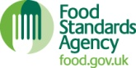 | You can find this template, including more information at www.food.gov.uk/allergy

