Home Learning – Cuddington and Dinton C of E Primary School
Year 2 – Daily Lesson Plans Week 2
Day 1
Lesson 1  Phonics, Spelling or Guided Reading | Phonics  Flash card practice - https://www.youtube.com/watch?v=te8ExL0RkcY or ‘Flash card speed trial’ on Phonics Play. https://www.phonicsplay.co.uk/resources/phase/2/flashcards-speed-trials  - Can you find all the different /oa/ sounds in the text below? How many different graphemes make the /oa/ sound? Make a list of the graphemes.  oa (boat), ow (snow), o_e (rose), o (radio), oe (toe), ough (though)  Spelling  Please practise your weekly spellings.  Guided Reading  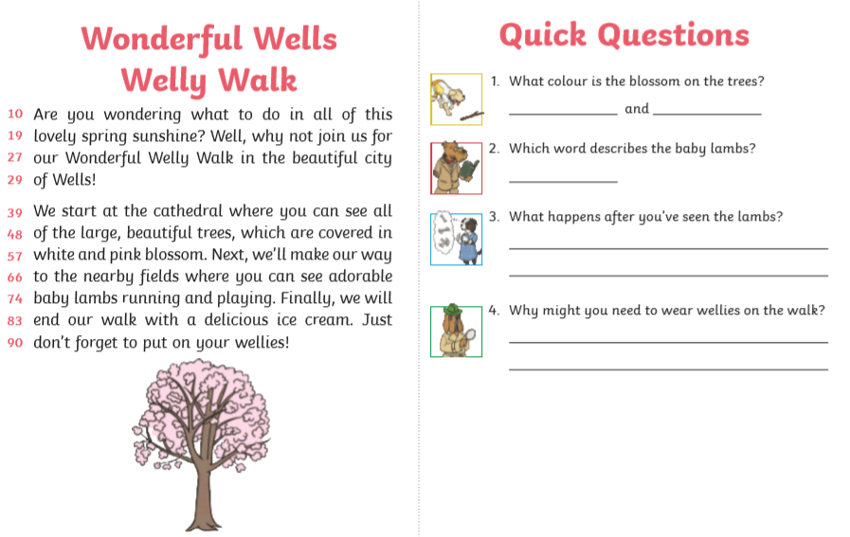
Lesson 2 Maths | Please find two MyMaths activities for you to complete.
Lesson 3  English | LO: Can I write a coherent sentence?  Look at the picture below and discuss.  What is it that is so strange about the ship?  Who do you think the crew are?  How old do you think the ship is?  What do you think the number 13 on the flag means?  What do you think the bell is used for?  Is there anything else strange that you notice about the picture?  Task 1:  Think about what the captain of the ship looks like.  Can you draw or describe what you have imagined? Is he a good guy? Is he evil? What does he wear? What things does he do?  Task 2:  Can you make the sentences below even better? Think of including exciting language, conjunctions, more information, exciting sentence starters.  The ship went through the water.  Fog and mist were all around her sails.  The crew looked out.
Lesson 4
PE

Day 2
Lesson 1  Phonics, Spelling or Guided Reading | Phonics  Please play the game on the link below, linking to consonant suffixes.  https://www.spellingplay.co.uk/planning-and-resources/year-2/more-suffixes/connies-consonant-suffixes  Spellings  Please practise your weekly spellings.  Guided reading  Please read the text below and answer the questions.
Lesson 2  English | LO: Can I write a coherent sentence?  Using the picture that you looked at yesterday we will use it to inspire a story or a part of a story.  I have started the story so you can continue it.  Shrouded in a veil of sea mist, the ghostly galleon swept through the black ocean waves. One minute you saw her, the next you didn’t. She was like no other ship. Blink, and you missed her.
Lesson 3  Maths | Please complete the maths activity mat below. It will cover lots of different areas which we have covered some far this year.  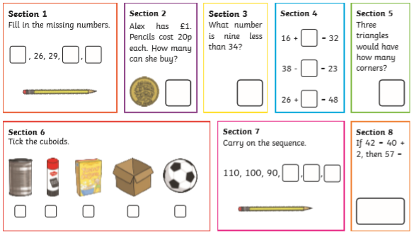
Lesson 4
Outdoor learning

Day 3
Lesson 1  Phonics, Spelling or Guided Reading | Phonics  Please play the game on the link below, linking to consonant suffixes.  https://www.spellingplay.co.uk/planning-and-resources/year-2/more-suffixes/connies-consonant-suffixes  Spellings  Please practise your weekly spellings.  Guided Reading  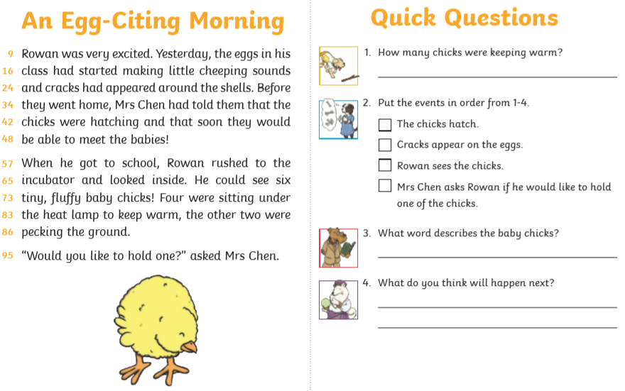
Lesson 2  Maths | Please complete the maths activity mat below. It will cover lots of different areas which we have covered some far this year.  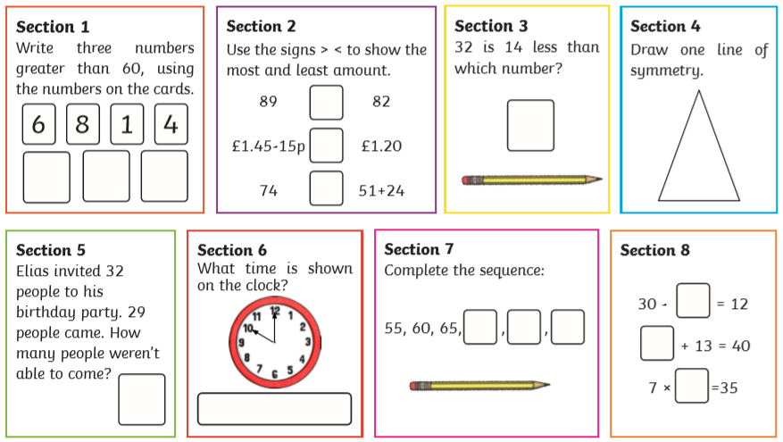
Lesson 3  English | LO: Can I write a coherent sentence?  Please continue with the story writing that you started yesterday. Make sure you read your work through to ensure it makes sense.
Lesson 4  Computing | We are going to use an online program to practise typing with two hands. The more we practise, the easier typing will become for us.  Please start with Level 1.  BBC Dance Mat Typing:  https://www.bbc.co.uk/bitesize/topics/zf2f9j6/articles/z3c6tfr  You may find it tricky but keep trying and, with practise, it will become easier for you. This is a skill that you will be able to use throughout your life.

Day 4
Lesson 1  Phonics, Spelling or  Guided Reading | Phonics and spelling  For phonics today, please practise spelling numbers. You can use the link below to help.  https://www.spellingplay.co.uk/planning-and-resources/year-2/homophones/spelling-numbers  Challenge: Can you include a word from your weekly spelling list and a number written as a word within a sentence?  Guided Reading  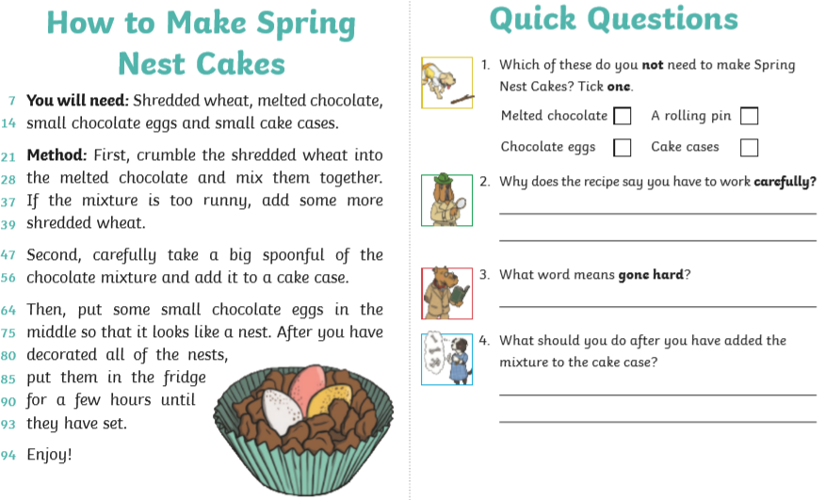
Lesson 2  English | LO: Can I write descriptive language?  What had happened when Brian fed the biscuits to his dogs?  How quickly did they grow to this size do you think?  Did Brian give the biscuits to anything/anyone else?  Have the creatures stopped growing?  How will Brian keep them as pets?  What are the benefits/problems with having such enormous pets?  Is there a way for Brian to restore his animals to their original size?  Task: Imagine Brian gave the biscuits to a different animal. Can you draw what they would look like before and after? Once you have drawn your animal can you add some descriptive language around it. This could be expanded noun phrases, key words, similes, adverbs and verbs etc..
Lesson 3  Maths | Please complete the maths activity mat below. It will cover lots of different areas which we have covered some far this year.  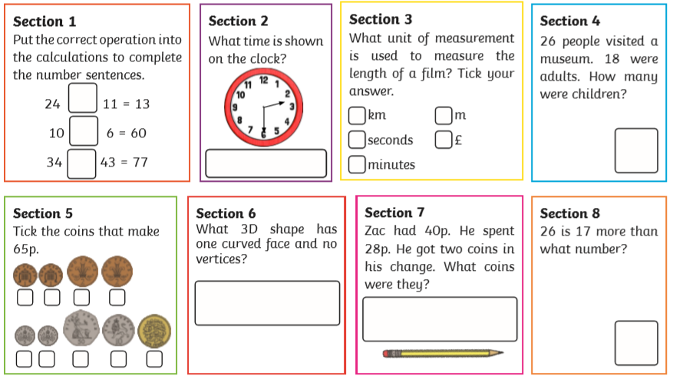
Lesson 4  Art/DT | LO: Can I use a range of different materials to make a product?  Today, you will need your setting backdrops that you painted last week.  Task: Please create your puppets today. You have a variety of choices, which can be found below. You can even make puppets that move.  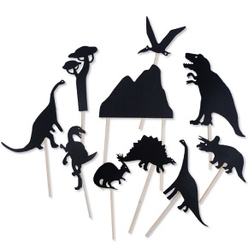  Shadow puppets Finger puppets  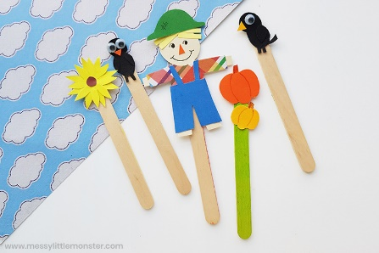  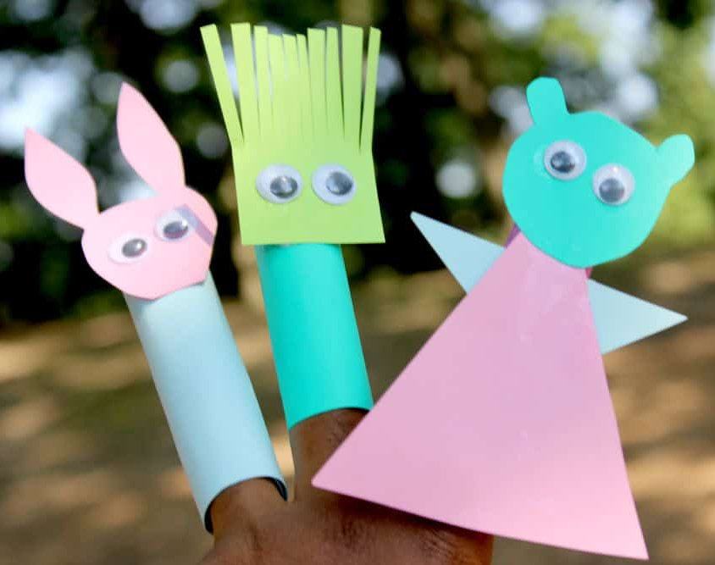  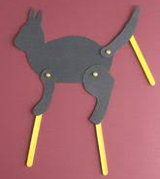  Once you have made your puppets, you can retell your favourite story.
Day 5
Lesson 1  Phonics, Spelling or Guided Reading | Phonics  Please play the game on the link below, linking to consonant suffixes.  https://www.spellingplay.co.uk/planning-and-resources/year-2/more-suffixes/connies-consonant-suffixes  Spellings  Please complete your spelling test.  Guided Reading  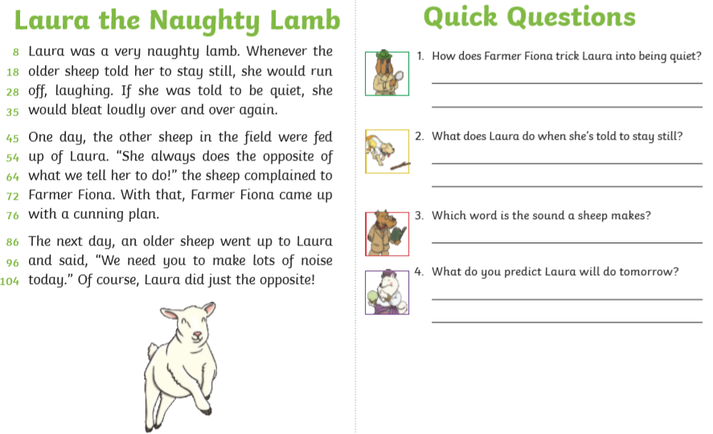
Lesson 2  Maths | For your maths learning today, please complete the MyMaths tasks set.  You can also spend some time on Numbots.  Your username and passwords will be in your Learning Logs.
Lesson 3  English | LO: Can I plan an adventure story?  Pretend you are one of the animals or Brian and create a story map about an adventure that you go on. You need to think about the different sections/parts of your story. Do not forgot to add key words.
Lesson 4
PE

