Home Learning – Cuddington and Dinton C of E Primary School
Year 1 – Daily Lesson Plans
Day 1
Lesson 1  Phonics, Spelling or Guided Reading | - Flash card practice - https://www.youtube.com/watch?v=te8ExL0RkcY or ‘Flash card speed trial’ on Phonics Play. https://www.phonicsplay.co.uk/resources/phase/2/flashcards-speed-trials  - Can you find all the different /or/ sounds in the text below? How many different graphemes make the /or/ sound?  or (fork), aw (lawn), au (August), al (talk), our (four), ore (ignore), oor (floor)
Lesson 2 Maths | Please find two MyMaths activities for you to complete.
Lesson 3  English | LO: Can I write a coherent sentence?  Look at the picture below and discuss.  What does the expression ‘if looks could kill’ mean?  What do you think the bird is angry about?  What kind of bird is it?  Do birds have feelings like humans?  What do you think the bird is looking at?  What different colours can you see on the bird?  Task 1:  After discussing the picture draw a picture of what you think the bird is looking at. What has made him so angry.  Task 2:  Can you make the sentences below even better? Think of including exciting language, conjunctions, more information, exciting sentence starters.  The black bird stared.  It had black feathers and black legs.  It had a black beak.  It was bad.
Lesson 4
PE

Day 2
Lesson 1  Phonics, Spelling or Guided Reading | Guided reading: Please read the text below and answer the questions.
Lesson 2  English | LO: Can I use adjectives?  Task 1: Can you make a list of as many words you can think of that describe the colour black in more detail? Here are a few of mine…  jet inky pitch midnight dark soot coal obsidian funereal gloomy sorrowful  Task 2:  Can you use these alternative words for black to describe the bird? Write several sentences using your new words.
Lesson 3  Maths | Please complete the maths activity mat below. It will cover lots of different areas which we have covered some far this year.
Lesson 4
Outdoor learning

Day 3
Lesson 1  Phonics, Spelling or Guided Reading | Use the class spellings list to make sentences that incorporate one or two of the spellings.
Lesson 2  Maths | Please complete the maths activity mat below. It will cover lots of different areas which we have covered some far this year.
Lesson 3  English | LO: Can I write a coherent sentence?  Look at the picture below and discuss.  Where do you think Zoya got the dragon egg?  How did she get it to hatch? Why has Zoya left home?  Did she tell anyone about the dragon?  What do you think she is planning to do with the dragon?  Where is she taking it?  Are there other dragons like it?  How will she feed it?  What is causing the shadow in the snow behind her?  Task 1:  Can you make the sentences below even better? Think of including exciting language, conjunctions, more information, exciting sentence starters.  Zoya held the dragon in her hands.  It had scales and wings.  It had a beak and horns.  She felt excited.
Lesson 4  Computing | We are going to use an online program to practise typing with two hands. The more we practise, the easier typing will become for us.  Please start with Level 1.  BBC Dance Mat Typing:  https://www.bbc.co.uk/bitesize/topics/zf2f9j6/articles/z3c6tfr  You may find it tricky but keep trying and, with practise, it will become easier for you. This is a skill that you will be able to use throughout your life.

Day 4
Lesson 1  Phonics, Spelling or  Guided Reading | - Flash card practice - https://www.youtube.com/watch?v=te8ExL0RkcY or ‘Flash card speed trial’ on Phonics Play. https://www.phonicsplay.co.uk/resources/phase/2/flashcards-speed-trials  - Can you find all the different /igh/ sounds in the text below? How many different graphemes make the /igh/ sound?  igh (light), y (sky) i_e (fine), I (hi), ie (pie)
Lesson 2  English | LO: Can I write a coherent sentence?  Using the picture that you looked at yesterday we will use it to inspire a story or a part of a story.  I have started the story so you can continue it.  When the dragon had hatched, crawling out of its shell onto her bed, Zoya knew that her life would never be the same again.
Lesson 3  Maths | Please complete the maths activity mat below. It will cover lots of different areas which we have covered some far this year.
Lesson 4  Art | LO: Can I consider tints and shades when painting an image?  For your Art lessons for the next two weeks, you are going to think about one of your favourite stories. Over the two lessons, you will create backdrops and shadow puppets to use to recreate your story.  Task: Create either one main backdrop or a range of backdrops for your story. You can use a picture from your story to help you or you can create a new setting design.  Please draw your setting using pencil first. Then, I would like you to use paint to add your colour and detail. Think about how we have used paint in school and how we can change the pure colour by adding white to make tints and by adding black to make shades.  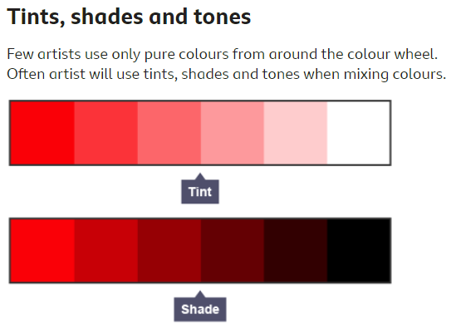  Please take your time on this. It should be clear what your setting is, and it must include detail. Please then keep your setting(s) safe, ready for next week.

Day 5
Lesson 1  Phonics, Spelling or Guided Reading | Spelling test
Lesson 2  Maths | For your maths learning today, please complete the MyMaths tasks set. If you would like to, you could also practise a task from the set of maths fluency resources.  You can also spend some time on Numbots.  Your username and passwords will be in your Learning Logs.
Lesson 3  English | LO: Can I use exciting language?  Zoya had found her own dragons and helped to hatch them.  Imagine you have found an egg and it has just hatched!  What does your dragon look like?  What environment does it like to live in?  What does it eat?  Can it do anything magical?  Task:  Draw your dragon and write some descriptive sentences. Do not forget to include:  * adjectives  * similies  * exciting sentence starters  * adverbs  * range of punctuation
Lesson 4
PE

