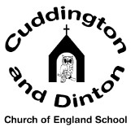 | Date: set 26th March for test 23rd April Year 6 Spellings: statutory spelling words
foreign
apparent
appreciate
persuade
individual
language
sufficient
determined
explanation
pronunciation
government
controversy

