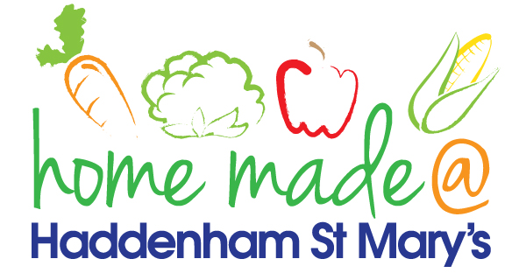

MENU – week commencing 24th May 2021
 | Meat Free Monday | Tuesday  Choose Day | Wednesday  Wonderful Roast | Thursday  Julie’s Jackets | Friday  Fish Friday
Lunch | Spring roll, rice and vegetables | Beef burger, chips and coleslaw | Turkey roast with all the trimmings | Jacket potato with a choice of toppings
Vegetarian option | Spring roll, rice and vegetables | Veggie burger, chips and coleslaw | Veggie sausage roast with all the trimmings | Jacket potato with a choice of toppings
Dessert | Mandarin segments | Mousse | Fresh fruit | Custard biscuit
Free From  option | Falafel and rice  Mandarin segments | Beef burger, chips and salad  Custard | Turkey roast with all the trimmings  Fresh fruit | Jacket potato with a choice of toppings  Biscuit
All meals will contain or be served with at least one portion of vegetables.
All hot puddings will be accompanied by custard or cream.
All roast dinners, sausage & mash and pie dishes will have the option of extra gravy.
All children will also be offered bread, a piece of fruit and a drink of milk or water with their main meal.

