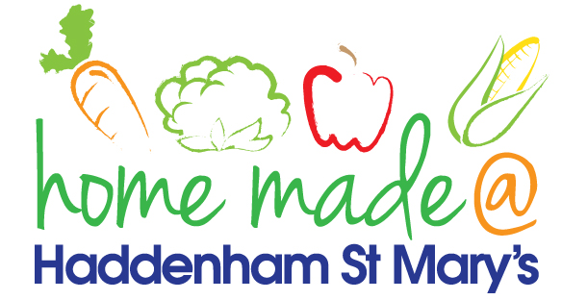

MENU – week commencing 19th April 2021
 | Meat Free Monday | Tuesday  Choose Day | Wednesday  Wonderful Roast | Thursday  Julie’s Jackets | Friday  Fish Friday
Lunch | Vegan sausage roll, potato rosti and baked beans | Tomato and bacon pasta bake | Roast beef with all the trimmings | Jacket potato with a choice of toppings | Scamp, chips and vegetables
Vegetarian option | Vegan sausage roll, potato rosti and baked beans | Tomato pasta bake | Quorn roast with all the trimmings | Jacket potato with a choice of toppings | Vegetable fingers, chips and vegetables
Dessert | Tinned peaches | Yoghurt | Fresh fruit | Shortbread | Chocolate muffin
Free From  option | Vegan sausage roll, potato rosti and baked beans  Tinned peaches | Tomato and bacon pasta bake  Vanilla pudding | Roast beef with all the trimmings  Fresh fruit | Jacket potato with a choice of toppings  Biscuit | Fish fingers, chips and vegetables  Cake
All meals will contain or be served with at least one portion of vegetables.
All hot puddings will be accompanied by custard or cream.
All roast dinners, sausage & mash and pie dishes will have the option of extra gravy.
All children will also be offered bread, a piece of fruit and a drink of milk or water with their main meal.

