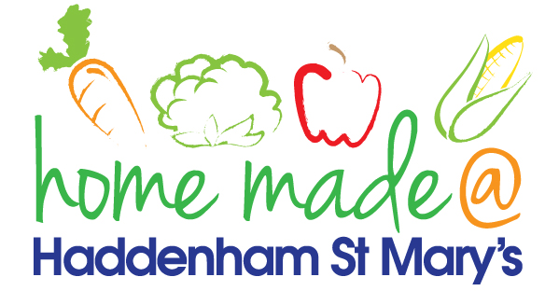

MENU – week commencing 10th May 2021
 | Meat Free Monday | Tuesday  Choose Day | Wednesday  Wonderful Roast | Thursday  Julie’s Jackets | Friday  Fish Friday
Lunch | Pizza, potato wedges and vegetables | Spaghetti Bolognese | Turkey roast with all the trimmings | Jacket potato with a choice of toppings | Jumbo fish fingers, potato lattice and vegetables
Vegetarian option | Pizza, potato wedges and vegetables | Veggie spaghetti Bolognese | Veggie sausage roast with all the trimmings | Jacket potato with a choice of toppings | Vegetable slice, potato lattice and vegetables
Dessert | Mandarin segments | Mousse | Fresh fruit | Rock cake | Chocolate muffin
Free From  option | Pizza, potato wedges and vegetables  Mandarin segments | Spaghetti Bolognese  Custard | Turkey roast with all the trimmings  Fresh fruit | Jacket potato with a choice of toppings  Biscuit | Fish fingers, potato lattice and vegetables  Cake
All meals will contain or be served with at least one portion of vegetables.
All hot puddings will be accompanied by custard or cream.
All roast dinners, sausage & mash and pie dishes will have the option of extra gravy.
All children will also be offered bread, a piece of fruit and a drink of milk or water with their main meal.

