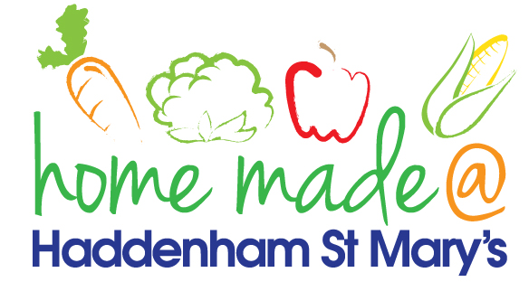

MENU – week commencing 3rd May 2021
 | Meat Free Monday | Tuesday  Choose Day | Wednesday  Wonderful Roast | Thursday  Julie’s Jackets | Friday  Fish Friday
Lunch |  | Chicken goujons, potato rosti and vegetables | Beef roast with all the trimmings | Jacket potato with a choice of toppings | Breaded fish, chips and vegetables
Vegetarian option |  | Vegetable fingers, potato rosti and vegetables | Quorn roast with all the trimmings | Jacket potato with a choice of toppings | Vegetable fingers, chips and vegetables
Dessert |  | Yoghurt | Fresh fruit | Ginger cookie | Chocolate chip muffin
Free From  option |  | Chicken, potato rosti and vegetables  Vanilla pudding | Beef roast with all the trimmings  Fresh fruit | Jacket potato with a choice of toppings  Biscuit | Fish fingers, chips and vegetables  Cake
All meals will contain or be served with at least one portion of vegetables.
All hot puddings will be accompanied by custard or cream.
All roast dinners, sausage & mash and pie dishes will have the option of extra gravy.
All children will also be offered bread, a piece of fruit and a drink of milk or water with their main meal.

