Home Learning – Cuddington and Dinton C of E Primary School
Foundation – Daily Lesson Plans
Day 1
Lesson 1  Phonics, | Re-cap all the Jolly Phonics songs for sounds and digraphs learned so far.  Phase 2: https://www.youtube.com/watch?v=2Xy2e78qxNg  Phase 3: https://www.youtube.com/watch?v=ixndECFUbIo
Lesson 2 Maths

Lesson 3  Writing | Story starter!  The books had minds of their own…  This was no ordinary library.  Books about knights and castles would gallop all over the library, bravely and boldly ordering the other books around. The books about thieves would sneak around, lurking behind bookshelves in the shadows. Books about wild animals would occasionally roar and bite other books. The ones containing stories set in the winter would often shiver, covering their neighbours with snow and frost.  Lucy loved this place like no other. Reading was the most exciting thing in the world here: everything she read seemed to come alive out of the pages…  Can you continue this story about The Greatest Library?  Question time!  How is this library different from a normal library?  What are your favourite types of books?  If you could choose for one of your books to come alive, which one would it be and why?  If you could be a character in a book, who would you like to be?  If you were to borrow every single book from your local library, would it still be a library?  In your opinion, what makes a good book? Can you come up with a top three favourite authors?
Lesson 4
PE
Day 2
Lesson 1  Phonics, | Speed writing digraphs. Ch, th, oo, ee, ng, ar, sh, ai, or, ck, ff, ss, ll, ie, oa, ow, zz. Play bingo with the digraphs. Choose 8 in total to play the game.
Lesson 2  Writing | 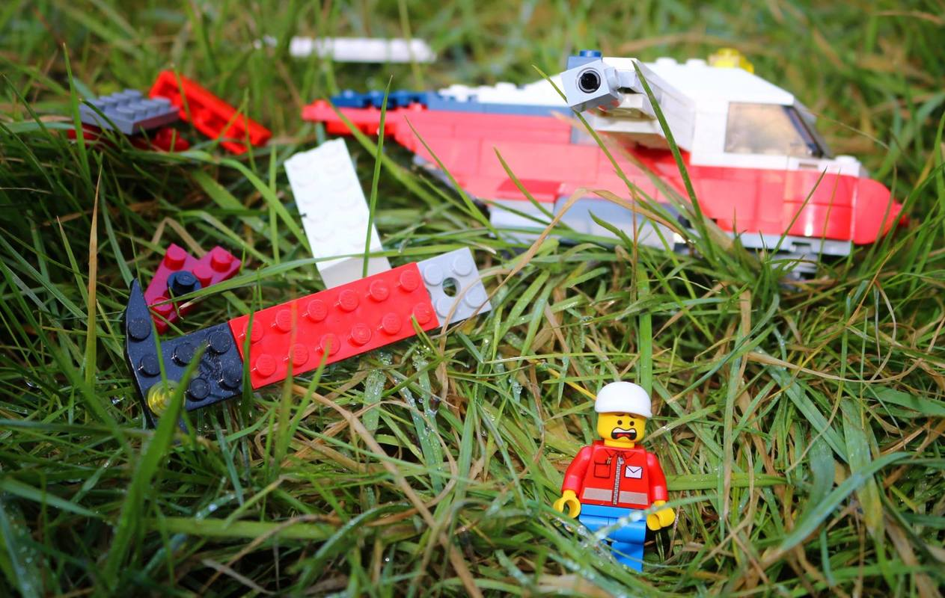  Story starter!  Lawrence was injured, afraid, lost and completely alone. He had been thrown viciously from the aircraft after the flock of birds had attacked the propellers.  As he laid there, listening to his racing heart, he wondered what would happen to him.  How would he make it out alive?  Question time!  How has the helicopter crashed?  What do you think he should try to do next?  Who might be able to help in this situation?  What do you think you would do if you were in a similar situation?  Why do you think he is afraid?  What might he be afraid of?  Perfect picture!  Draw a picture of what Lawrence might have seen before the helicopter crashed.
Lesson 3
Maths
Lesson 4
Outdoor learning
Day 3
Lesson 1  Phonics, | Mr Thorne and Geraldine the Giraffe phonics looking at digraphs and trigraphs. Have a go at writing a sentence with as many digraphs in it as you can.  https://www.youtube.com/channel/UC7sW4j8p7k9D_qRRMUsGqyw
Lesson 2
Maths

Lesson 3  Writing | Create a character, e.g., a mouse, a superhero, a child, or an animal/bird or whatever you wish. Can you remember the ingredients we need for a story?  - A beginning – one stormy night …  - A middle where the characters do something.  - And ending – happy? Sad? Cliff hanger?
Lesson 4  Reading | Read your favourite stories with an adult. See how many tricky or high frequency words you can find in your stories.

Day 4
Lesson 1  Phonics, | Re-cap all the tricky words and high frequency words you have learned so far. Which ones are you finding trickiest? Cut up the words and put them around the house and then go on a tricky/hfw word hunt.
Lesson 2  Writing | 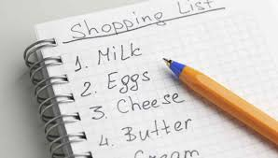Can you write a list for shopping, or for going on holiday, a list of things for a picnic, or things you would take into space, or a wish list of things you’d like to do or places you’d like to go to? Remember a list is written one item under each other.
Lesson 3
Maths
Lesson 4  Outdoor Learning | Make a kite for a windy day and fly it. Bin bags and straws or twigs work well. Or use a piece of material or a lightweight scarf to fly in the wind. Attach to a stick or just hold behind you are you run to let it flutter in the wind.
Day 5
Lesson 1  Phonics, | 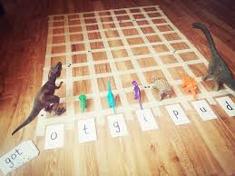 Choose different phonemes and digraphs and create some words. When you choose a word, move the dinosaurs one space that have those sounds in the word. You can use masking tape, chalk, or a large piece of paper to create your grid and use whichever toys you wish.
Lesson 2
Maths
Lesson 3  Writing | 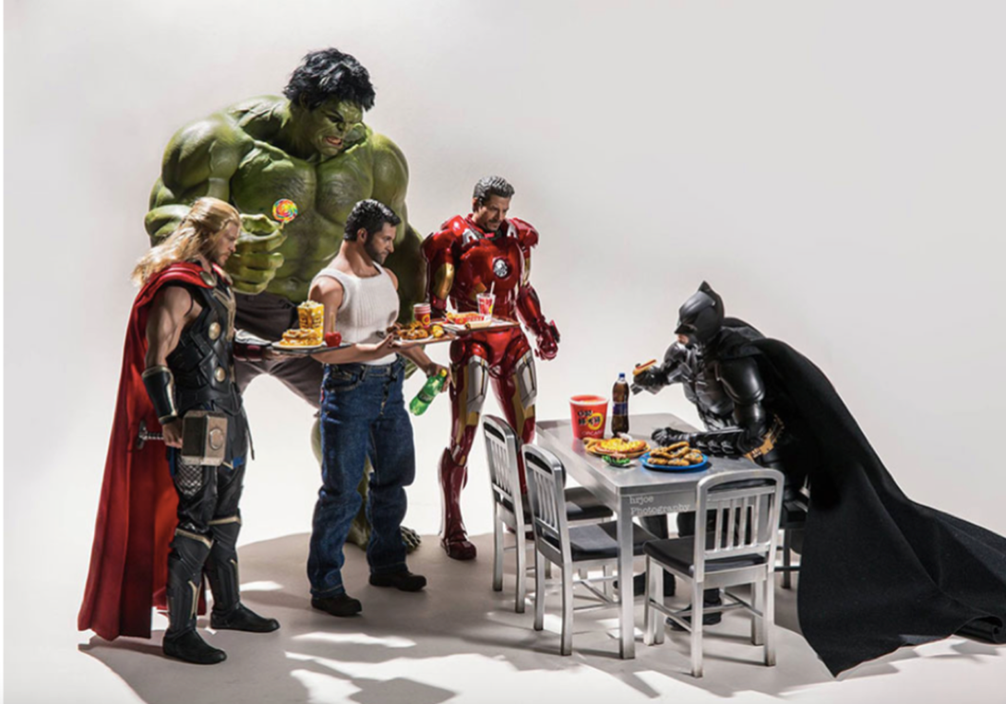  Story starter!  Despite being a superhero, spending the majority of his time battling against crime and dangerous villains in Gotham City with an array of different skills and deadly weapons, Batman had a weakness for chicken nuggets.  The other superheroes were also making the most of their afternoon off from saving the world. However, they didn’t have long: soon they would have to get back to business…  Question time!  Can you recognise each of the characters?  What do you think each of them do on a daily basis?  What do you think each of their favourite foods might be?  What do you think each of the characters are really like?  Perfect picture!  Can you draw the perfect lunch for superheroes? Think carefully about what they would eat.
Lesson 4
PE

