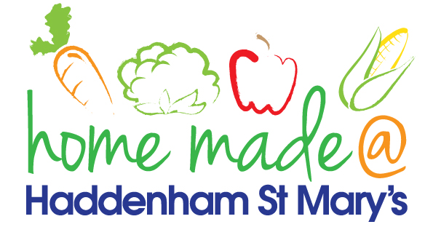

MENU – week commencing 08/02/21
 | Meat Free Monday | Tuesday  Choose Day | Wednesday  Wonderful Roast | Thursday  Julie’s Jackets | Friday  Fish Friday
Lunch | Pizza, potato wedges and vegetables | Chicken goujons, potato rosti and vegetables | Sausage roast with all the trimmings | Jacket potato with a choice of toppings | Jumbo fish fingers, potato lattice and vegetables
Vegetarian option | Pizza, potato wedges and vegetables | Veggie goujons, potato rosti and vegetables | Veggie sausage roast with all the trimmings | Jacket potato with a choice of toppings | Vegetable slice, potato lattice and vegetables
Dessert | Bananas and custard | Cheesecake | Fresh fruit | Chocolate muffin | Homemade chocolate biscuit
Free From  option | Pizza, potato wedges and vegetables  Bananas and custard | Chicken goujons, potato rosti and vegetables  Custard | Sausage roast with all the trimmings  Fresh fruit | Jacket potato with a choice of toppings  Cake/brownie | Fish fingers, potato lattice and vegetables  Cookie
All meals will contain or be served with at least one portion of vegetables.
All hot puddings will be accompanied by custard or cream.
All roast dinners, sausage & mash and pie dishes will have the option of extra gravy.
All children will also be offered bread, a piece of fruit and a drink of milk or water with their main meal.

