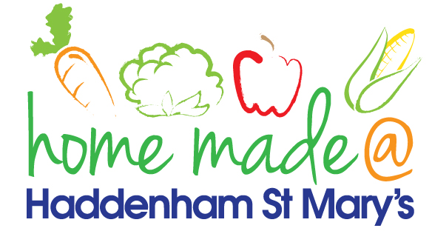

MENU – week commencing 25/01/21
 | Meat Free Monday | Tuesday  Choose Day | Wednesday  Wonderful Roast | Thursday  Julie’s Jackets | Friday  Fish Friday
Lunch | Vegetable curry and rice | Beef burger, chips and vegetables | Sausage roast with all the trimmings | Jacket potato with a choice of toppings | Fish cake, potato rosti and vegetables
Vegetarian option | Vegetable curry and rice | Veggie burger, chips and vegetables | Veggie sausage roast with all the trimmings | Jacket potato with a choice of toppings | Veggie fingers, potato rosti and vegetables
Dessert | Mandarin segments | Cheesecake | Fresh fruit | Apple cake | Coconut crunch
Free From  option | Vegetable curry and rice  Mandarin segments | Beef burger, chips and vegetables  Custard | Sausage roast with all the trimmings  Fresh fruit | Jacket potato with a choice of toppings  Cake | Fish fingers, chips and vegetables  Biscuit
All meals will contain or be served with at least one portion of vegetables.
All hot puddings will be accompanied by custard or cream.
All roast dinners, sausage & mash and pie dishes will have the option of extra gravy.
All children will also be offered bread, a piece of fruit and a drink of milk or water with their main meal.

