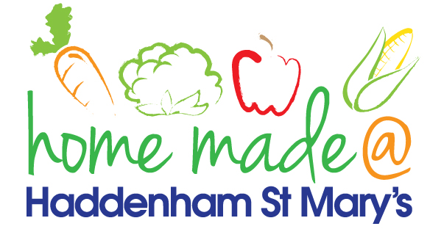

MENU – week commencing 01/02/21
 | Meat Free Monday | Tuesday  Choose Day | Wednesday  Wonderful Roast | Thursday  Julie’s Jackets | Friday  Fish Friday
Lunch | Vegetable fingers, vegetables and potato rosti | Spaghetti Bolognese | Sausages, mashed potato and vegetables | Jacket potato with a choice of toppings | Breaded fish, chips and vegetables
Vegetarian option | Vegetable fingers, vegetables and potato rosti | Spaghetti Bolognese | Veggie sausages, mashed potato and vegetables | Jacket potato with a choice of toppings | Vegetable  fingers, chips and vegetables
Dessert | Mandarin segments | Mousse | Fresh fruit | Carrot cake | Viennese whirl
Free From  option | Vegetable patty, vegetables and potato rosti  Mandarin segments | Spaghetti Bolognese  Vanilla pudding | Sausages, mashed potato and vegetables  Fresh fruit | Jacket potato with a choice of toppings  Cake | Fish fingers, chips and vegetables  Cookie/flapjack
All meals will contain or be served with at least one portion of vegetables.
All hot puddings will be accompanied by custard or cream.
All roast dinners, sausage & mash and pie dishes will have the option of extra gravy.
All children will also be offered bread, a piece of fruit and a drink of milk or water with their main meal.

