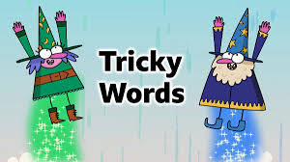
14.01.21
Dear Parents/Carers,

We have been using high frequency and tricky words in the captions and sentences we have been using in our phonics sessions. Please find a copy of the first 100 high frequency/tricky words on our website. This is the list for the year. Please start looking at the words and help your child to learn them. They are a mixture of ‘tricky’ words and high frequency words. There are many words that are irregular. These cannot be spelt accurately by listening for the sounds. These are called the ‘tricky’ words and have to be learnt from memory. They cannot and should not be sounded out.
The high frequency words will be used when creating sentence structures in class. These can be sounded out.
We will be focussing on tricky and high frequency words from this list starting this term which they will be tested on verbally. I will upload five from the list of the words each week on to the website to be tested on a Friday.
Many thanks for all the support you give your children. Together we are supporting them to become great readers and writers.

Mrs Harvey

