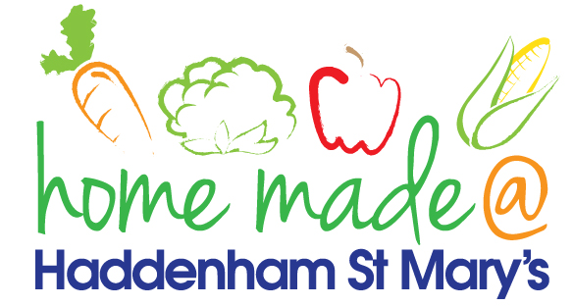

MENU – week 4
 | Monday  Around the world | Tuesday  Plant Based | Wednesday  Wonderful Roast | Thursday  Julie’s Jackets | Friday  Fish Friday
Lunch | Chilli, rice and nachos | Sausage roll, potato wedges and vegetables | Roast turkey with all the trimmings and gravy | Jacket potato with a choice of toppings | Fish cake, potato rosti and vegetables
Vegetarian option | Vegetable chilli, rice and nachos | Sausage roll, potato wedges and vegetables | Quorn roast with all the trimmings | Jacket potato with a choice of toppings | Veggie fingers, potato rosti and vegetables
Dessert | Mandarin segments | Jelly | Fresh fruit | Madeira cake | Coconut crunch
Free From  option | Chilli, rice and nachos  Mandarin segments | Sausage, potato wedges and vegetables  Custard | Roast turkey with all the trimmings and gravy  Fresh fruit | Jacket potato with a choice of toppings  Cake | Fish fingers, chips and vegetables  Biscuit
All meals will contain or be served with at least one portion of vegetables.
All hot puddings will be accompanied by custard or cream.
All roast dinners, sausage & mash and pie dishes will have the option of extra gravy.
All children will also be offered bread, a piece of fruit and a drink of milk or water with their main meal.

