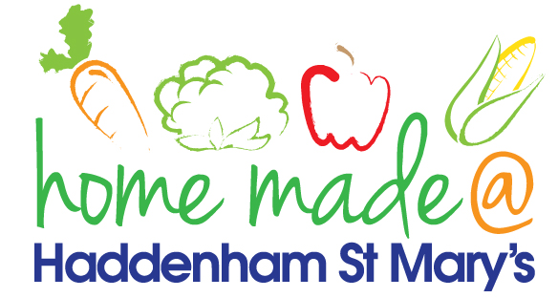

MENU – week 3
 | Monday  Around the World | Tuesday  Plant Based | Wednesday  Wonderful Roast | Thursday  Julie’s Jackets | Friday  Fish Friday
Lunch | Meatballs and spaghetti | Lentil and vegetable curry | Roast beef with all the trimmings and gravy | Jacket potato with a choice of toppings | Tuna pasta bake
Vegetarian option | Veggie meatballs and spaghetti | Lentil and vegetable curry | Falafel roast with all the trimmings | Jacket potato with a choice of toppings | Tuna pasta bake
Dessert | Bananas and custard | Pancakes and Fruit | Fresh fruit | Mousse | Homemade biscuit
Free From  option | Meatballs and spaghetti  Bananas and custard | Lentil and vegetable curry  fruit | Roast beef with all the trimmings and gravy  Fresh fruit | Jacket potato with a choice of toppings  Jelly | Tuna pasta bake  Cookie/flapjack
All meals will contain or be served with at least one portion of vegetables.
All hot puddings will be accompanied by custard or cream.
All roast dinners, sausage & mash and pie dishes will have the option of extra gravy.
All children will also be offered bread, a piece of fruit and a drink of milk or water with their main meal.

