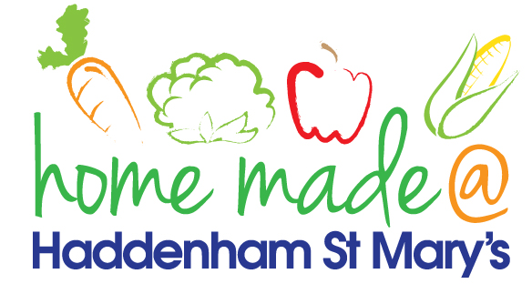

MENU – week 2
 | Monday  Around the world | Tuesday  Plant Based | Wednesday  Wonderful Roast | Thursday  Julie’s Jackets | Friday  Fish Friday
Lunch | Macaroni cheese | Vegetable patty, potatoes and vegetables | Roast turkey with all the trimmings and gravy | Jacket potato with a choice of toppings | Jumbo fish fingers, chips and vegetables
Vegetarian option | Macaroni cheese | Vegetable patty, potatoes and vegetables | Veggie sausage roast with all the trimmings | Jacket potato with a choice of toppings | Vegetable slice, chips and vegetables
Dessert | Peach slices | Dried fruit salad | Fresh fruit | Cheesecake | Homemade chocolate biscuit
Free From  option | Macaroni cheese  Peach slices | Sausages, potatoes and vegetables  Custard | Roast turkey with all the trimmings and gravy  Fresh fruit | Jacket potato with a choice of toppings  Custard | Fish fingers, chips and vegetables  Cookie
All meals will contain or be served with at least one portion of vegetables.
All hot puddings will be accompanied by custard or cream.
All roast dinners, sausage & mash and pie dishes will have the option of extra gravy.
All children will also be offered bread, a piece of fruit and a drink of milk or water with their main meal.

