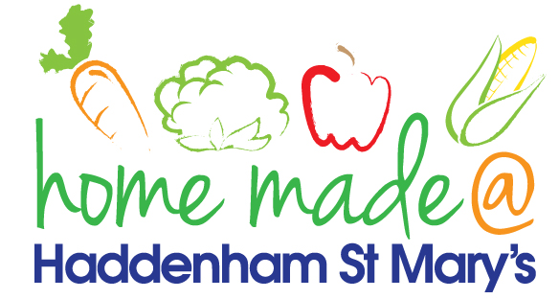

MENU – Christmas Week
 | Monday | Tuesday | Wednesday | Thursday | Friday
Lunch | Pasta with a choice of topping | Hotdog sausages, potato wedges and vegetables | Roast turkey with all the trimmings and gravy | Jacket potato with a choice of toppings | Goujons and chips
Vegetarian option | Pasta with a choice of topping | Hotdog sausages, potato wedges and vegetables | Veggie sausage with all the trimmings | Jacket potato with a choice of toppings | Goujons and chips
Dessert | Bananas and custard | Pancakes and fruit | Ice cream | Pinwheel | Festive biscuit
Free From  option | Pasta with a choice of topping  Bananas and custard | Hotdog sausages, potato wedges and vegetables  Fruit | Roast turkey with all the trimmings and gravy  Fresh fruit | Jacket potato with a choice of toppings  Cake | Goujons and chips  Cookie/flapjack
All meals will contain or be served with at least one portion of vegetables.
All hot puddings will be accompanied by custard or cream.
All roast dinners, sausage & mash and pie dishes will have the option of extra gravy.
All children will also be offered bread, a piece of fruit and a drink of milk or water with their main meal.

