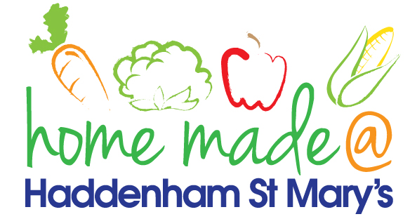

MENU – week 1
 | Monday  Around the World | Tuesday  Plant Based | Wednesday  Wonderful Roast | Thursday  Julie’s Jackets | Friday  Fish Friday
Lunch | Sweet and sour pork and rice | Spaghetti Bolognese | Roast beef with all the trimmings and gravy | Jacket potato with a choice of toppings | Breaded fish, chips and vegetables
Vegetarian option | Sweet and sour vegetables and rice | Spaghetti Bolognese | Quorn roast with all the trimmings | Jacket potato with a choice of toppings | Vegetable  fingers, chips and vegetables
Dessert | Mandarin segments | Pancakes and fruit | Fresh fruit | Honey cake | Custard biscuit
Free From  option | Sweet and sour pork  Mandarin segments | Spaghetti Bolognese  Pancakes and fruit | Roast beef with all the trimmings and gravy  Fresh fruit | Jacket potato with a choice of toppings  Cake | Fish fingers, chips and vegetables  Cookie/flapjack
All meals will contain or be served with at least one portion of vegetables.
All hot puddings will be accompanied by custard or cream.
All roast dinners, sausage & mash and pie dishes will have the option of extra gravy.
All children will also be offered bread, a piece of fruit and a drink of milk or water with their main meal.

