Year 3 Prayer
Recognising what is special in others
Hands together and eyes closed.

Thank you God for all the special people in our lives. We have kind and loving friends and families that are always there for us.
We have special people who care for and protect us. Vets are special to animals who make them better and feel loved.

Special people are those that play with us and help us when we need help. They consider other people’s feelings and are honest.
Help us be the sort of person that others can trust. Help us know that it is important to keep our promises and look after others.
Help us remember that we can learn from everyone, whether they are older or younger than us.

We are all unique and we all deserve respect and to feel safe wherever we go.
Jesus was special, he cared for people and told stories to remind us that everyone should be thoughtful of other people’s views.
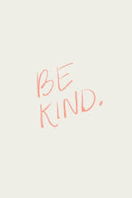
We are all special.
Amen

