Spring Eye-Spy!
Can you spot any of these natural beauties?
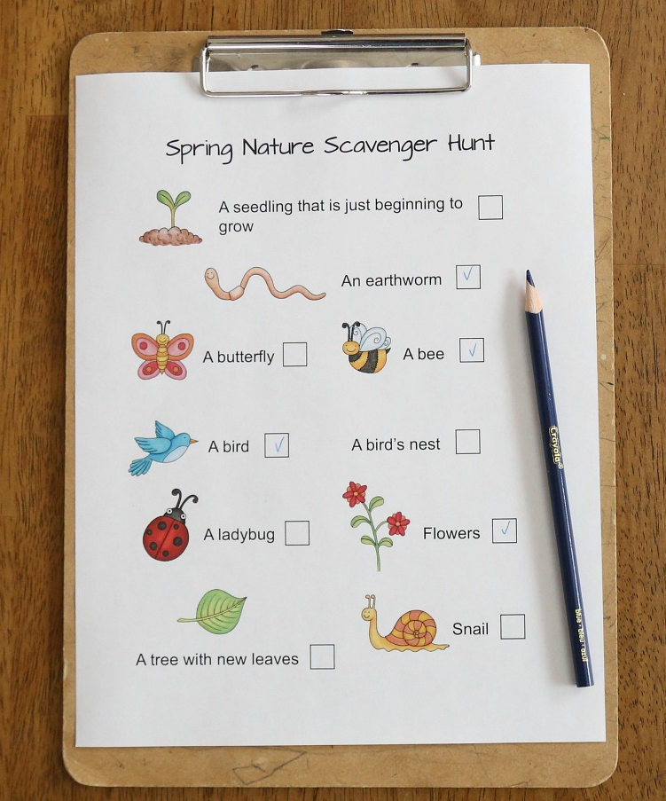
(Even if this is just from your window!)

