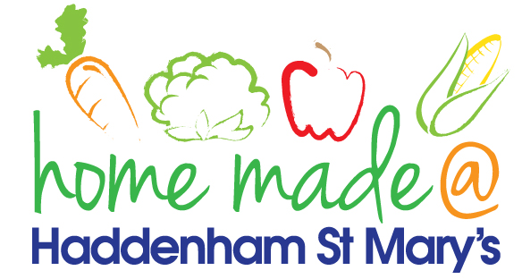

MENU – week commencing 27/01/20
 | Monday  Around the world | Tuesday  Family  Favourites | Wednesday  Wonderful Roast | Thursday  Julie’s Jackets | Friday  Fish Friday
Lunch | Turkey pastichio | Sausages, mash and vegetables | Roast turkey with all the trimmings and gravy | Jacket potato with a choice of toppings | Fishcake, chips and vegetables
Vegetarian option | Veggie pastichio | Veggie sausages, mash and vegetables | Veggie sausage roast with all the trimmings | Jacket potato with a choice of toppings | Vegetable slice, chips and vegetables
Dessert | Peach slices | Trifle | Fresh fruit | Fruit crumble | Ginger snap
Free From  option | Turkey pastichio  Peach slices | Sausages, mash and vegetables  Mousse/yoghurt | Roast turkey with all the trimmings and gravy  Fresh fruit | Jacket potato with a choice of toppings  Fruit crumble | Fish fingers, chips and vegetables  Cookie
All meals will contain or be served with at least one portion of vegetables.
All hot puddings will be accompanied by custard or cream.
All roast dinners, sausage & mash and pie dishes will have the option of extra gravy.
All children will also be offered bread, a piece of fruit and a drink of milk or water with their main meal.

