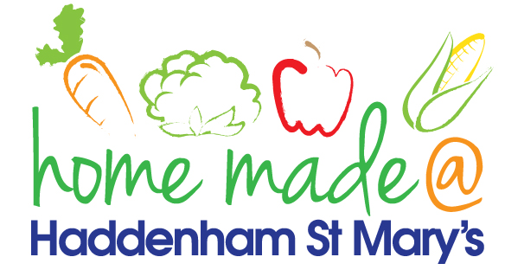

MENU – week commencing 10/02/20
 | Monday  Around the World | Tuesday  Family  Favourites | Wednesday  Wonderful Roast | Thursday  Julie’s Jackets | Friday  Fish Friday
Lunch | Meatballs and spaghetti | Mediterranean chicken and rice | Roast turkey with all the trimmings and gravy | Jacket potato with a choice of toppings | Fishcake, chips and sweetcorn
Vegetarian option | Veggie meatballs and spaghetti | Mediterranean vegetables and rice | Falafel roast with all the trimmings | Jacket potato with a choice of toppings | Vegetable fingers, chips and sweetcorn
Dessert | Bananas and custard | Fruit yoghurt | Fresh fruit | Jam sponge | Valentine biscuit
Free From  option | Meatballs and spaghetti  Bananas and custard | Mediterranean chicken and rice  Mousse/Yoghurt | Roast turkey with all the trimmings and gravy  Fresh fruit | Jacket potato with a choice of toppings  Cake | Fish fingers, chips and sweetcorn  Biscuit
All meals will contain or be served with at least one portion of vegetables.
All hot puddings will be accompanied by custard or cream.
All roast dinners, sausage & mash and pie dishes will have the option of extra gravy.
All children will also be offered bread, a piece of fruit and a drink of milk or water with their main meal.

