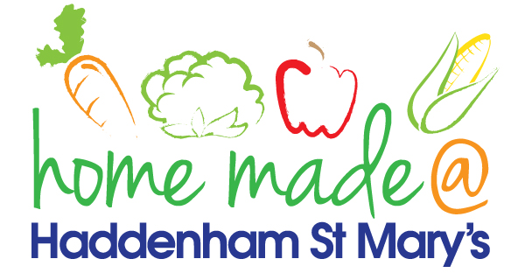

MENU –week commencing 7/01/20
 | Monday  Around the world | Tuesday  Family  Favourites | Wednesday  Wonderful Roast | Thursday  Julie’s Jackets | Friday  Fish Friday
Lunch |  | Chicken Kiev, potato rosti and vegetables | Roast beef with all the trimmings and gravy | Jacket potato with a choice of toppings | Fish burger, potato lattice and vegetables
Vegetarian option |  | Veggie Kiev, potato rosti and vegetables | Quorn roast with all the trimmings | Jacket potato with a choice of toppings | Veggie burger, potato lattice and vegetables
Dessert |  | Mandarin segments | Fresh fruit | Fruit crumble | Homemade biscuit
Free From  option |  | Chicken breast, potato rosti and vegetables  Mousse/yoghurt | Roast beef with all the trimmings and gravy  Fresh fruit | Jacket potato with a choice of toppings  Fruit crumble | Fish fingers, chips and peas  Biscuit
All meals will contain or be served with at least one portion of vegetables.
All hot puddings will be accompanied by custard or cream.
All roast dinners, sausage & mash and pie dishes will have the option of extra gravy.
All children will also be offered bread, a piece of fruit and a drink of milk or water with their main meal.

