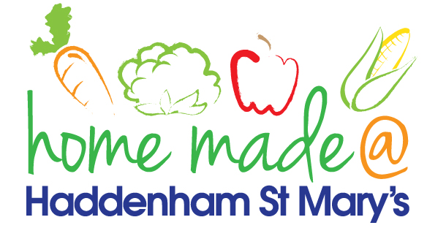

MENU – week commencing 03/02/20
 | Monday  Around the world | Tuesday  Family  Favourites | Wednesday  Wonderful Roast | Thursday  Julie’s Jackets | Friday  Fish Friday
Lunch | Chilli, rice and nachos | Chicken Kiev, potato rosti and vegetables | Roast beef with all the trimmings and gravy | Jacket potato with a choice of toppings | Fish burger, potatoes and vegetables
Vegetarian option | Vegetable chilli, rice and nachos | Veggie Kiev, potato rosti and vegetables | Quorn roast with all the trimmings | Jacket potato with a choice of toppings | Veggie burger, potatoes and vegetables
Dessert | Mandarin segments | Fruit yoghurt | Fresh fruit | Toffee cake | Oatybix biscuit
Free From  option | Chilli, rice and nachos  Mandarin segments | Chicken breast, potato rosti and vegetables  Mousse/yoghurt | Roast beef with all the trimmings and gravy  Fresh fruit | Jacket potato with a choice of toppings  Cake | Fish fingers, potatoes and vegetables  Biscuit
All meals will contain or be served with at least one portion of vegetables.
All hot puddings will be accompanied by custard or cream.
All roast dinners, sausage & mash and pie dishes will have the option of extra gravy.
All children will also be offered bread, a piece of fruit and a drink of milk or water with their main meal.

